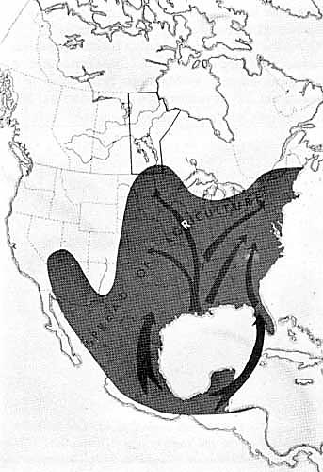
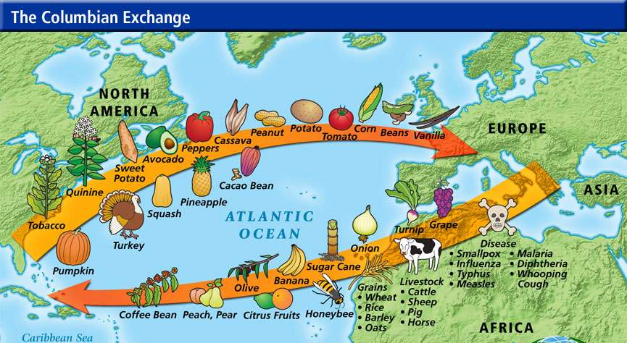
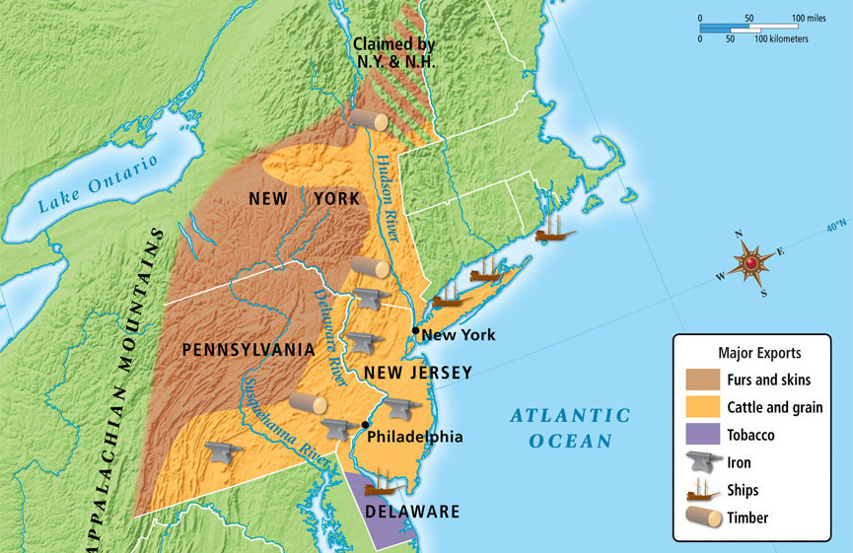
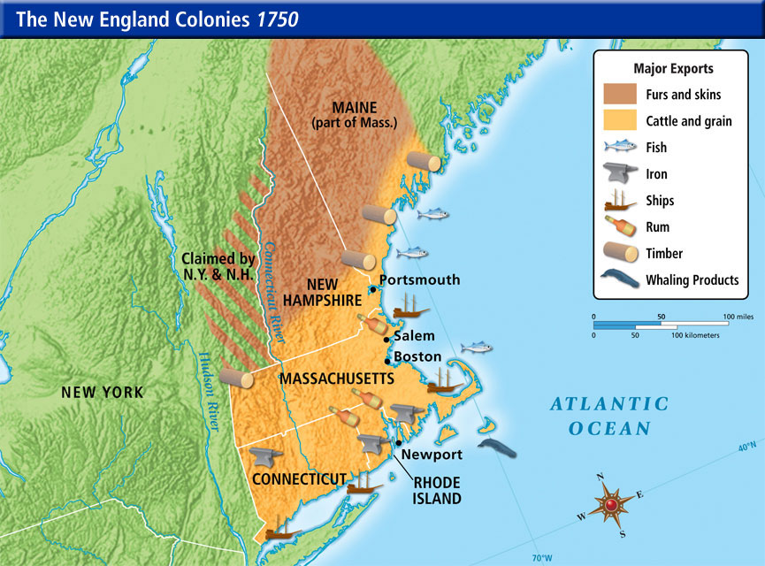
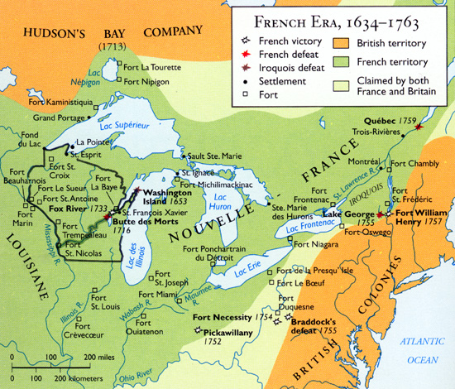
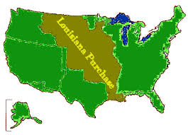
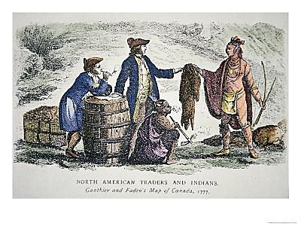
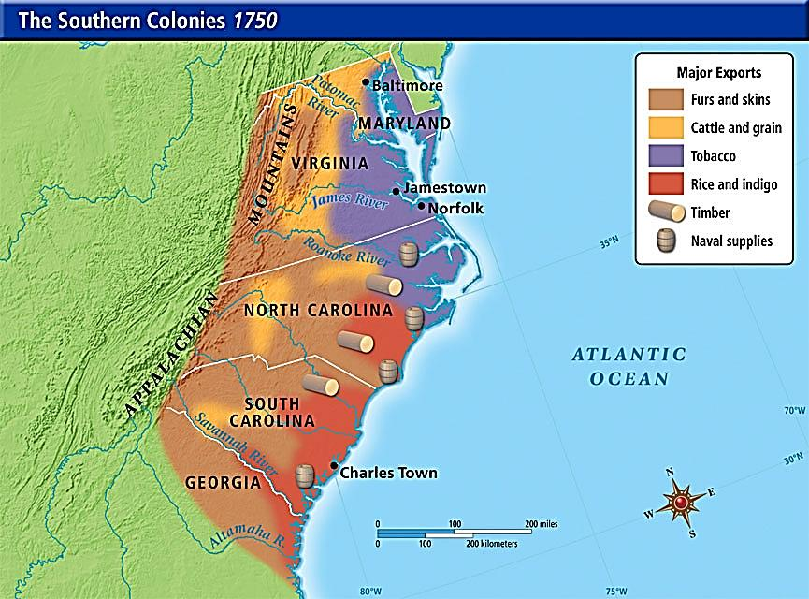
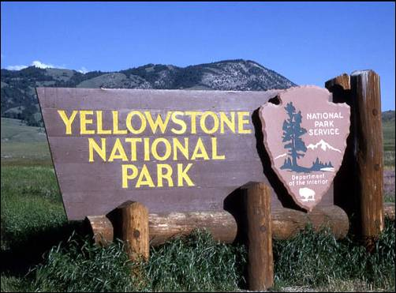
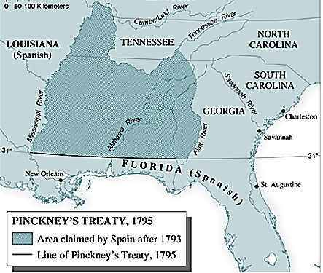
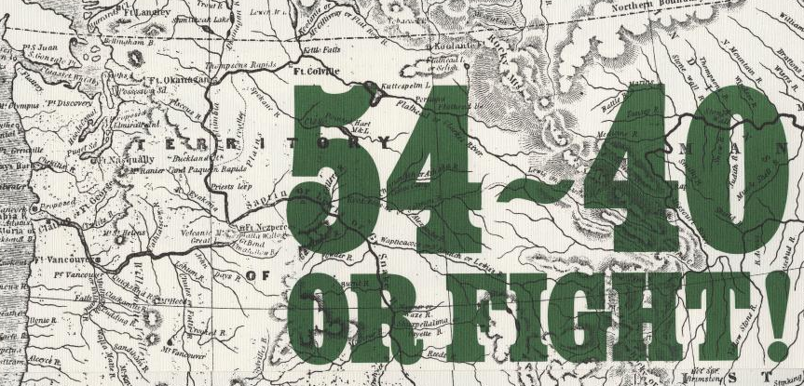
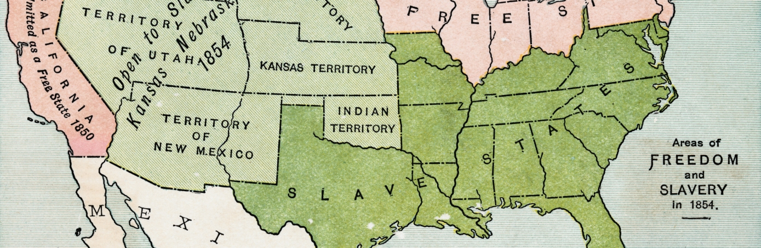

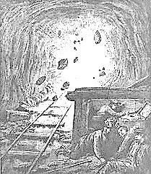
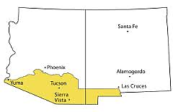
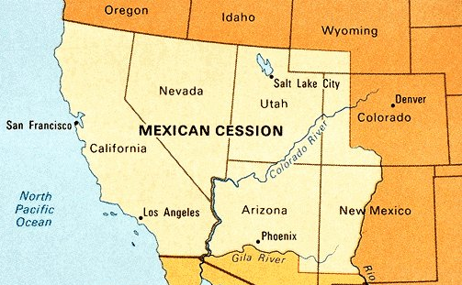

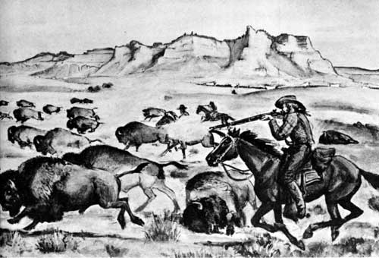
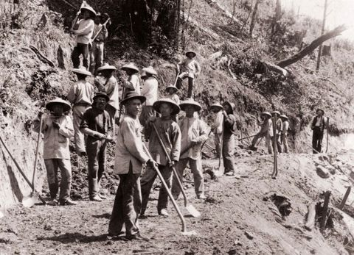
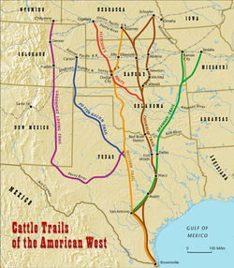

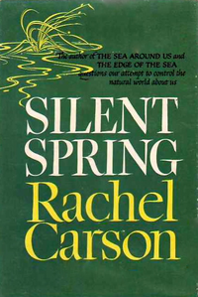
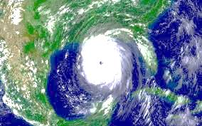
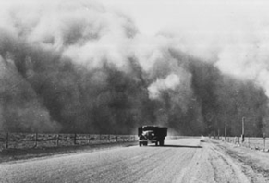
Hurricane Katrina
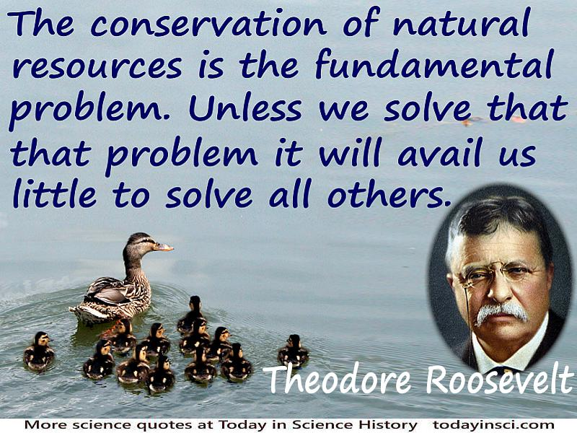
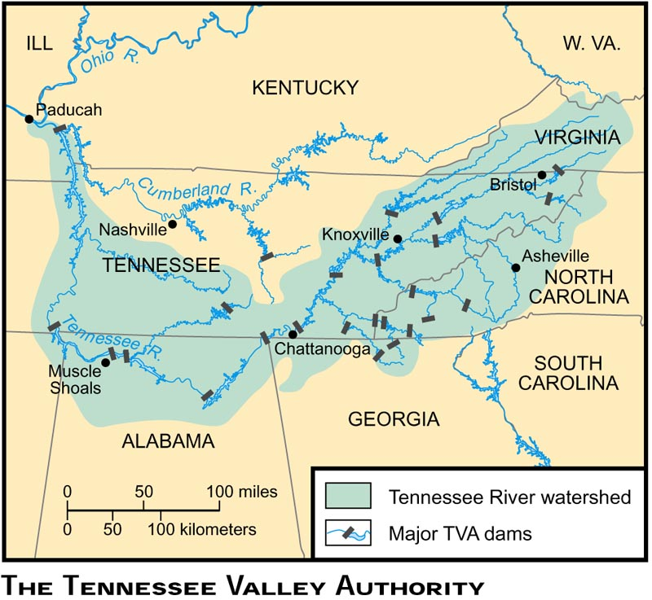
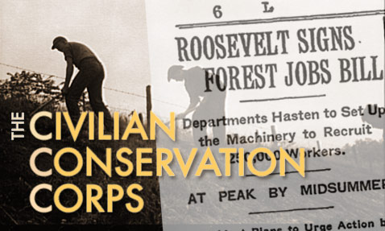
Hoover Dam
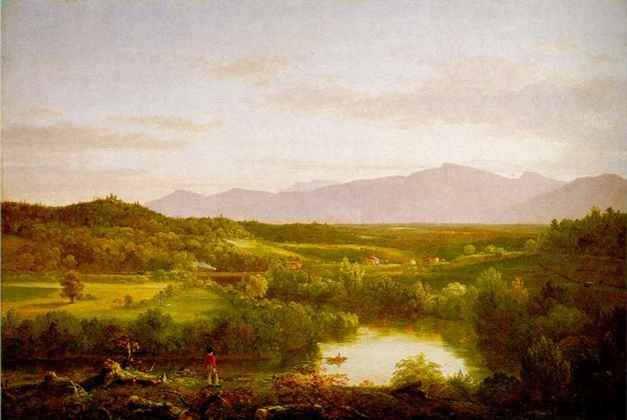
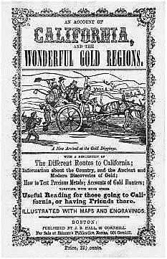
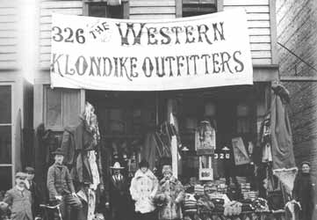
Thomas Cole

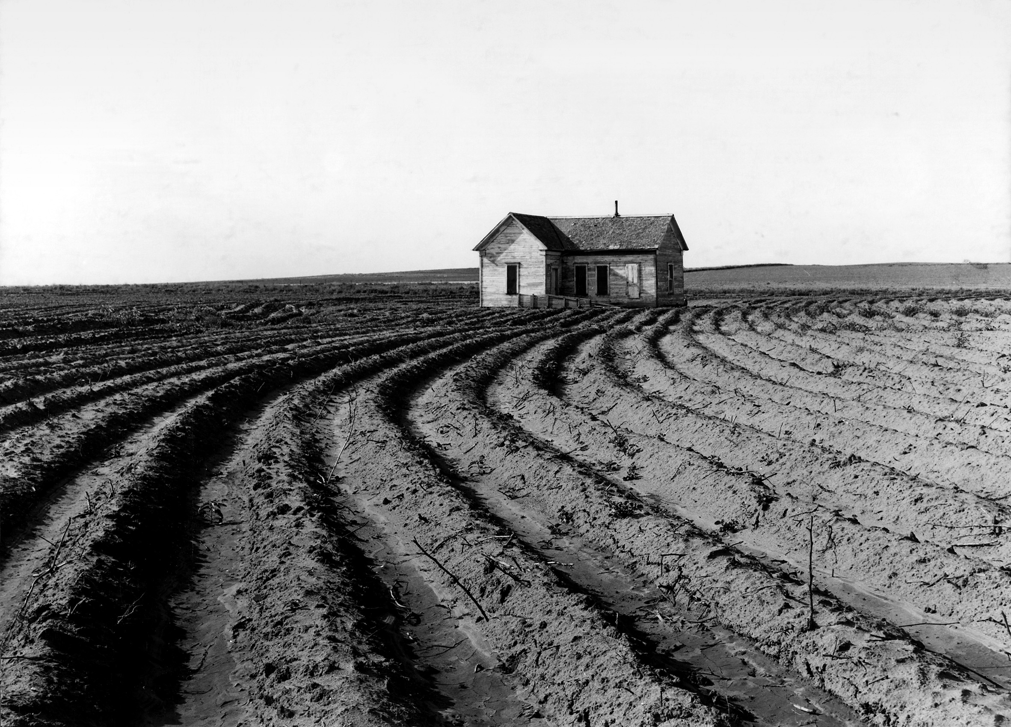
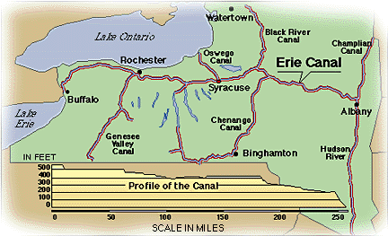
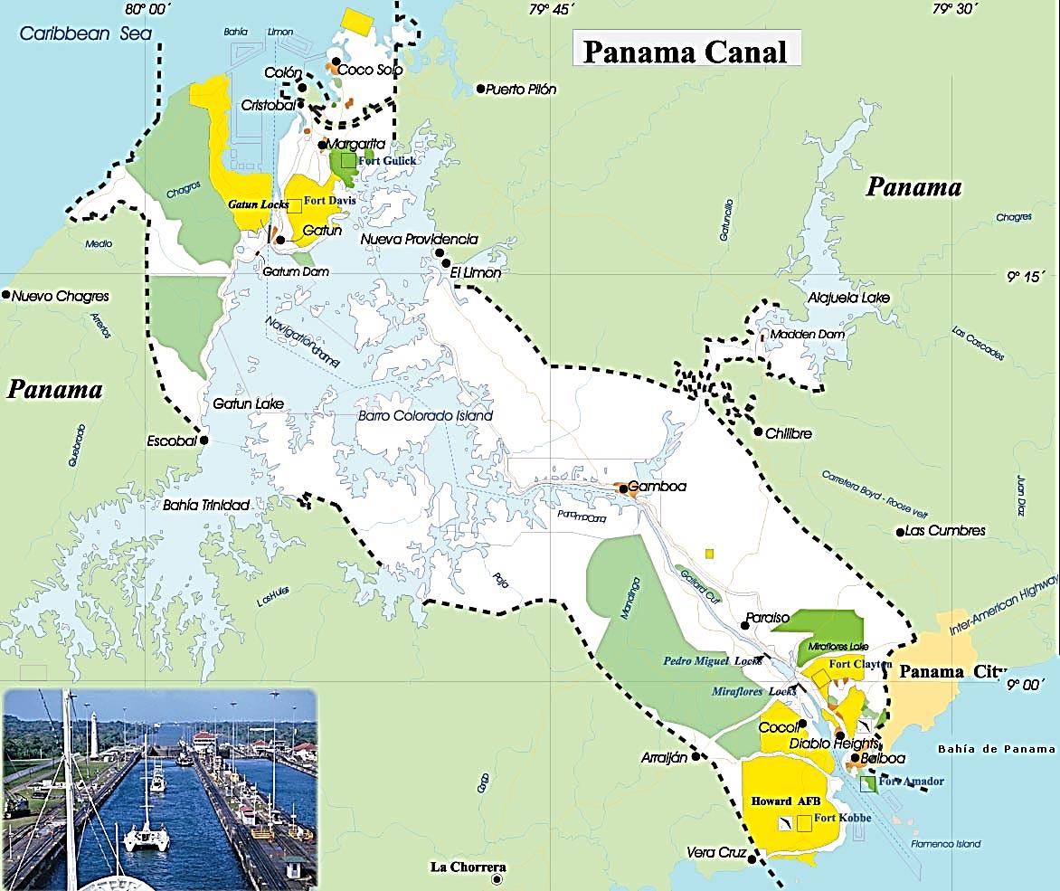
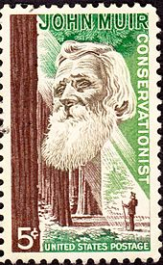

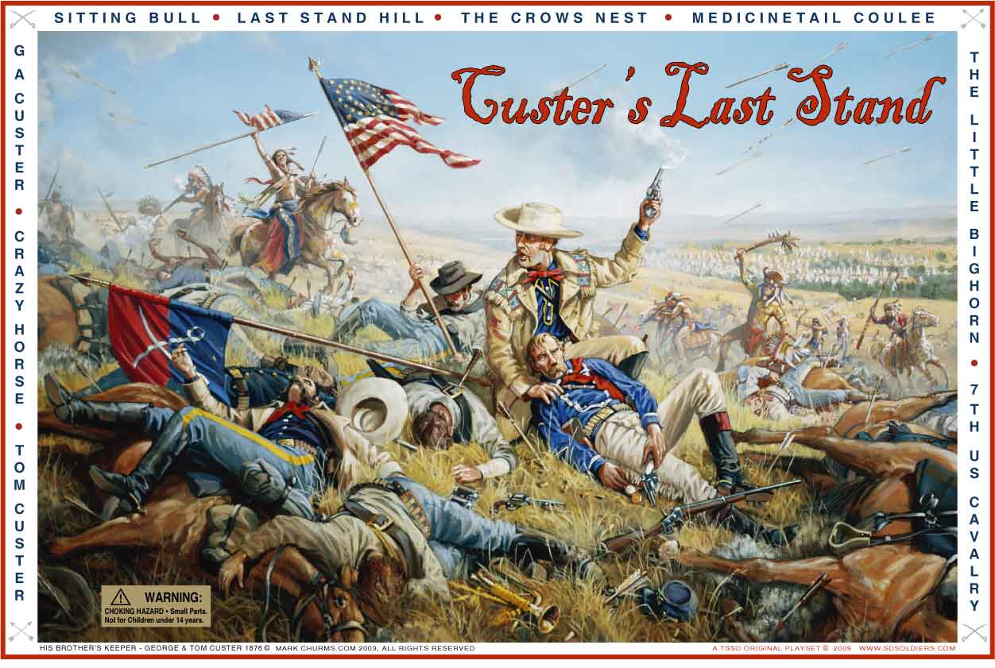
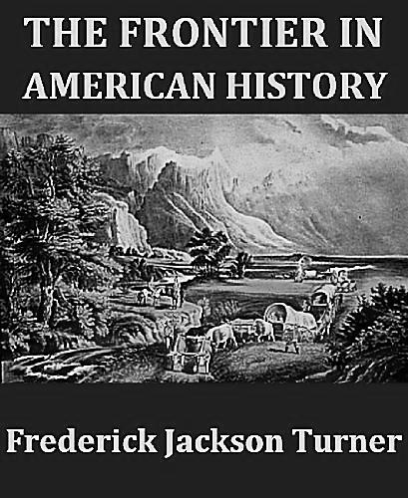
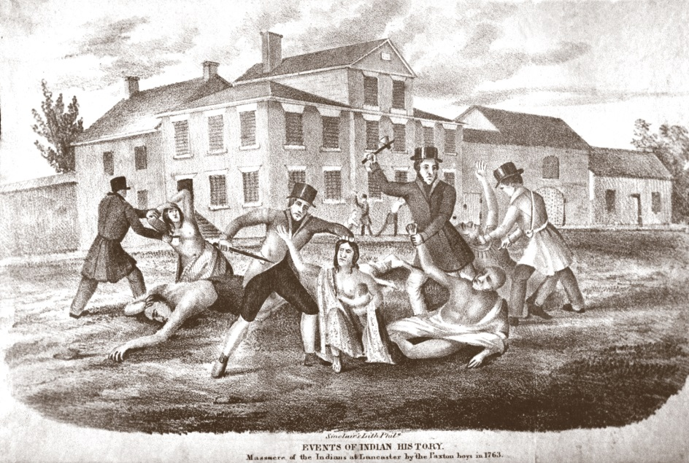
Paxton Boys

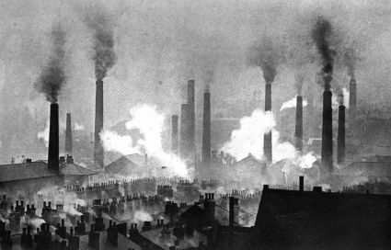
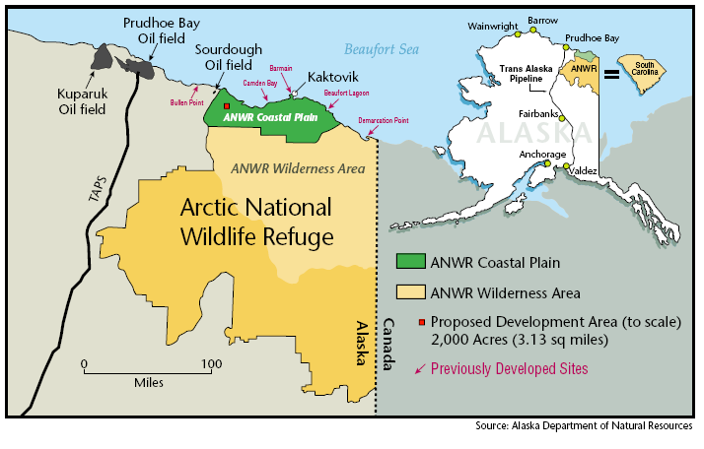
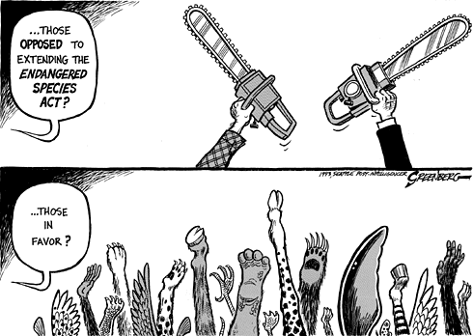

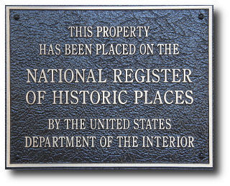
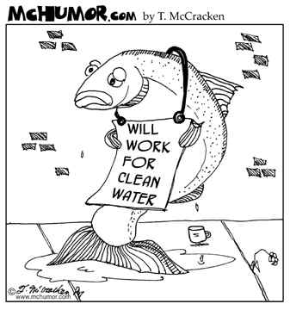
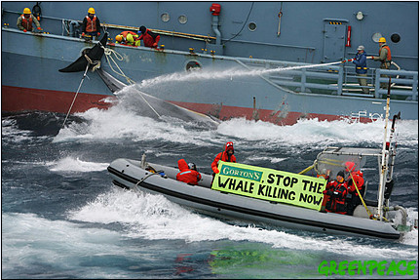

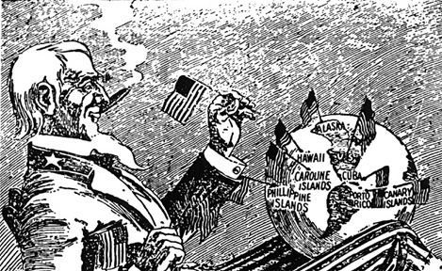
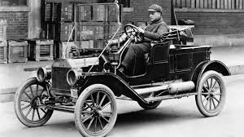
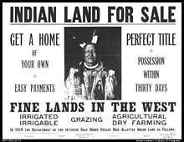
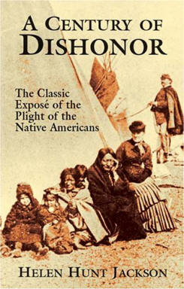
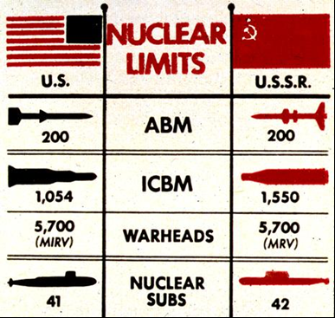
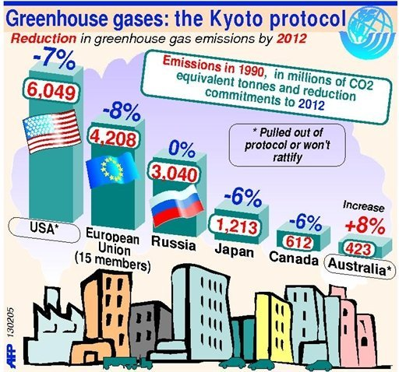

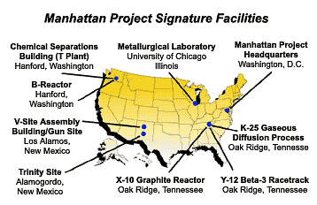
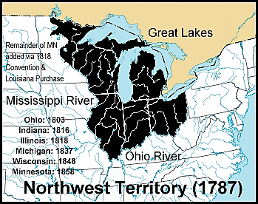

Geography and the Environment Thematic Review
Objective: Analyze the historical significance of geography and environment in the development of the United States.
Directions:
- Clear off your table (move everything to the floor).
- Lay out your timeline in chronological order – make three rows with 1 foot space below each row.
- Sort your events by era using the cards and timeline provided. If you don’t have room in an era to lay out all the cards, overlap in a way that still shows some of the image.
- Record your evidence (after events are sorted) in the chart below and discuss in your group how to address each of the objectives.
- Complete the writing activities in the Geography packet that correspond as you do this.

ENV Objectives | Relevant Eras | Corresponding Page in Packet | List of Relevant Evidence
Explain how the introduction of new plants, animals, and technologies altered the natural environment of North America and affected interactions among various groups in the colonial period. (ENV-1)  Period 1 (1491-1607): As settlers migrated and settled across the vast expanse of North America over time, they developed quite different and increasingly complex societies by adapting to and transforming their diverse environments.  Period 1 (1491-1607): The arrival of Europeans in the Western Hemisphere in the 15th and 16th centuries triggered extensive demographic and social changes on both sides of the Atlantic.  Period 1 (1491-1607): European expansion into the Western Hemisphere caused intense social/ religious, political, and economic competition in Europe and the promotion of empire building.  Period 2 (1607-1754): Competition over resources between European rivals led to conflict within and between North American colonial possessions and American Indians. | Exploration and Colonization, 1491-1754 | 4, 6
Explain how the natural environment contributed to the development of distinct regional group identities, institutions, and conflicts in the pre-contact period through the independence period. (ENV-2)  Period 1 (1491-1607): As settlers migrated and settled across the vast expanse of North America over time, they developed quite different and increasingly complex societies by adapting to and transforming their diverse environments.  Period 1 (1491-1607): Native peoples and Africans in the Americas strove to maintain their political and cultural autonomy in the face of European challenges to their independence and core beliefs.  Period 2 (1607-1754): Along with other factors, environmental and geographical variations, including climate and natural resources, contributed to regional  differences in what would become the British colonies.  Period 3 (1754-1800): Throughout the second half of the 18th century, various American Indian groups repeatedly evaluated and adjusted their alliances with Europeans, other tribes, and the new U.S. government. | Exploration and Colonization, 1491-1800 | 8

Explain how and why debates about and policies concerning the use of natural resources and the environment more generally have changed since the late 19th century. (ENV-5)  Period 6 (1865-1898): Westward migration, new systems of farming and transportation, and economic instability led to political and popular conflicts.  Period 6 (1865-1898): As transcontinental railroads were completed, bringing more settlers west, U.S. military actions, the destruction of the buffalo, the confinement of American Indians to reservations, and assimilationist policies reduced the number of American Indians and threatened native culture and identity.  Period 7 (1890-1945): Progressive reformers responded to economic instability, social inequality, and political corruption by calling for government intervention in the economy, expanded democracy, greater social justice, and conservation of natural resources.  Period 7 (1890-1945): Many Americans began to advocate overseas expansionism in the late 19th century, leading to new territorial ambitions and acquisitions in the Western Hemisphere and the Pacific.  Period 8 (1945-1980): As the United States focused on containing communism, it faced increasingly complex foreign policy issues, including decolonization, shifting international alignments and regional conflicts, and global economic and environmental changes.  Period 8 (1945-1980): As federal programs expanded and economic growth reshaped American society, many sought greater access to prosperity even as critics began to question the burgeoning use of natural resources.  Period 9 (1980-Present): The increasing integration of the United States into the world economy was accompanied by economic instability and major policy, social, and environmental challenges. | Gilded Age  Through modern times  1877-2015 | 11, 12, 21
Analyze how the search for economic resources affected social and political developments from the colonial period through Reconstruction. (ENV-4)  Period 1 (1491-1607): European expansion into the Western Hemisphere caused intense social/ religious, political, and economic competition in Europe and the promotion of empire building.  Period 2 (1607-1754): Seventeenth-century Spanish, French, Dutch, and British colonizers embraced different social and economic goals, cultural assumptions, and folkways, resulting in varied models of colonization.  Period 3 (1754-1800): Throughout the second half of the 18th century, various American Indian groups repeatedly evaluated and adjusted their alliances with Europeans, other tribes, and the new U.S. government. | Colonial through Civil War Recon-struction Era  1607-1877 | 10, 17
Analyze the role of environmental factors in contributing to regional economic and political identities and how they affected conflicts such as the American Revolution and the Civil War. (ENV-3)  Period 3 (1754-1800): New voices for national identity challenged tendencies to cling to regional identities, contributing to the emergence of distinctly American cultural expressions.  Period 4 (1800-1848): The American acquisition of lands in the West gave rise to a contest over the extension of slavery into the western territories as well as a series of attempts at national compromise.  Period 5 (1844-1877): Enthusiasm for U.S. territorial expansion, fueled by economic and national security interests and supported by claims of U.S. racial and cultural superiority, resulted in war, the opening of new markets, acquisition of new territory, and increased ideological conflicts.  Period 5 (1844-1877): The North’s greater manpower and industrial resources, its leadership, and the decision for emancipation eventually led to the Union military victory over the Confederacy in the devastating Civil War. | Revolutionary through Civil War and Recon-struction Eras  1754-1877 | 7, 8, 10

