REGULAR MEETING
MARCH 17, 2022
The Regular Meeting of the Town Board of the Town of Hampton, County of Washington and the State of New York was held at the Town Hall, 2629 State Route 22A, Hampton, New York, also via Zoom and live streaming on the You Tube Channel for “Town of Hampton New York” on the 17th day of March 2022.

Due to the Corona Virus, occupancy inside the Town Hall is limited at this time. Supervisor O’Brien did provide a link to join the meeting via Zoom.

PRESENT: David K. O’Brien------------Supervisor
Donald Sady-----------------Councilman
Tamme Taran----------------Councilwoman
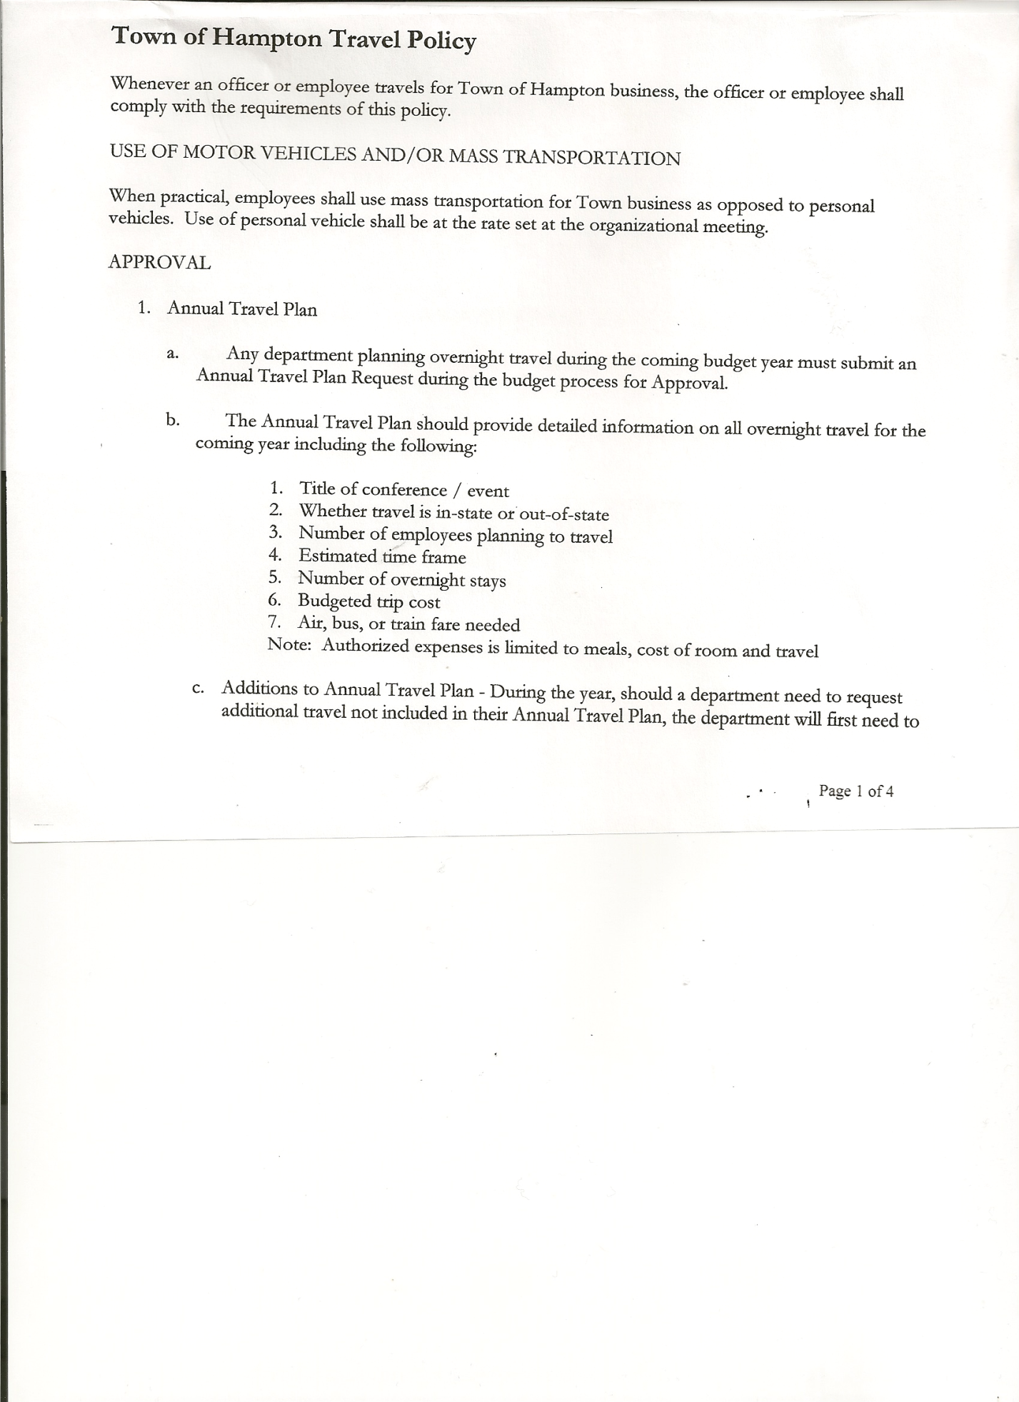
Michael Pietryka------------Councilman - absent
Travis Dean------------------Councilman
Rebecca Jones---------------Town Clerk
Camilla Shaw----------------Tax Collector/Deputy Town Clerk
Tyler McClure---------------Highway Superintendent

Planning Board Member (s):… Bonnie Hawley, Chair; Matthew Pratt and Richard Cole
Others present at the Town Hall: Artie Pratt and Leonard Reed

The Regular Meeting was called to order by Supervisor O’Brien at 7:30pm, followed by the Pledge of Allegiance. Location of Fire Exits were given. Quorum of board members present.

Supervisor O’Brien asked for a moment of silence in memory of Collie Warren, James Matta Jr. and Rosemary Morse

RESOLUTION NO. 22-2022
APPROVAL OF THE MINUTES
On a motion of Councilman Sady, seconded by Councilwoman Taran, the following resolution was ADOPTED: AYES 4 O’Brien, Sady, Taran, Dean
NAYS 0
ABSENT 1 Pietryka
RESOLVED, that the Regular Town Board Meeting Minutes for February 17, 2022 are approved.

Larry Carman, Dog Control Officer…no report

Camilla Shaw, Tax Collector…. .86 parcels left to pay. Submitted her February 2022 Report to the Board for review. Also Submitted Bank Statement to the Board for review and signatures.

Bonnie Hawley, Chair gave Planning Board Report……copy of the minutes of their meeting held March 9, 2022 are attached.

Tyler McClure, Highway Superintendent submitted his report, copy of which, is attached.
Tyler also noted that the Pressure Washer broke. Should be under $500 to replace.

TOWN BOARD MEETING
MARCH 17, 2022 PAGE 2

SUPERVISOR’S REPORT/ COUNTY UPDATES/ COMMUNICATIONS

RESOLUTION NO. 23-2022
BUDGET AMENDMENTS-GENERAL FUND
On a motion of Councilman Sady, seconded by Councilwoman Taran, the following resolution was ADOPTED:
By Roll Call Vote: Supervisor O’Brien AYE
Councilman Sady AYE
Councilwoman Taran AYE
Councilman Dean AYE
Councilman Pietryka ABSENT
RESOLVED that, the following Budget Amendments to the General Fund are approved:
Increase Unexpended Balance in the amount of $26,458.11
Increase Contingent CE Account A1990.4 in the amount of $26,458.11

RESOLUTION NO. 24-2022
BUDGET AMENDMENTS-HIGHWAY FUND
On a motion of Councilwoman Taran, seconded by Councilman Sady, the following resolution was ADOPTED:
By Roll Call Vote: Supervisor O’Brien AYE
Councilman Sady AYE
Councilwoman Taran AYE
Councilman Dean AYE
Councilman Pietryka ABSENT
RESOLVED that, the following Budget Amendments to the Highway Fund are approved:
Increase Appropriated Balance in the amount of $10,472.90
Increase General Repairs CE Account DA5110.4 in the amount of $10,472.90

RESOLUTION NO. 25 -2022
APPROVAL OF SUPERVISOR’S MONTHLY REPORT
On a motion of Councilman Sady, seconded by Councilwoman Taran, the following resolution was ADOPTED: AYES 4 O’Brien, Sady, Taran, Dean
NAYS 0
ABSENT 1 Pietryka
RESOLVED that, the Supervisor’s Monthly report be accepted as submitted for FEBRUARY
01/31/22 02/28/22
ACCOUNT BALANCE RECEIPTS DISBURSEMENTS BALANCE
General Fund $ 78,090.73 $ 183.44 $ 15,789.80 $ 62,484.37
Highway Fund $433,856.30 $ 8.07 $ 14,501.99 $ 419,362.38
Equipment Reserve $ 79,925.50 $ 1.84 $ 0.00 $ 79,927.34
Fire #1 $ 44,163.00 $ 0.00 $ 0.00 $ 44,163.00
Fire #2 $ 10,404.00 $ 0.00 $ 0.00 $ 10,404.00
Cemetery $ 1,755.21 $ 0.98 $ 0.00 $ 1,756.19
Totals $648,194.74 $ 194.33 $ 30,291.79 $ 618,097.28
All Board Members present signed Supervisor’s Report.

TOWN BOARD MEETING
MARCH 17, 2022 PAGE 3

OLD BUSINESS
Stimulus Funds Proposed Usage handed out.

NEW BUSINESS
Following a discussion regarding an Agreement for Shared Services with the County for data collection, the following resolution was introduced.
RESOLUTION NO. 26 -2022
SHARED SERVICE AGREEMENT
On a motion of Councilman Sady, seconded by Councilwoman Taran the following resolution was ADOPTED: AYES 4 O’Brien, Sady, Taran, Dean
NAYS 0
ABSENT 1 Pietryka
RESOLVED that, the Town enter into an Agreement with Washington County for Shared Services for data collection. (Copy of Agreement is attached)

RESOLUTION NO. 27 -2022
AUDIT OF CLAIMS
On a motion of Councilman Sady, seconded by Councilwoman Taran the following resolution was ADOPTED: AYES 4 O’Brien, Sady, Taran, Dean
NAYS 0
ABSENT 1 Pietryka
RESOLVED that the bills have been reviewed by the Town Board and are authorized for payment in the following amounts.
General Fund No. 34 through No. 43 $ 3,261.01
Highway Fund No. 26 through No. 34 $ 5,559.22
Total both funds $ 8,820.23

The Town Clerk’s report for February 2022 was submitted to the Board. The Town Clerk had Board Members review and sign bank reconciliation statements for the Town Clerk Account and Special Clerk Account dated February 28, 2022.

RESOLUTION NO. 28-2022
MEETING ADJOURNED
On a motion of Councilwoman Taran , seconded by Councilman Sady, the following resolution was ADOPTED: AYES 4 O’Brien, Sady, Taran, Dean
NAYS 0
ABSENT 1 Pietryka
RESOLVED that the meeting adjourned at 8:03pm.

Respectfully submitted,

Rebecca S. Jones, RMC
Town Clerk

