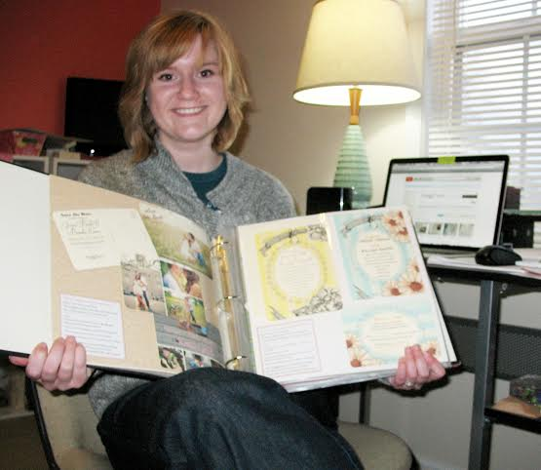
"Jennifer (Savage) Britton is a long-time lover and student of the fine arts, including classes in her youth with Chanelle Owens, Mrs. Wells, and Mrs. Cherry, and a 2006 honor graduate of MCHS. With a knowledge and training in the arts, she wanted to grow those skills into a marketable career, which lead her to attend O'More College of Design in Franklin, TN. There she combined her artistic abilities with learning graphic design and working with the computer and design softwares. She graduated Cum Laude, earning her a BFA in Visual Communications in 2010. She is currently working as a freelance graphic designer and illustrator out of her home studio in Lewisburg, Tennessee. She has worked on projects such as logos, catalog design, promotional pieces, book illustrations, and more.
She also started 'Cordially Creative' (2010), an online invitation and stationery shop, where she sells many items that include hand-painted illustrations. She feels this gives her pieces a special touch, something functional yet fun. This is a way she combines her fine art skills with her training in graphic design. She sells to clients all over the country as well as inter-nationally.
Her husband, Elijah, helps with the technical aspects of running the business, and their long-haired, dappled dachshund, Oliver, also helps with moral support of tail wags and puppy love.
She is excited to see her business grow and where it will take her and would like to thank everyone for their continued support.
You can see more about Cordially Creative on her website: www.cordiallycreative.com"

The Marshall County Art Guild will be holding an artist reception for Jennifer Friday, Jan 3rd from 6pm – 8pm at the Gallery located at 123 W. Commerce. Refreshments will be served and the public is welcome to attend. Please feel free to tour our Gallery and Studio. In the event of inclement weather it will be the following Fri. Jan 10th.

The selected ARTIST for each month will have their art displayed in the MCAG’s front gallery window. The artist's work will also be posted on Marshall County Art Guild's website, facebook page, monthly newsletter & submitted as a press release(s) in our community paper (s).
February's Artist of the Month will be Debbie Hill.

