Businesses, Individuals, Organizations and Faith Communities in Mecklenburg County are coming together in partnership with

SAMARITAN’S FEET

To Help Us Host a Shoe Distribution for Our Local Children and Youth
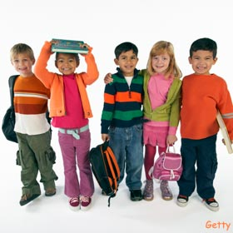
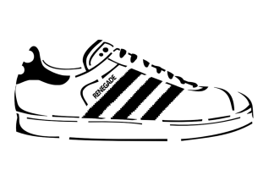
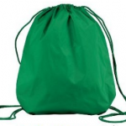
Saturday, August 25, 2018 * 10am-1pm
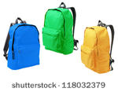

*WE WILL BE GIVING OUT SHOES TO CHILDREN & YOUTH IN OUR COMMUNITY ON A FIRST-COME, FIRST-SERVED BASIS
*CHILDREN MUST ACCOMPANY GUARDIAN IN ORDER TO RECEIVE SHOES
*SCHEDULING SPORTS PHYSICALS
*SCHOOL REGISTRATION & INFORMATON
*PROVIDING DENTAL INFO, FREE HAIR CUTS and EYE EXAMS
*GIVING OUT BACKPACKS, SCHOOL SUPPLIES & OTHER GOODIES, AS WELL AS IMPORTANT INFORMATION TO HELP YOUR CHILD BE SUCCESSFUL IN SCHOOL!

LOCAL VENDORS ONSITE FOR YOUR CONVENIENCE!

Still accepting school supplies at the church or the contact info below.

Location of Shoe Distribution:
Greater Bethel AME Church
5232 The Plaza
Charlotte, NC 28215

To volunteer or learn more about the Back to School Distribution or Greater Bethel AME Church, contact:
purple22@carolina.rr.com
Website: www.ccoc2016.org

