Public Aquarium California Specimen List
Marine Aquaria Receiver’s Lis. 84973

ARTHROPODS SPECIMEN LIST
Robert Burhans: (858) 774-2806 or email: Bob@matsucollections.com
*Special order specimens are those which are infrequently encountered or pose specific collecting challenges.

EXAMPLE | COMMON NAME  LATIN NAME | COMMENTS* | SIZE & DISTRIBUTION | US$
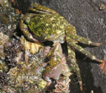 | Striped Shore Crab  Pachygrapsus crassipes | Upper and middle intertidal. Forages in and out of the water | To: 1.9 inches (48mm)  Oregon to Gulf of California | 3.00
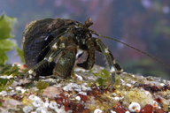 | Pacific Hermit Crabs  Pagurus hirsutiusculus | Upper and middle intertidal. Forages in and out of the water.  Variable number of hairs on legs | .7” (11mm) | 2.50
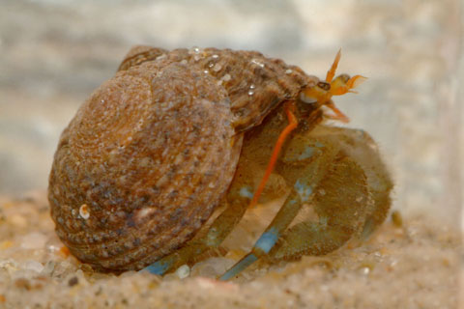 | Blueband Hermit Crab  Pagurus samuelis | Bright blue bands near end of each walking leg | To: .75”  Range: British Columbia to Baja California | 3.50
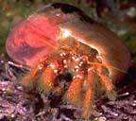 | Hermit Crabs  Paguristes ulreyi | Found on rocky reefs in deeper water | To: 1.5 inch (33mm)  British Columbia to Baja California | 10.00
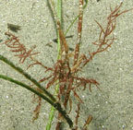 | Hemphill’s Kelp Crab  Podochela hemphilli | Found on pilings and sand and rock bottoms. Cryptic in algae. | To: .9 inches (22mm)  Central California to Panama | 25.00
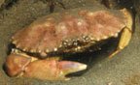 | Cancer Crabs  Cancer species | Sandy and muddy bottoms | To: 7 inches (178mm)  All along the Pacific coast | 15.00
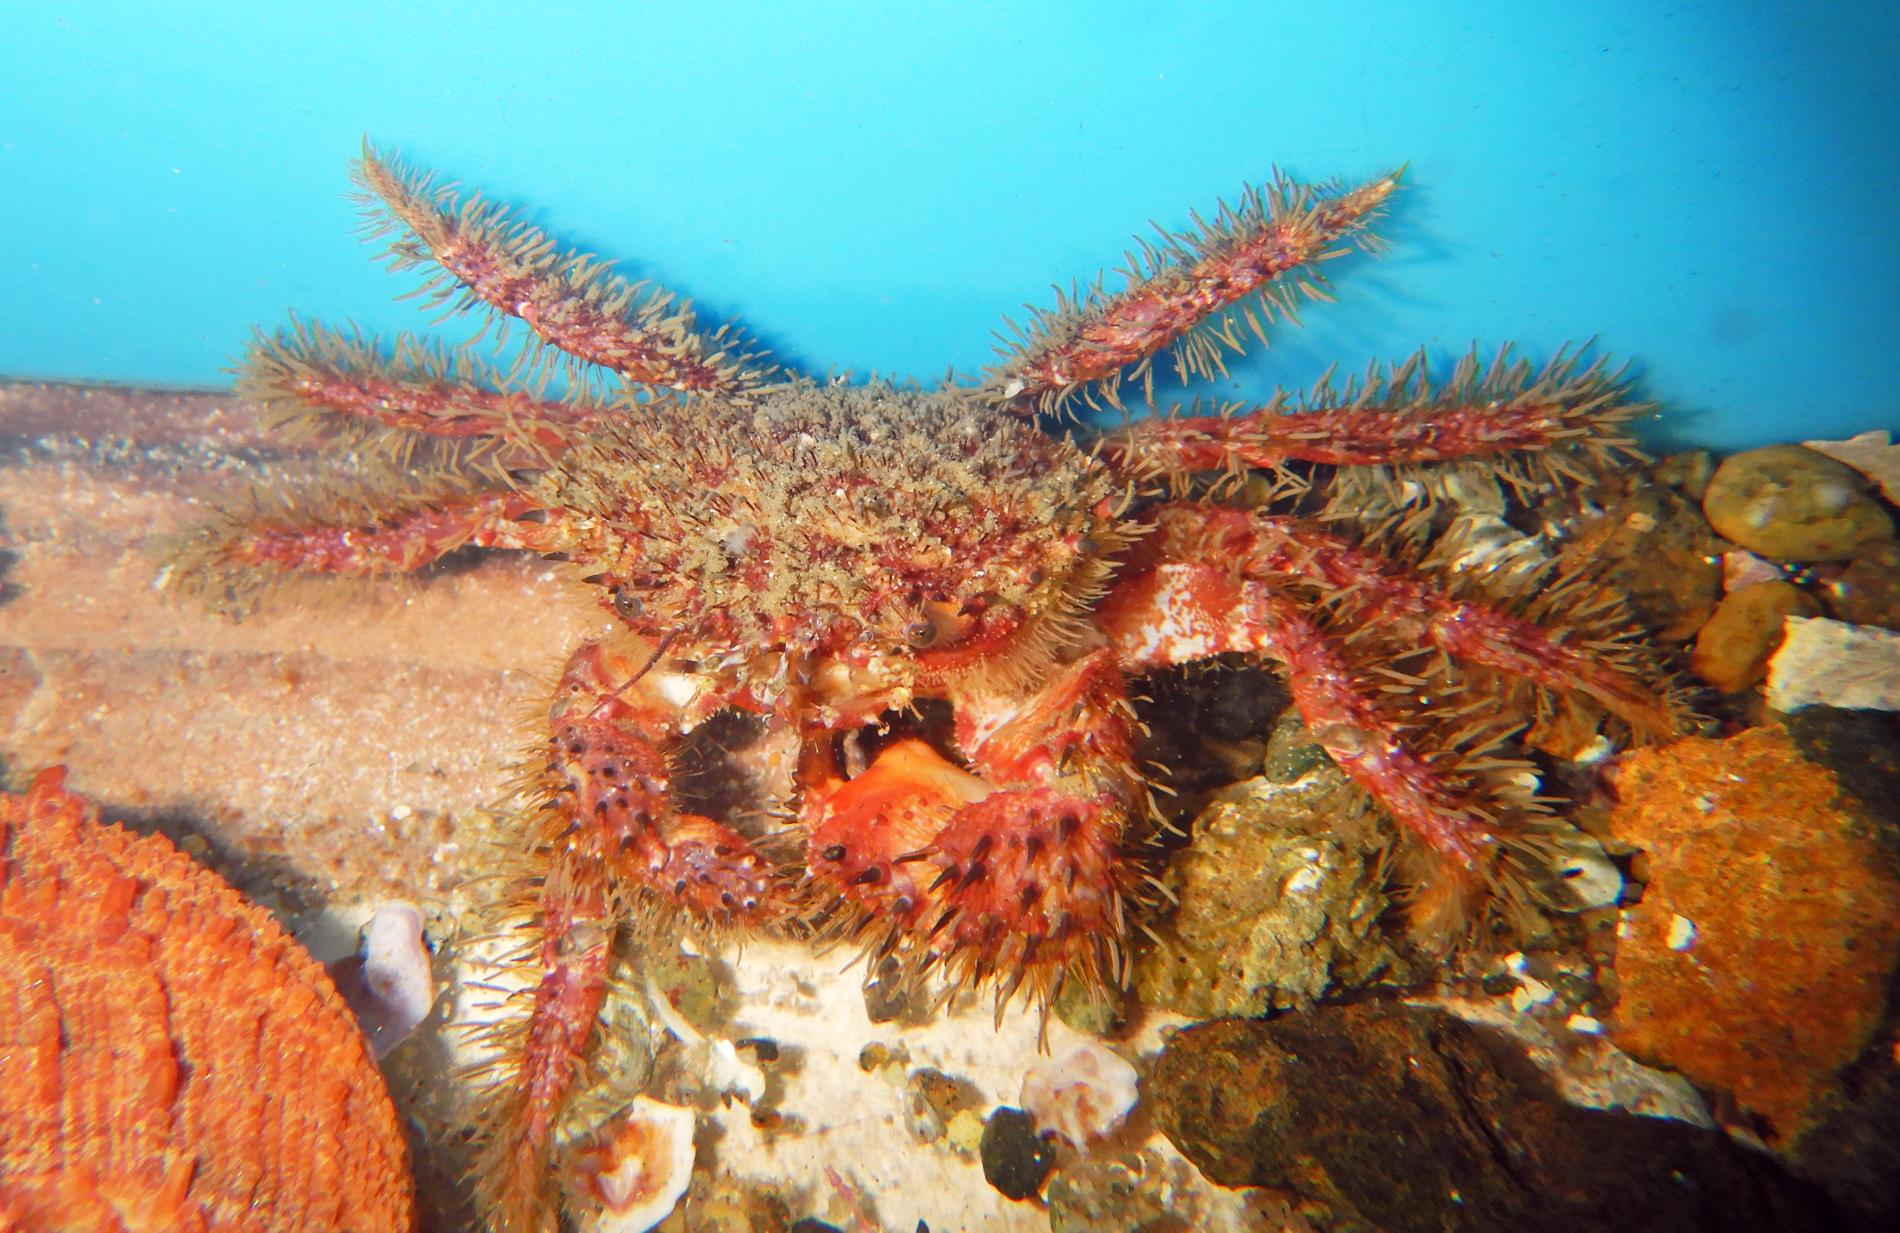 | Retiring Southerner  Pilumnus spinohirsutus | Carapace, Claws, and Legs adorned with a stiff covering of light brown hairs | Carapace to 1.5” | 25.00
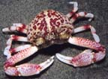 | *Purple Globe Crab  Randallia ornate | Found on Sandy bottoms | To: 2 inches (53mm)  Mendocina County, California to Baja California | 40.00
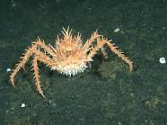 | California King Crab  Paralithoides californiensis | Deep water | To: 8” (body) | 5” < 125.00  5” > 150.00
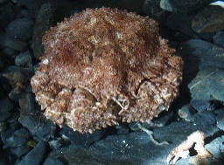 | Box Crab  Lopholithodes formaminatus  Obtained through commercial collector | mud bottom or on vertical rock faces above the mud | To: 6’ (15cm)  Range: Alaska to San Diego | 75.00
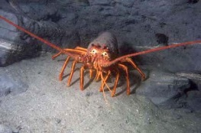 | California Spiny Lobster  Panulirus interruptus  Obtained from licensed collector | Seasonal  Found in rocky habitat | Must be legal size and in season  San Louis Obispo to Baja California | 50.00
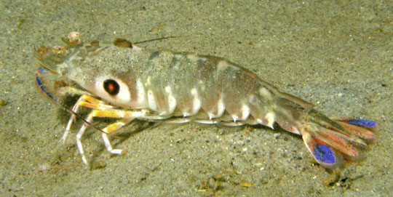 | Target Shrimp  Siconia penicillata | Sandy or mud bottom | To: 10 inches (250mm)  San Francisco Bay to Peru | 25.00
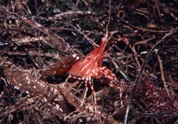 | Spot Prawn  Pandalus platyceros  Obtained through commercial collector | Rocky bottoms and vertical rock face | To: 9.9 inches (250mm)  Alaska to San Diego, California | Lg. 25.00  Sm. 20.00
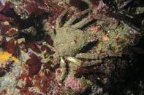 | Masking Crab  Loxorhynchus crispis |  | To: 3.5” (9cm)  Redding to Baja California | 40.00
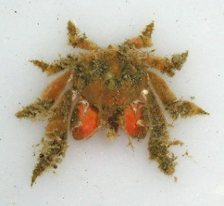 | Dwarf Teardrop Crab  Pelia tumida | Usually has sponge growing on it making it look more bulky, | To 0.5” (14mm)  Monterey, California to Mexico | 15.00
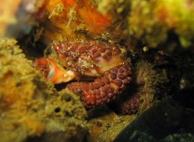 | Lumpy Crab  Paraxanthias taylori | Walking legs very hairy. Has many prominent bumps covering the surface of the claws. | To 1’ (25mm)  Monterey, California to Baja Mexico | 20.00
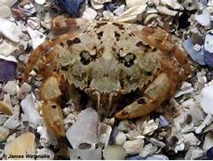 | Hairy Cancer Crab  Cancer jordani |  | To: 1.25” (3.3cm)  Oregon to Baja California | 25.00
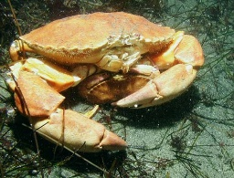 | Yellow crab  Cancer anthonyi  Obtained through commercial collector | Found over open sandy bottoms. | To: 6.9” (17.6cm)  Range: Humboldt California to Mexico | 20.00
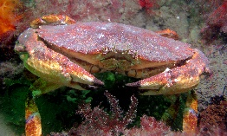 | Red Crab  Cancer productus  Obtained through commercial collector | Most commonly found over gravel bottoms. | To: 7.8” (20cm)  Range: Alaska to Baja California | 20.00
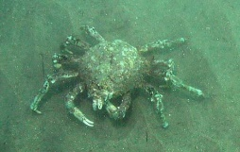 | Sheep Crab  Loxorhynchus grandis  Obtained through commercial collector | A very large spider crab, legs are as long as the carapace | To: 6.5” (16cm)  Range: Point Reyes to Baja California | 50.00
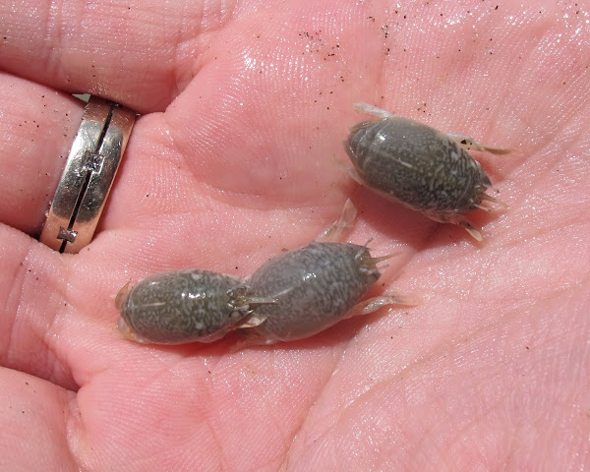 | Pacific Sand Crab  Emerita analoga  Collected on Tidal invertebrate permit | Wave Swept Sandy Beaches. | To: 1.4”  Range: Oregon to Chile | 12 for $5
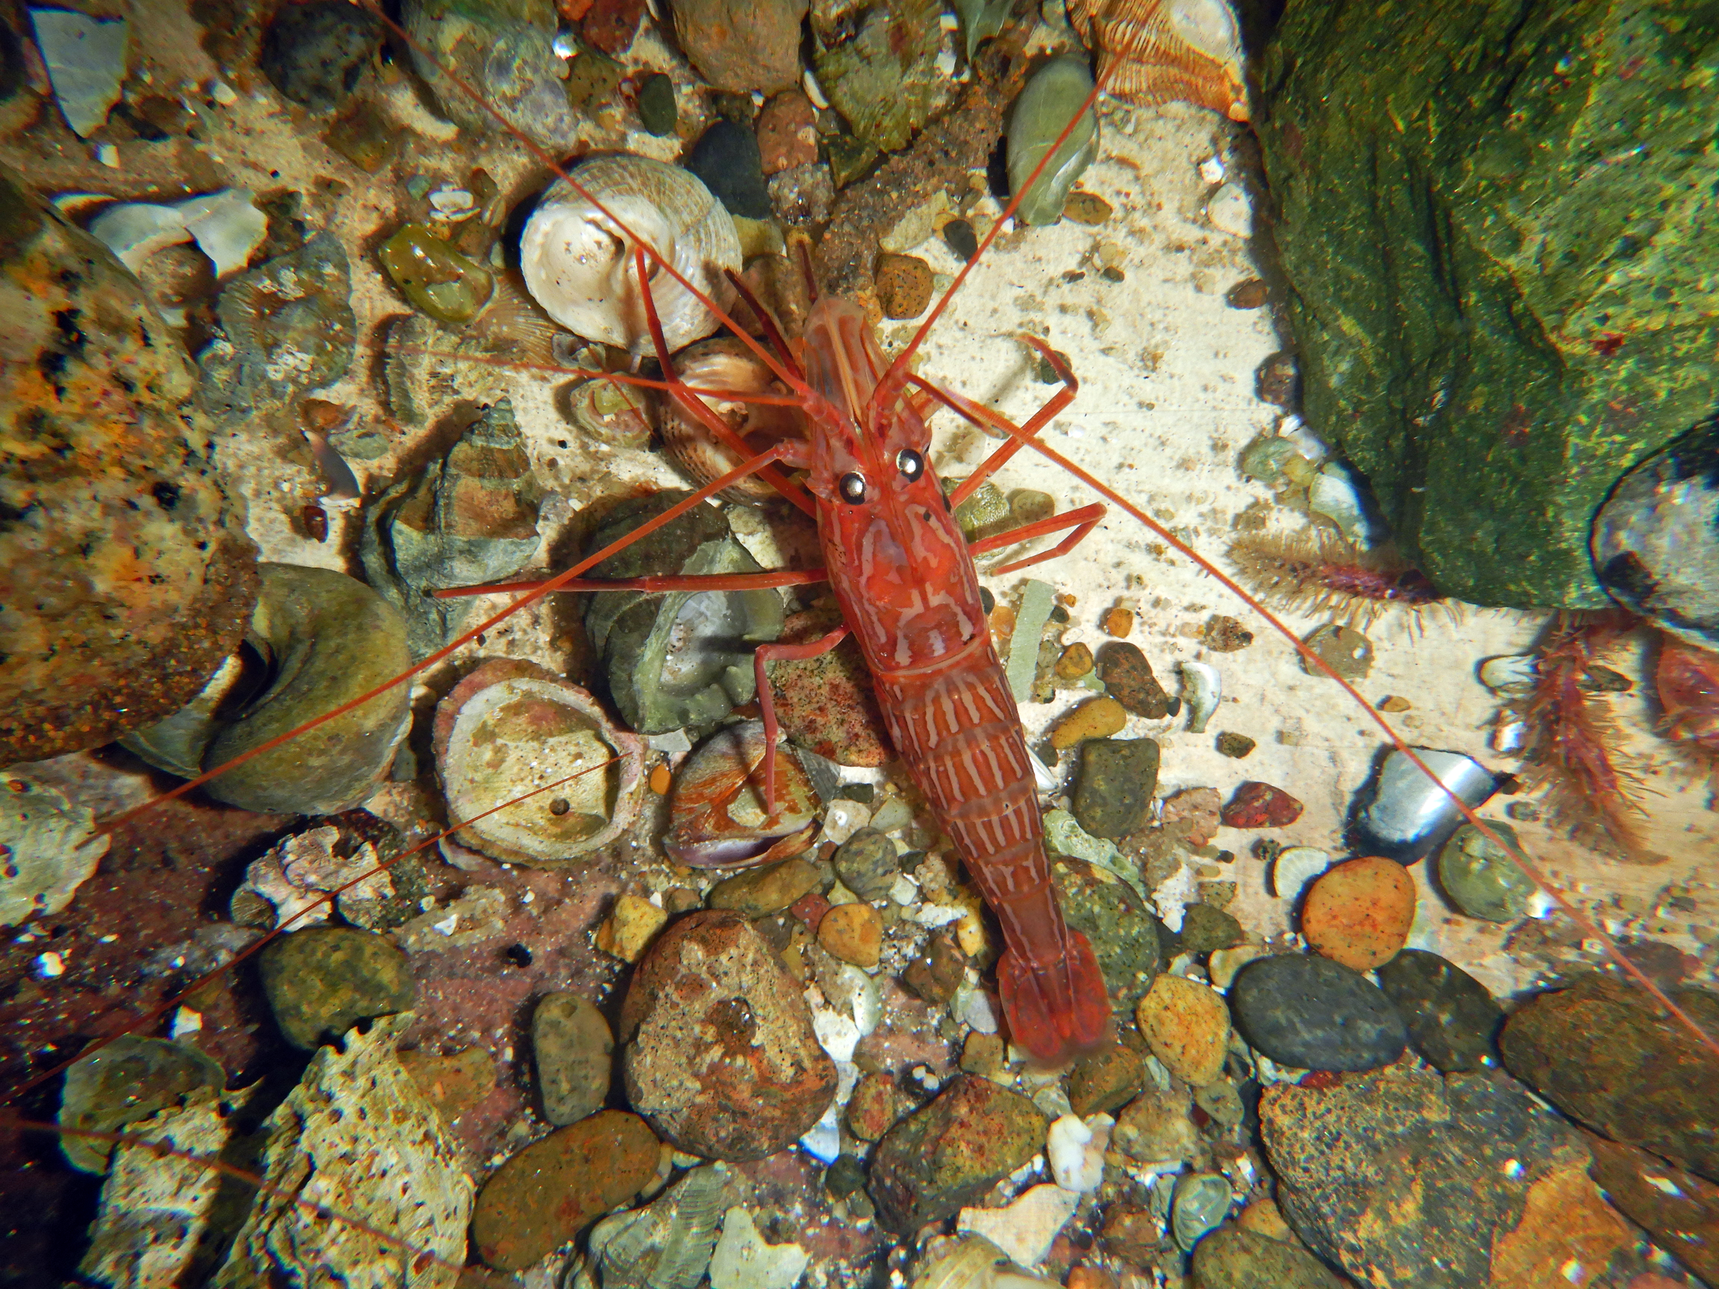 | Redrock shrimp  Lysmata californica  Collected on Tidal invertebrate permit | Act as cleaners. | To: 2.75” (7cm)  Range: Santa Barbara to Baja California | 15.00
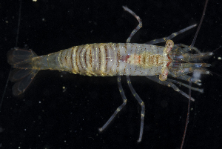 | Broken-back Shrimp  Heptacarpus palpator | Occurs under rocks intertidally down to 40 feet. Usually found among various alga. | To: 1.2”  Range: San Francisco to Baja California | 6.00
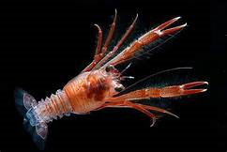 | Tuna Crab  Peuroncodes planiceps | Pelagic drifters  Seasonal | To: 3” (75mm)  Eureka California to Baja California | 15.00
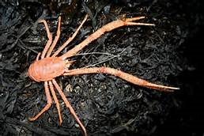 | Squat Lobster  Munida quadrispina | Similar to Tuna Crab,  But is larger, spinier, has longer arms, and is a bottom dweller. | To: 5” (125mm)  Alaska to Southern California | 50.00
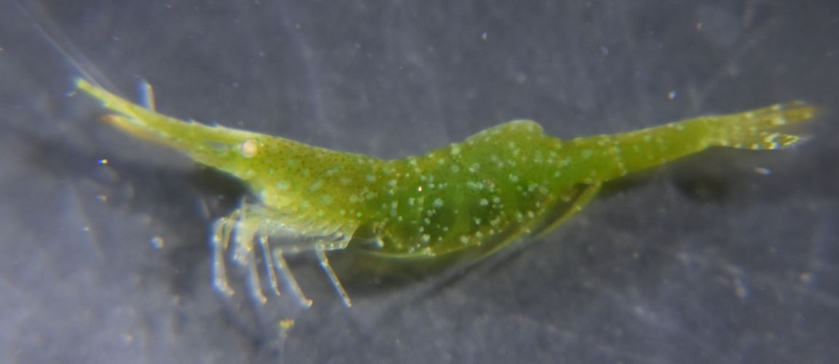 | Grass Shrimp  Hyppolyte clarki | Found in eelgrass beds.  Great seahorse food. | To: 1.2”  Range: Alaska to Baja California | 50 @ $75  100 @ 125  200 @ 150  500 @ 250
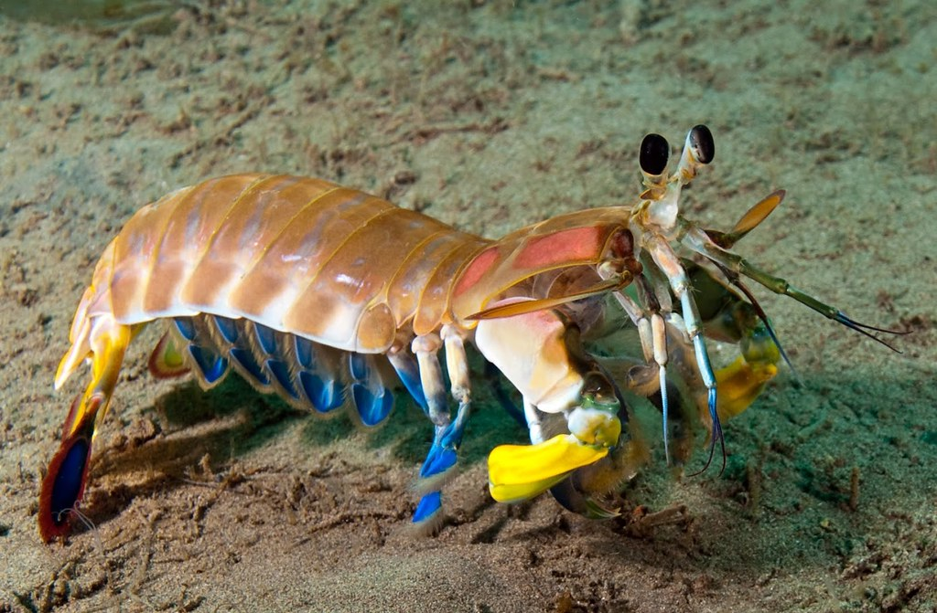 | Mysis Shrimp | Free swimming, congregate along sandy bottom. Normally has a burrow for protection. |  | 75.00

