**Come One, Come All!!**

**SATURDAY 9/10**

**Wilmington Sons & Daughters of Italy & Wildcat Band Parents**

***FLEA MARKET***

**8am to 3pm**

**Wilmington Town Common**

**Parking Lot**

**$20 per SPACE**

**Sell all your Treasures**

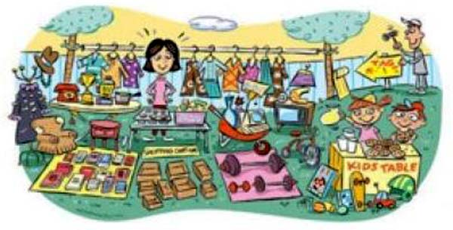

**FOR MORE INFO OR TO RENT A SPOT CONTACT: jromano45@gmail.com or (617) 750-9749**

**BBQ & Music,**