

2022
CLUB SINGLES CUP

26 players took part in this years tournament, one of our best attended this year, enjoying great sunshine.

Round one saw Champion Andrew turn up late and almost paid the price but for Lorna moving the coche to give Andrew a 7 – 6 win.

Neil Selby lost to Andrew Limbrick and James Gennoe lost 13 – 2 to Tom Le Sueur. Brian Harris just got over the line 12 – 11 against Jean Stewart and Ross beat Paul 13 – 9.

Wins as expected for Laurent, Geoffroy, Toby and Callum with Cassie also beating Mo 13 – 2.

Round two saw a big shock as despite leading Callum lost to Daniel 12 – 10, some close matches though as Geoffroy just beat Brian 12 – 11 and the same result for James Villalard over Branden and Alex beat Tim 13 – 12.

Laurent beat Andrew Limbrick with ease 13 – 4, as did Toby winning 13 – 1 over Tom Le Sueur.

Ross beat Matt Buesnel 13 – 8 for a big result and Andrew Bellamy beat Cassie.

Round three saw a really close match between Laurent and Toby going down to the last end at 12 all, Toby fired out Laurent last boule on the terrain to win the match and make it three wins from three.

Andrew Bellamy handed Neil his second defeat ending his tournament early and this was also the case as Matt Buesnel beat Callum, his second defeat.

A surprise result as Geoffroy lost to Joey, despite playing on the same terrain as his first two matches.

James Villalard made it two in a row with a win over Cassie. Tom beat Jean to be in with a chance of qualifying and Brain did the same over James Gennoe.

Some big wins as Lorna beat Jim 12 – 5, Mo beat Martin 13 – 2 and Tim beat John 13 – 0!

The final round would decide the top eight players going through. Both players on three wins Toby and Ross played each other and despite his best efforts Toby ran out comfortable winner 13 – 1 to top the Rankings for the second singles competition in a row. Ross finishing third.

Andrew Bellamy-Burt also made it four wins from four beating Joey 13 – 7 to finish second with Joey still going through in fifth place.

Laurent was a comfortable winner 13 – 2 over Daniel to make sixth spot and Geoffroy beat Paul 13 – 7 to finish fourth.

Tom Le Sueur provided a shock 10 – 9 win over Andrew Limbrick to knock last years third place out of the tournament. Matt Buesnel just made it in eighth by one BHN point over Brian Harris after beating James Villalard 13 – 9.

FINAL SWISS RANKINGS

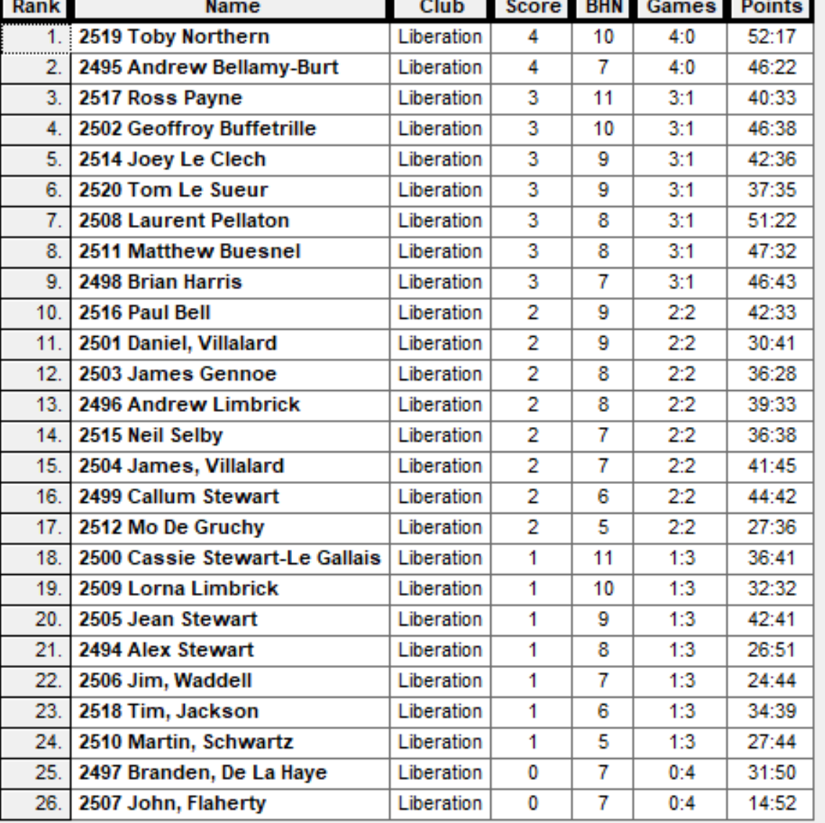

Quarter Finals

Ranked 1st Toby Northern v Matt Buesnel Ranked 8th

Ranked 2nd Andrew Bellamy-B v Laurent Pellaton Ranked 7th

Ranked 3rd Ross Payne v Tom Le Sueur Ranked 6th

Ranked 4th Geoffroy Buffetrille v Joey Le Clech Ranked 5th

No shocks in the quarter finals as Toby ended Matt’s hopes with to perfect fires to win 13 – 9. Andrew continues to have the best of Laurent winning 13 – 6 and big wins for Ross and Geoffroy 13 – 5, and 13 – 4 respectively.

Semi Finals

Ranked 1st Toby Northern v Geoffroy Buffetrille Ranked 4th

Ranked 2nd Andrew Bellamy-B v Ross Payne Ranked 3rd

Toby and Geoffroy went end to end in the scores until top took three perfect points to go 11 – 8 up, but unfortunately Geoffroy consistent pressure with perfect shooting saw him come back to win 13 – 11.

Another very close second semi final went down to one point as Ross hit top gear with his shooting making the difference as he made the final at Andrew expense.

Andrew went on to take third place beating Toby 13 – 10.

So a repeat of the 2015 final between Geoffroy & Ross, but with a final heavily reliant of shooting it was Geoffroy turn to win taking it 13 – 11.

2022 - Winner

Thanks to all those who helped out on the day to make it another great competition.

Sponsored by



CoinShares | Digital Asset Investment Strategies for Professionals 🚀

Club email address - liberationpc@gmail.com

Club Website - www.liberationpetanque.co.uk

Kind Regards

Toby Northern

Chairman

Liberation Petanque Club

