STEP BY STEP PRESCHOOL
FAMILY
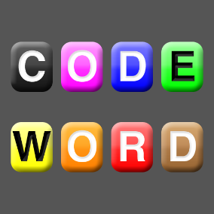
STEP BY STEP PRESCHOOL HAS INSTITUTED AN ADDITIONAL SECURITY STEP IN THE PICKUP OF ALL CHILDREN IN OUR SCHOOL IN CASE OF AN EMERGENCY.

What is a Family Code Word? It is a single word that is affiliated with your family in case of an emergency. You come up with your code. It will add another layer of security for picking up your child by a non-parent in case of an emergency. SBS Preschool will keep the code word confidential in your file.

When will you need to use the Family Code Word? If you are notifying SBS Preschool that you cannot pick up your child that day due to an unforeseen emergency WITHOUT having a signed permission slip, you will have to confirm your family code word over the phone.

Why do we need a Family Code Word when we already have a list of people on file that can pick up our child? The list of people that can pick up your child is on file and establishes the only people who can pick up your child. If you are unable to pick up your child, a permission slip would have been signed that morning. The Family Code Word is only used in case of an emergency when you did not inform the school at drop off and did not sign a permission slip and you need to inform us over the phone.

Can I text or email this information? NO. SBS Preschool will never accept a non-verbal communication regarding picking up a child.

PLEASE FILL OUT THE FORM BELOW.
----------------------------------------------------------------------------------------------------------------------------------------------------------------
FAMILY CODE WORD

NAME OF CHILD:____________________________________________________________________________________

NAME OF PARENTS/GUARDIANS:______________________________________________________________________

FAMILY CODE WORD:________________________________________________________________________________

PARENT/GUARDIAN SIGNATURE:____________________________________________________Date:__________

PARENT/GUARDIAN SIGNATURE:____________________________________________________Date:__________

