Part 1 – Getting Started

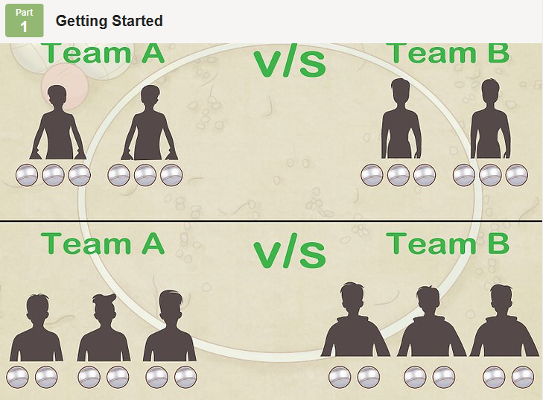
- Split up into two teams.
Pétanque is played with two teams. Decide which players will be on which team.
There are three ways you can play:
  - Singles (one against one).
Each player gets three boules.
  - Doubles (2 players per team).
Each player gets three boules.
  - Triples (3 players per team).
Each player gets two boules.

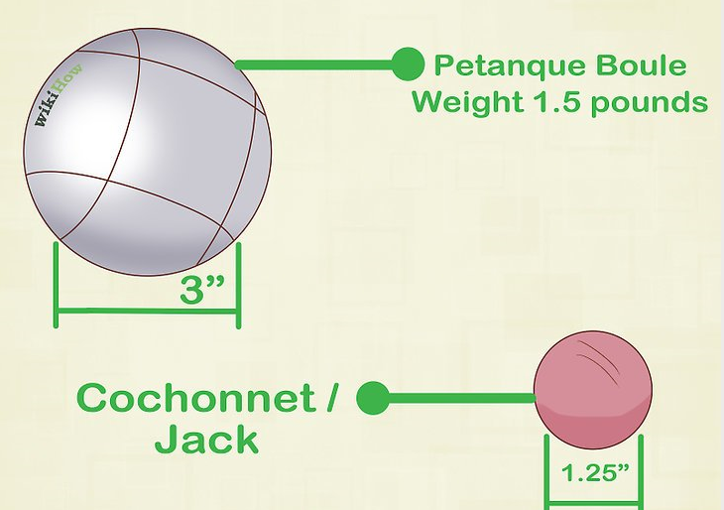
- Pass out the boules to the members of each team.

Make sure they are the right material and size. Pétanque boules should be metal, about 3 inches (7.5 cm) in diameter, and weigh 1.5 pounds (700g).

You should also have one target ball, known as the “cochonnet” or “jack.” The jack should be 1.25 inches (3 cm) in diameter.

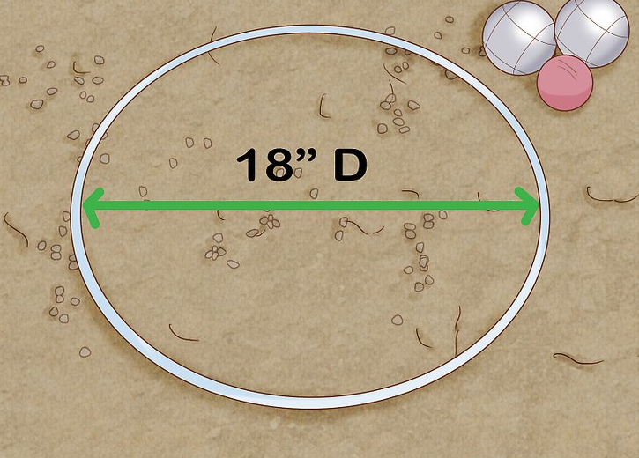
- Draw a circle on the ground wherever you’re playing the game.

The circle should be about 20 inches (50 cm) in diameter.

Whenever any player is playing they must stand in the circle, and both of their feet must be planted on the ground.

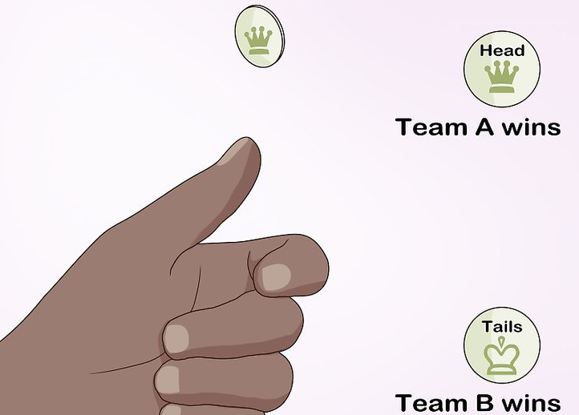
- Flip a coin to see which team goes first.

One team calls heads or tails before the coin is tossed. If the coin lands on that side, that team goes first.

Part 2 – Playing the Game

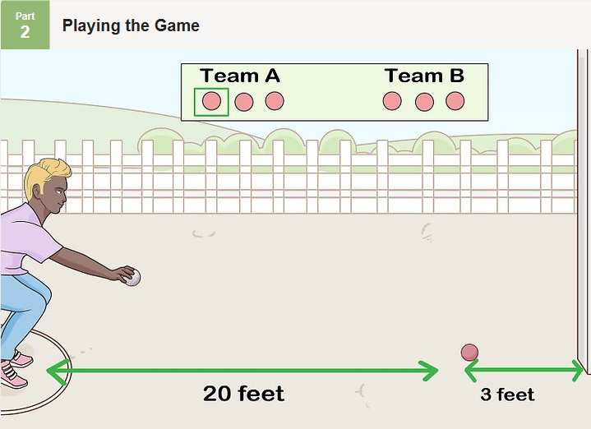
- Have a member from the first team stand in the circle and toss the jack.

They can toss the jack in any direction. It should land between 20-33 feet (6-10 meters) away from the circle, and it should be at least 3 feet (1 meter) away from any object (like a tree) that might interfere with a player's swing.

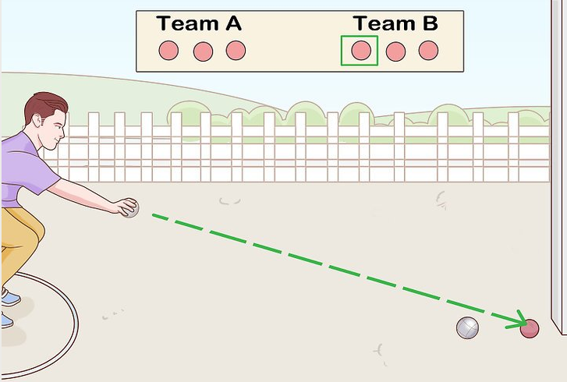
- After throwing the jack, have a member of the same team throw the first boule.

They should stand in the circle and try to get their boule close to the jack and (preferably) in front of it.

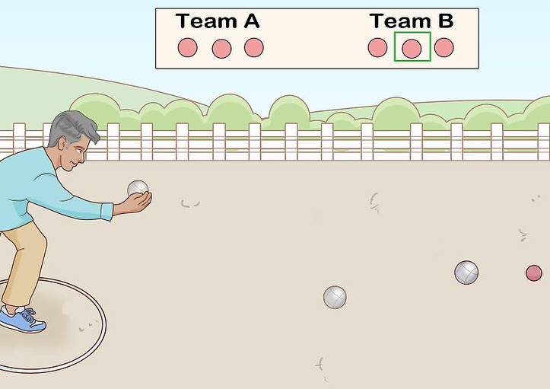
- Have a member from the second team stand in the circle and throw a boule.

The goal of the second team is to end up with their boule closer to the jack. They will either "point" (try to roll their boule close to the jack) or "shoot" (try to hit the opponent's boule away from the jack.)
  - If the second team succeeds, then they will have the boule that is closest to the jack—they will “have the point.” The team that does not have the point (that is, the team that does not have the closest boule) must play the next boule, and must keep playing until they have the point or run out of boules.

  - For example, if Team B tosses a boule and it doesn’t land closer to the jack than Team A's boule, then Team B would have to toss another boule. This would continue until they get a boule closer to the jack than Team A's boule or run out of boules.

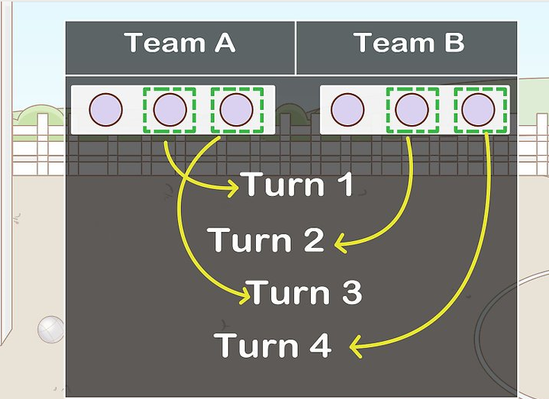
- Change teams when the throwing team gains the point.

If a member of Team A tosses a boule and it lands the closest to the jack, then Team A has the point and it would then be Team B’s turn to throw. If Team B then tosses a boule and it lands closer to the jack than Team A's boule, then Team B has gained the point and it is Team A's turn to throw. This continues, until both teams are out of boules.

Part 3 – Winning the Round – End

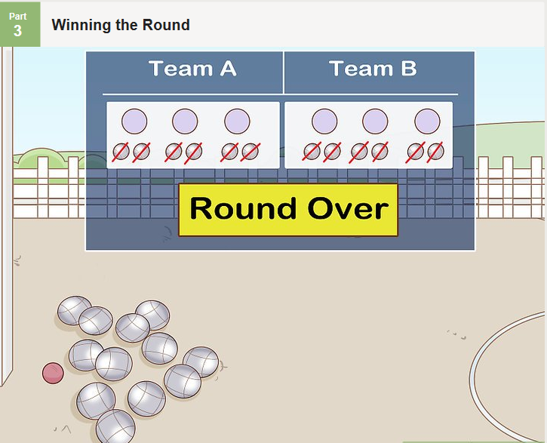
- Keep going until both teams have thrown all of their boules.

This ends the round. If one team uses all of their boules before the other, the other team throws all of their remaining boules. The round is over once all of the boules of both teams have been tossed.

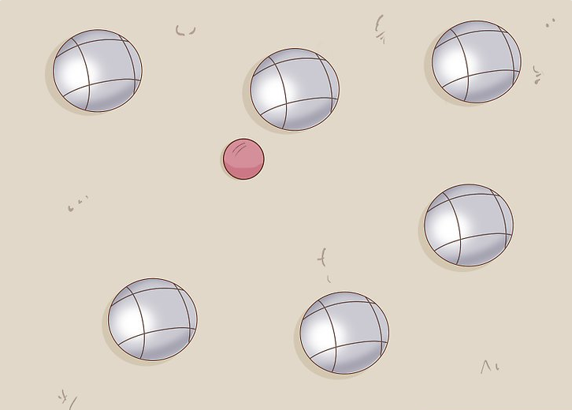
- Count the score for the winning team.

After all boules have been thrown, the team whose best boule is closest to the jack wins the round. The winning team gets one point for each of their boules that is closer to the jack than the losing team’s closest boule. The losing team doesn't score any points.

Part 4 – Starting a New Round – End

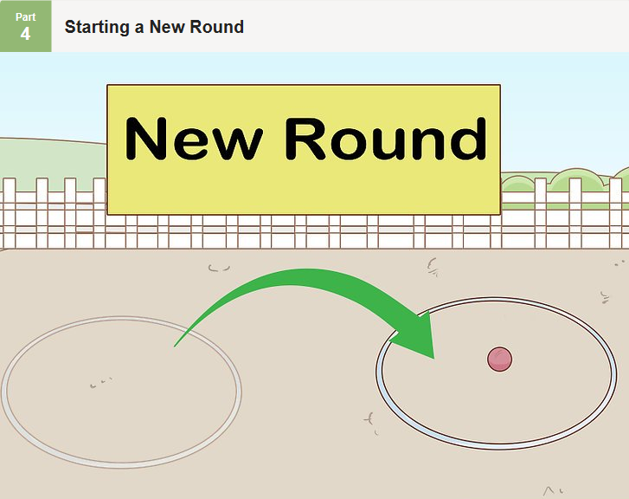
- Start the next round.

To do this, the team that won the last round draws a new circle on the ground, around the place where the jack was in the last round.

They also throw out the jack.

The new circle is now where all players must stand to toss their boules.

The winning team from the previous round goes first.

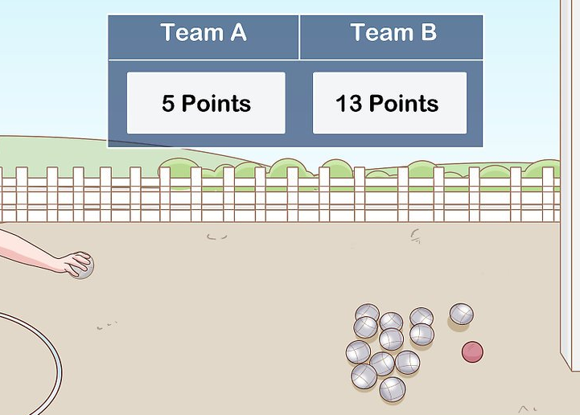
- Continue playing rounds until one team reaches 13 points.

Credit: Wikihow.com

