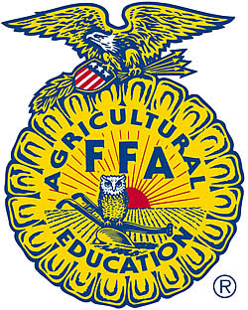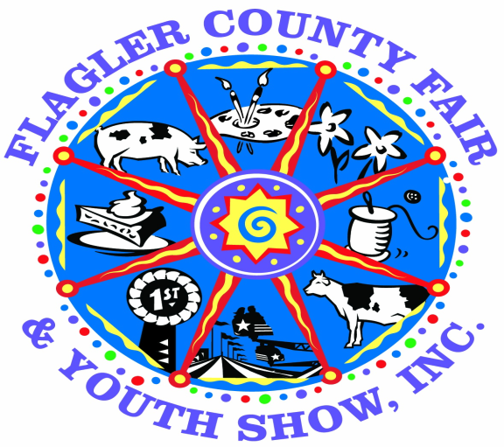

**4-H and FFA Youth Pullet Project and Show**

**Entry Deadline: October 7, 2019**

**BRING REGISTRATIONS TO THE CATTLEMANS HALL FROM 4 PM TO 7 PM**

**PULLET DIVISION OPEN TO CLOVERBUD, JUNIOR AND INTERMEDIATE 4H AND FFA MEMBERS**

**Superintendent: Jeanette Jones**

Receiving for pullets will be March 29, 2020 from 3 pm to 6 pm. at the Livestock Barn. Showmanship and Judging will begin at Monday March 30th at 5:30 pm Sale of Pullets will be Friday April 3rd at 7 pm. Removal will be Sunday April 7th after 6:00 P.M.. Please use entrance from Sawgrass Road to drop off animals. The State Inspector will be available during these times only to inspect birds. Birds that arrive at any other time will be asked to leave the premises. The Fair Association reserves the right to refuse entry to any fowl that appears to be sick, diseased or infected with lice or mites. Any fowl disqualified by the judge, must be removed immediately by the exhibitor. All other entries must remain for the duration of the Fair. Exhibitors must make their own arrangements for delivery.

* Poultry will be limited to the first 25 entries. They will be date and time stamped.
* Poultry must be brought to the fair in a ventilated container and may not be removed until the inspection is completed, then may be placed directly into their cages by the Exhibitor only. All storage containers must be removed from livestock barn during the fair. Exhibitors must make their own arrangements for delivery and pick up of the birds.
* Once the birds have been received, exhibitors may not relocate their birds.
* Exhibitors may not handle birds during the operating hours of the fair.
* ALL BIRDS WILL BE AUCTIONED AND SOLD. NO EXCEPTIONS!
* Your birds will be auctioned off in the livestock arena prior to the livestock sale. You will be required to follow the rules for proper attire that are in the livestock rules.
* No signs or unauthorized cards are to be placed on the cage except by the official superintendent**.**
* YOU ARE REQUIRED TO CLEAN YOUR CHICKEN CAGE, UNDER YOUR CAGE AND DISMANTLE PEN ONCE CHICKENS ARE REMOVED AFTER FAIR. A PENALTY OF $50.00 WILL BE IMPOSED IF YOUR PEN IS NOT CLEANED AND WILL BE DEDUCTED FROM YOUR PROCEEDS

**PULLET EXHIBITION CLASS**

Exhibitors will be limited to showing female birds under the age of 6 months- DO NOT BRING ROOSTERS!

All pullets must be purchased through the Fair Board

**ROSETTES AND AWARDS**

**Awards will be given on March 30th 2020 after judging.**

* All entries will receive participation ribbons.
* Best of each Breed will receive a Rosette and $25.00
* Best of Show will receive $50.00 and a Rosette.
* Showmanship awards will be given to each age division and will receive $50.00 and a Rosette.
* No rosettes will be given to Cloverbuds – they will receive participation ribbons.
* Record Book awards will be given to each age division and will receive $100.00 and a Certificate. (Must score 80 points or higher)

**Rules: Pullet Division**

1. Eligibility of Exhibitor: Qualified 4-H and FFA Members, 5 to 13 years of age (as of September 1, 2019). 4-H and FFA members must be enrolled in good standing by October 1, 2019.
2. Eligibility of animal: Exhibitors must have purchased their pullets from the Fair Board in October, 2019. Rules for judging will be strictly adhered to. Each exhibitor will pick one specific breed when they turn in their registration form. Due to limited space, birds will be accepted on a first come first served basis. Because of their pugnacious disposition, roosters will not be accepted.
3. Entry forms: Completed and signed Official Entry form must be received no later than October 7, 2019 to ensure entry into the shows. Incomplete, unsigned and late entry forms will be declined.
4. All eggs laid during the show become the property of the fair association.
5. Health Requirements: Poultry will be tested by a state livestock inspector on receiving date and animals received after that time will be denied entry into the fair. State Health and USDA requirement will supersede any other rules or health requirements.
6. Removal Date: All pullets must be removed from the barn on Sunday April 5th after 6:00 p.m. The Flagler County Fair will not be held responsible for any animal left in the barn.
7. Records Books: are required for all age divisions.
8. Fair Board will feed and water the pullets during the fair.
9. Exhibitors may bring any excess feed left over to feed pullets during the fair.

**Time and date of pullet clinic to be determined.**

**SHOWMANSHIP**

1. Entries must be a Pullet Exhibitor and show a pullet they have entered in the fair.
2. All entries are required to participate in showmanship.
3. Exhibitors will demonstrate showmanship on an individual basis to the Judge.
4. Rosettes and $50.00 will be awarded in each age division for showmanship winner.
5. Cloverbuds are not eligible for Rosettes.
6. Showmanship is scheduled for Monday March 30th at 5:30 p.m.
7. Proper 4H and FFA Attire is required (see attached guidelines)

**RECORD BOOKS**

1. Record books will be required on all pullets.
2. Record Books due at the Cattleman’s Hall on May 1st, 2020 from 4 pm to 7 pm
3. Certificates and $100.00 will be awarded in each age division. (Must score 80 points or higher)

**SALE OF PULLETS**

1. The pullets will be live auctioned off in the livestock arena prior to the livestock auction on April erd. Each exhibitor will be required to bring pullet into the ring for sale.
2. Pullets will be sold to the highest bidder during the auction.
3. Pullets must remain at the fairgrounds until Sunday April 5th After 6 PM
4. Exhibitors should make arrangements with their respective buyers on issues concerning pick- up and delivery. The pullets cannot be removed from the fairgrounds prior to 6 PM on Sunday

April 5th. NO EXCEPTIONS!

**Appropriate Attire**

1. **Attire:** Exhibitors will be REQUIRED to show and sell in appropriate 4H or FFA clothing. Exhibitors will **NOT** be allowed in the ring if not appropriately dressed. The guidelines are included in the rules, for any additional questions see your 4H Agent or FFA Advisor.

**FFA –** White shirt with white collar, Dark black jeans or slacks, appropriate tie or scarf as outlined in FFA guidelines.

**4H –** Black pants, belt, short sleeve oxford style white shirt with collar if you are wearing a jacket - a long sleeve oxford type shirt with collar and official 4H emblem (patch)if you are not wearing a jacket - 4H insignia, 4H jacket

No hats, caps or headgear.

Closed toe shoes or boots (dark in color) **TENNIS SHOES ARE NOT ALLOWED.**

Clothes should be well fitted, with pants worn at the waist. No baggy, gaudy or otherwise inappropriate clothing allowed in the show/sale ring (including bling)

Shirts must be tucked into pants.

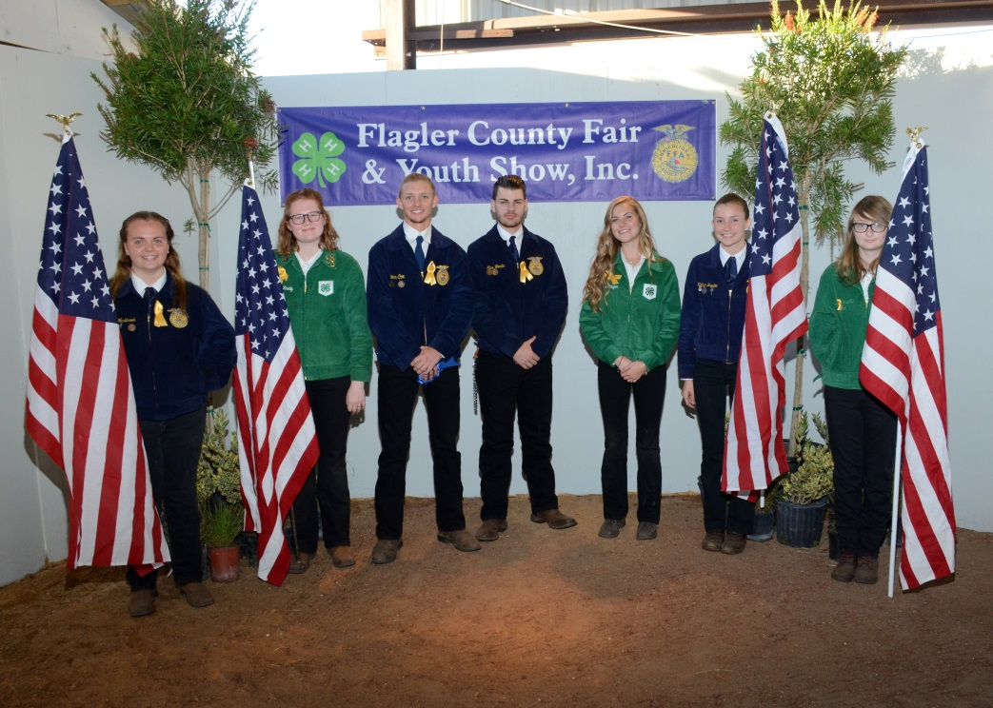

**Dorothy Wright Bullard Award**

**The purpose of this award is to:**

* ***Encourage more youth participation and increase entries in the Flagler County Fair and Youth Show’s other divisions.***
* ***Encourage currently participating youth to explore other divisions***

**All livestock exhibitors are required to participate. Including chapter animals.**

**Requirements:**

1. **Must be a resident of Flagler County or attend a Flagler County School AND be a member of an appropriate Flagler County 4H Club or FFA Chapter. *Exhibitor must meet minimum membership requirements of the respective club/chapter as accepted by the Flagler County Fair and Youth Show***.
2. **Age Requirements AS OF SEPTEMBER 1, 2019**

**Junior 8 to 10 years Intermediate 11 to 13 years Senior 14 to 18 years**

1. **Any youth participating in any livestock exhibition (including rabbits and chickens) must participate in at least 3 or more of the following programs:**
   1. **Horticulture**
   2. **Home and family Division (a list will be provided of each division within this division - you can enter this division numerous times)**
   3. **Shoe Box Float –**
   4. **Country Critter**
   5. **Skillathon – To be determined**
2. **All non-perishable entries must be turned in Sunday March 29, 2020 from 1 pm to 6 pm at the cattleman’s hall. (Please see the rules for each division you are entering in.) If you have not met this requirement, you will not be permitted to show or sell your animal. All perishable items must be turned in on Monday March 31st from 1 pm to 6 pm**
3. **All entries must be picked up on Sunday April 5th after 6 pm**
4. **Points awarded based on placing in each division**

**For example:**

**1st place – Blue Ribbon 20 Points**

**2nd Place – Red Ribbon 15 Points**

**3rd place – White Ribbon 10 points**

**Best in Show 50 points**

1. **Cash Awards for each age division for Most Points**

**Best in Show $50.00 1st Place $20.00 2nd Place $10.00 3rd Place $5.00**

**Buyers Letters**

* Exhibitors are expected to distribute individual letters to prospective buyers in order to encourage their participation in the Flagler County Fair and Youth Show Livestock Sale. You are also required to provide a minimum of **5 “NEW”** prospective buyers addresses to the Fair Board.
* The Flagler County Fair provides each prospective buyer with an information packet and a VIP pass if they are a previous buyer. If they need entrance passes, please contact the fair board.
* The exhibitor is responsible for developing their own list of potential buyers along with their correct addresses by Friday February 14, 2020. (The Flagler County Fair or its representatives will not provide any exhibitor with a list of potential buyers.)
* Suggestions:

**Who to Send to:**

Family Friends Family Business Contacts

Local Businesses Relatives

Producers Any one you think might consider participating in the sale

**What to include:**

Personal Information (Name, Age, etc)

Project Information (Types, Breed, Age, Current or Projected Weight)

Fair Times & Dates (Show, Sale)

Invitation to attend and participate

Optional:

Years experience

Skills learned

Plans for profits (for example: expand project, college, etc)

**Tips**

* Most buyers respond better to handwritten letters.
* Pictures help buyers identify with your project.
* Invite buyers to view your project or meet you before the sale.
* **Have a parent, leader, agent, or advisor proofread your draft copy for errors.**

Buyer’s names and addresses are due at the Fair Board by ***Friday, February 14, 2020*** We will be mailing out buyers information packet and VIP Passes to previous buyers.

Please remember to include your name, the buyer’s full name, and their complete and verified address. (The Bunnell Post Office will not deliver to a street address unless there is a mailbox. We have spent several days trying to hand deliver returned mail in past years because the exhibitors did not use the correct Post Office Box.) It would be very helpful if your addresses were in Microsoft Excel (or almost any table format) and e-mailed to flaglerctyfair@bellsouth.net

* (If you must submit addresses hand written, please be sure they are easily read.)

**FLAGLER COUNTY FAIR**

**4-H AND FFA PULLET ENTRY FORM**

**Entry deadline: October 7, 2019**

**EXHIBITOR:_________________________________AGE:__________Age as of 9/1/19__________**

**GROUP/CLUB NAME:________________________INDEPENDENT/FFA/4H (CIRCLE ONE)**

**ADDRESS:__________________________CITY:__________________STATE:________ZIP________**

**TELEPHONE:______________________ EMAIL:_______________________________________________**

**PARENT SIGNATURE__________________________________________________________________**

**PLEASE CHECK AGE DIVISION: ( AS OF SEPTEMBER 1, 2018)**

**( ) 4H cloverbud – 5 to 7 years ( ) 4H/FFA junior 8 to 10 years ( ) 4H/FFA Intermediate 11 to 13 years**

**BREED SELECTION (select 1 breed per exhibitor): Please mark a 1st choice and a 2nd choice**

**___Gold Lace Weyandotte _____Barred Rock ____Buff Orpingtons**

Please make $30.00 check payable to Flagler County Fair. This fee includes a starter kit for your chicks.

**BRING ALL FORMS WITH CHECK TO THE CATTLEMANS HALL ON OCT 7th FROM 4 PM TO 7 PM**

**Please note we will no longer provide feeders and waterers**

Flagler County Fair and Youth Show’s

Parent/4H and FFA Leaders

Code of Conduct

1. I will be responsible for my behavior as well as for the behavior of those who attend the fair as my guest.
2. I hereby pledge to provide positive support, care and encouragement for my child participating in Fair Events by following this code of conduct
3. I will encourage good behavior by demonstrating positive support for all exhibitors, fair board members and volunteers at fair events.
4. I will place the emotional wellbeing of my child ahead of personal desire to win.
5. I will be in control of my emotions.
6. I will remain in the spectator area during all shows and sale.
7. I will support the fair board members and volunteers working with my child, in order to encourage a positive and enjoyable experience for all.
8. I will not advise the Fair Board and Volunteers on how to do their job.
9. I will remember that the fair and youth show is for the youth and that participation in the shows and sale is a privilege and not a right.
10. I will ask my child to treat other exhibitors, fair board members, volunteers and judges with respect, regardless of race, age, sex, creed or ability.
11. I will not make insulting comments to other exhibitors, fair board members, judges or volunteers.
12. I promise to help my child enjoy the youth show experience by doing whatever I can to make the event a more positive experience.
13. We are all volunteers, if you have a disagreement, please bring it to the attention of a Fair Board member and not discuss with others, as this causes a lot of undue stress during a very stressful event.
14. You must respect the volunteers who put their time and efforts into this event.
15. Children need encouragement. Criticism and negativity will cause your child to be less enthusiastic.

The Flagler County Fair and Youth Show Fair Board will not tolerate inappropriate behavior. Consequently at any event, a person verbally abuses, attempts to intimidate, becomes rude, lacks control over their language and/or lacks control of actions towards an exhibitor, volunteer, judge or fair board member; That person will be asked to leave the fair grounds and possibly be banned from future events.

______________________________________________ _________________

Parent Signature Date

______________________________________________ _________________

Exhibitor Signature Date

______________________________________________ ________________

4H Leader or FFA Advisor Signature Date

ALL THREE SIGNATURES REQUIRED

This form is a “required” form in order for your 4H group, FFA leaders and all exhibitor parents are required to turn in with your animal registration.

**FLAGLER COUNTY FAIR AND YOUTH SHOW, INC.**

**PARTICIPANT RELEASE, CONSENT AND WAIVER OF LIABILITY**

**READ CAREFULLY BEFORE SIGNING**

In consideration of my/our child’s participation in the activities, events and programs promoted, produced and/or sponsored by FLAGLER COUNTY FAIR AND YOUTH SHOW, INC., a Florida not-for-profit corporation, I/we hereby RELEASE, WAIVE, DISCHARGE AND COVENANT NOT TO SUE the FLAGLER COUNTY FAIR AND YOUTH SHOW, INC. and its respective employees, agents, representatives, trustees, directors, officers and/or volunteers (hereinafter referred to as “RELEASEES”) for any and all liability, claims, demands, actions and causes of action whatsoever arising out of or related to any loss, damage, or injury, including death, that may be sustained by me/us, my/our child, or to any property belonging to me/us, my/our child, WHETHER CAUSED BY THE NEGLIGENCE OF THE RELEASEES or otherwise, while participating in the Program, or while in, on, or upon the premises where the Program is being conducted, including transportation to and from the Program.

Program activities may include, but are not limited to, the following:

**_____________________________________________**

**IDENTIFICATION AND ACKNOWLEDGMENT OF RISK**

I/we am/are fully aware of the risks and potential hazards connected with me/us my/our child’s participating in the Program, including, but not limited to, the risk of loss of personal property from theft or destruction, injuries associated with the above referenced Program activities, and other injuries that may not be foreseeable, all of which may include lacerations, contusions, abrasions, broken bones, fractures, concussions, sprains, internal injuries, head and brain traumas, etc. and may lead to serious injury, paralysis, or even death, and I/we hereby elect to allow me/us, my/our child to voluntarily participate in the Program, and engage in such activity knowing that the activity may be hazardous to me/us, my/our child and my/our/the child’s property. Being on fairgrounds property, involves risks, known and unknown, for all persons, including Program participants. I/WE VOLUNTARILY ASSUME FULL RESPONSIBILITY FOR ANY RISKS OF LOSS, PERSONAL INJURY OR DEATH, that may be sustained by me/us, my/our child, or any loss or damage to property owned by me/us, my/our child, as a result of me/us, my/our child being engaged in any Program, WHETHER CAUSED BY THE NEGLIGENCE OF RELEASEES or otherwise.

**ACKNOWLEDGEMENT OF GOOD PHYSICAL CONDITION**

I/we further acknowledge that me/we, my/our child is in good physical condition and I/we do not know of any medical or physical condition or other reason that me/we, my/our child should not participate in the Program or which could interfere with my/our, my/our child’s safety in such Program, or else I/we am/are willing to assume and bear the cost of all risks that may be created, directly or indirectly, by any such condition. My/our, My/our child’s participation in any Program activity is purely voluntary, and I/we elect to have me/us, my/our child participate in spite of the risks and known or unknown dangers associated with Program activities.

**CONSENT TO MEDICAL TREATMENT**

I/we hereby give permission for the Program staff (including the Releasees) to administer appropriate medical attention to my/our child in the event of any accident, illness, or injury, including non-prescription medications and/or any medications my child brings in original containers with dosage instructions that is provided to Program staff. I/we will be responsible for any and all costs of medical coverage and treatment provided not covered by my/our child’s insurance. My/our contact and insurance information is set forth below and I/we will notify a representative of the FLAGLER COUNTY FAIR AND YOUTH SHOW, INC. immediately if any of the information contained below changes:

I/We can be reached at: Address:__________________________________________

Home Phone Number:_______________ Work Phone Number:______________

Cellular Phone Number:_________________

Family Physician Name and Number:____________________________________

Medical Insurance Company and Policy Number:________________________________________

Prescribed Medications Taken:_______________________________________________________

Special Needs (allergies, asthma, etc.):_________________________________________________

In the event I/We cannot be reached in an emergency, please contact ____________________________ at phone number:__________________________

**CONSENT TO PHOTOGRAPHY AND VIDEO**

In addition, I/we realize that during the year we/us, my/our child may be photographed or videotaped in connection with my/our, my/our child’s involvement with the Flagler County Fair and Youth Show, Inc., or any of its Programs. These photographs or videos may be used for marketing or publicity purposes and may be released for use by the media, i.e. newspapers, brochures, videos, the fair’s website, slide and video presentations, marketing and television without compensation of any kind to me/us, or my/our child. All negatives, video and images, together with the prints or video, shall become the property of the Flagler County Fair and Youth Show, Inc. By signing this Form, I/we am/are giving the Flagler County Fair and Youth Show, Inc., and its agents permission to use such photographs or videos at their discretion without compensation to or prior approval from me/us, or my/our child. Photos will be made available for resale to me/us.

**RELEASE AND WAIVER OF LIABILITY**

I/WE HEREBY EXPRESSLY RECOGNIZE AND ASSUME ALL RISKS ASSOCIATED WITH MY/OUR, MY/OUR CHILD’S PARTICIPATION IN THE PROGRAM AND VOLUNTARILY RELEASE, WAIVE, DISCHARGE, COVENANT NOT TO SUE AND HOLD HARMLESS THE RELEASEES. I/WE AGREE TO INDEMNIFY AND HOLD HARMLESS the RELEASEES from any loss, liability, damage or costs, including court costs and attorneys’ fees, that we may incur due to my/our, my/our child’s participation in the Program WHETHER CAUSED BY THE NEGLIGENCE OF RELEASEES or otherwise. It is my/our express intent that this Participant Release, Consent and Waiver of Liability shall bind the members of my/our family and spouse, if I/we am/are alive, and my/our heirs, assigns and personal representative, if I/we am/are deceased, and shall be deemed as a RELEASE, WAIVER, DISCHARGE AND COVENANT NOT TO SUE the above-named RELEASEES. I/we hereby further agree that this Participant Release, Consent and Waiver of Liability shall be construed in accordance with the laws of the State of Florida.

IN SIGNING THIS PARTICIPANT RELEASE, CONSENT AND WAIVER OF LIABILITY, I/WE ACKNOWLEDGE AND REPRESENT THAT I/WE have read the foregoing, understand it and sign it voluntarily as my/our own free act and deed; no oral representations, statements, or inducement, apart from the foregoing written agreement, have been made; this Participant Release, Consent and Waiver of Liability shall remain in effect for all Programs and shall continue in full force and effect until it is revoked in writing and the writing is delivered to the Flagler County Fair and Youth Show, Inc.; I/we am/are at least eighteen (18) years of age and fully competent and I/we am/are either are the participant(s) or am/are the parent(s) or guardian(s) of the child participant named below, and I/we execute this Participant Release, Consent and Waiver of Liability for full, adequate and complete consideration, fully intending to be bound by same.

Printed Participant Name:

Printed Parent/Guardian/Participant Name:

Signature of Parent/Guardian/Participant:

Printed Parent/Guardian/Participant Name:

Signature of Parent/Guardian/Participant:

Date:

State of ____________County of _________________

The foregoing instrument was acknowledged before me this________Day of _______, 20____.

Personally Known_________or Provided Identification Shown___________________________

My Commission Expires/Commission Number_______________________________________

[See Florida Statutory Notice contained on the next page]

**STATUTORY NOTICE TO MINOR CHILD’S PARENT/NATURAL GUARDIAN**

READ THIS FORM COMPLETELY AND CAREFULLY. YOU ARE AGREEING TO LET YOUR MINOR CHILD ENGAGE IN POTENTIALLY A DANGEROUS ACTIVITY/PROGRAM. YOU ARE AGREEING THAT, EVEN IF THE FLAGLER COUNTY FAIR AND YOUTH SHOW, INC. AND/OR ITS OFFICERS, TRUSTEES, DIRECTORS, EMPLOYEES, VOLUNTEERS AND/OR AGENTS USES REASONABLE CARE IN PROVIDING THIS ACTIVITY/PROGRAM, THERE IS A CHANCE YOU OR YOUR CHILD MAY BE SERIOUSLY INJURED OR KILLED BY PARTICIPATING IN THIS ACTIVITY/PROGRAM BECAUSE THERE ARE CERTAIN DANGERS INHERENT IN THE ACTIVITY/PROGRAM WHICH CANNOT BE AVOIDED OR ELIMINATED. BY SIGNING THIS FORM YOU ARE GIVING UP YOUR CHILD’S RIGHT AND YOUR RIGHT TO RECOVER FROM THE FLAGLER COUNTY FAIR AND YOUTH SHOW, INC. OR ITS OFFICERS, TRUSTEES, DIRECTORS, EMPLOYEES, VOLUNTEERS AND/OR AGENTS, IN A LAWSUIT FOR ANY PERSONAL INJURY, INCLUDING DEATH, TO YOU, YOUR CHILD OR ANY PROPERTY DAMAGE THAT RESULTS FROM THE RISKS THAT ARE A NATURAL PART OF THE ACTIVITY/PROGRAM. YOU HAVE THE RIGHT TO REFUSE TO SIGN THIS FORM AND THE FLAGLER COUNTY FAIR AND YOUTH SHOW, INC., OR ITS OFFICERS, TRUSTEES, DIRECTORS, EMPLOYEES, VOLUNTEERS AND/OR AGENTS, HAS THE RIGHT TO REFUSE TO LET YOUR CHILD PARTICIPATE IF YOU DO NOT SIGN THIS FORM

**Flagler County 4-H Youth Development Program**

**Exhibitor Requirement Record**

As of September 1, 2008 all Flagler County 4-H members will adhere to the following policies:

***The Flagler County Fair Board states that in order to show an animal in the Flagler County Fair & Youth Show, you must be enrolled in the Flagler County 4-H Youth Development Program by October 1st and be a member in good standing as related to the policies stated below.***

In order to show a market animal in the Flagler County Fair & Youth Show, 4-H members must attend at least 5 club meetings. In the event that a 4-H member needs a make up opportunity, an alternate activity may be assigned to you by the Fair Board. This may include: a community service activity, an extra club responsibility, or a public speaking event. You are allowed one makeup. It is your responsibility to communicate in a timely manner (within one week) with the Fair Board if you miss a meeting to discuss how you can make it up. And it is each member’s responsibility to ensure they have met these requirements.

If 4-H members are enrolled as an independent member, they must meet with the 4-H Agent 5 times before the fair. In the absence of a 4-H Agent, independent members must meet with the Livestock Agent. Clubs meet monthly and so independent members must also meet monthly. If you are enrolled as an independent member, you will need to meet with the agent at least once per month at the Extension Office beginning September and ending in March. Independent members must obtain the 4-H Project Book that relates to their chosen project. The project books available are: Beef, Cattle, Meat Goat, Poultry, and Swine. You must obtain your books from the 4-H office in September, complete one activity per month and discuss what you have learned during your monthly agent meeting. You must also have the agent sign off on your progress using this sheet. Independent members do not have the opportunity for alternate activities as make ups.

If you fail to meet these requirements, you will be denied the opportunity to show your animal in the fair. **This form is due to the Fair Board by March 31, 2020**

**Exhibitor Requirement Record**

|  |  |  |  |
| --- | --- | --- | --- |
| Monthly 4-H Club or Agent Meeting | Date of Meeting or  Alternate Activity Completed | Leader or Agent Initials | Date |
| Meeting 1 |  |  |  |
| Meeting 2 |  |  |  |
| Meeting 3 |  |  |  |
| Meeting 4 |  |  |  |
| Meeting 5 |  |  |  |
| Alternate Activity |  |  |  |

I agree that all requirements have been met.

Exhibitor: ________________________________________________ Date: ____________

Parent: __________________________________________________ Date: ____________

Leader/Agent: ____________________________________________ Date: ____________

IMPORTANT DATES TO REMEMBER

2020 FLAGLER COUNTY FAIR

APRIL 1, 2020 THROUGH APRIL 5, 2020

PLEASE NOTE: ALL LIABILITY WAIVER AND CODE OF CONDUCT FORMS MUST BE TURNED IN WITH YOUR LIVESTOCK/SMALL ANIMAL APPLICATIONS

October 7, 2019 Swine, Wether, Pullet and Rabbit reservations 4 to 7 pm at Cattleman’s Hall at fairgrounds.

October 26, 2019 Pick-up Pullets and Rabbits at Bunnell Feed

November 7, 2019 Steer & Heifer Weigh In 3 pm to 6 pm

Registration forms and Liability waiver must be

Turned in prior to unloading your animal. If you

Do not have it with you, you will not be able to

Weigh your animal.

December 12 2019 Mandatory Exhibitor Workshop 6 pm to 8 pm

All exhibitors required to attend including Clover

Bud.

January 1, 2020 Official Certification of Veterinary inspection

(OCVI) cannot be obtained until after this date

Must be done within 90 days of fair

January 24, 2020 Blue Jeans and Bling at the Moose Lodge

February 14, 2020 Buyers add on lists due to Fair Board.

March 21, 2020 Fair Workday Cleanup of barn area and set up

Arena (Mandatory Service Hours) All cloverbud

Come to this workday.

March 29, 2020 Fair Workday Setup of Cattleman’s Hall

9 am to 11 am (Mandatory Service Hours)

March 29, 2020 Dorothy Wright Bullard entries turned in

From 1 pm to 6 pm

March 30, 2020 Rabbit and Pullet check in from 3 pm to 5 pm

March 30, 2020 Rabbit and Pullet Show 6 pm

March 30, 2020 4H and FFA Exhibits and Table Settings and

Perishable food items must be set up from 1 to 6 pm

March 31, 2020 All livestock must be turned in from 3 pm to 6 pm

Health certificates required.

April 1, 2020 Heifer, Steer and Wether shows begin at 7:00 pm

Heifer, Steer & Wether exhibitor meeting at 6 pm

April 2, 2020 Swine show begins at 7:00 pm

Exhibitor meeting begins at 6 pm

April 3, 2020 Exhibitor Meeting in Barn 6 pm

Pullet, Rabbit, Swine and Steer sale begins

At 7 pm

April 5, 2020 Removal of animals after 6 pm

Removal of Dorothy Wright Bullard and

Exhibits in Hall can be removed after 6 pm

April 12, 2020 All pens must be cleaned or will be fined

May 1, 2020 Record Books Due at Cattlemans Hall from

4 pm to 7 pm

PLEASE NOTE: ALL LIABILITY WAIVER AND CODE OF CONDUCT FORMS MUST BE TURNED IN WITH YOUR LIVESTOCK/SMALL ANIMAL APPLICATIONS

The Flagler County Fair and Youth Show reserves the right to make changes to the dates and times of each event.

IF YOU NEED ANY ADDITONAL INFORMATION YOU CAN CONTACT ONE OF OUR OFFICERS OR DIRECTORS

Walton Cowart, President 386-931-5384

Penny Buckles, Vice President and Fair Manager 386-931-6597

Sterling Westbrook, Assistant Fair Manager 386-264-1994

Jeanette Jones, Secretary 386-931-9013

Tonya Gordon, Treasurer 386-523-5036

Mike Boyd, Board Member and Livestock Superintendent 386-503-4134

Dan Cody, Board Member and Barn Superintendent 386-503-5335

Kellie Worley 386-931-7916

Craig Barton 386-931-3113

Dowlin Cody 386-569-8256

Ennasea Coute, Dorothy Wright Bullard 386-627-4122