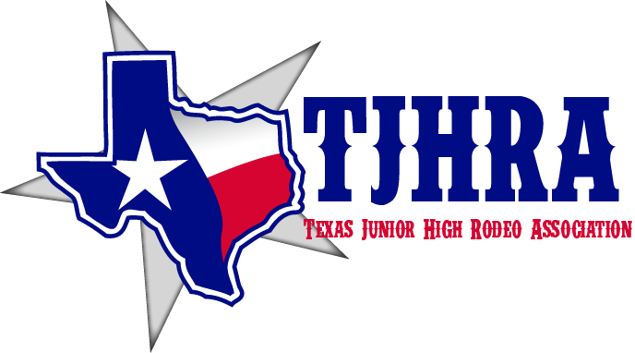
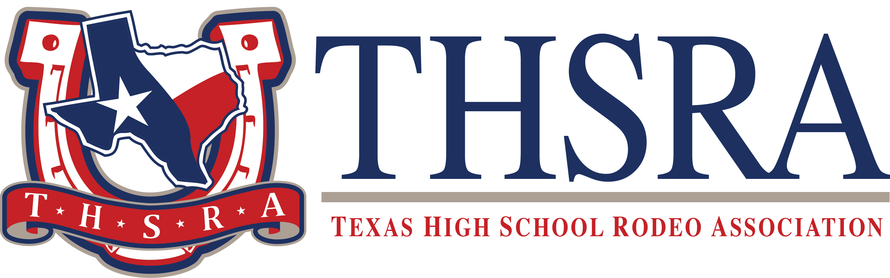

Texas Region X Rodeo
6500 CR 1202, Cleburne, TX 76031

Sponsorship Form

Event Sponsor – Saddle to Champion, Reserve Buckle $2000.00

Banner at rodeos, awards ceremony, and on website
Champion Saddle Sponsor $1500.00

Banner at the Rodeo and on website

Awards Sponsor $750.00

Banner at the Rodeo
Buckle Award Sponsor......................................................................... $ 300.00

Recognition on website

Other Sponsor – (amount of your choice) $ _______________

Enclosed please find check for $ and/ or prizes of equivalent value.
If a Buckle, Saddle or Event Sponsor, the event I would like to sponsor is.

____________________________________________________________________________________________________

PLEASE PRINT OR TYPE:

____________________________________________________________________________________
Name Of Company or Individual

____________________________________________________________________________________________
Address City State Zip Phone

_____________________________________________________________________________________________
Signature Date

Please return your contribution with this completed form to: Region X Rodeo
Rodeo Charitable Fund
EIN# 74-2093972
c/o Stephanie Shoemaker, 6500 CR 1202, Cleburne, TX 76031

