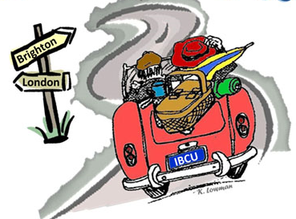
INDIANA BRITISH CAR UNION PRESENTS
2016 LONDON to BRIGHTON RUN
SATURDAY, JULY 16, 2016
On November 14, 1896, the first London to Brighton Run was held in England to celebrate raising the speed limit from 4 to 14 mph. IBCU celebrates the 120th anniversary of this event with its annual rally/tour across Indiana, for all British cars.
Participants will enjoy an approximate 100 mile drive along some interesting roads in central Indiana, answering challenging questions and taking photos along the way. Trophy plaques will be awarded to the top ten finishers.
Start:
The run will start at the Moral Township Community Center (next to the fire station), 8333 Frontage Road, Fairland, IN 46126 (Exit 103 off I-74 south of Indy). We will again partner with our Northamptonshire Sister City to provide an English breakfast (included in the registration!) at around 8am, with driver’s meeting at 9am and first car off at 9:30am.
End:
The run will end at the Key West Shrimp House in Madison, IN. Expect to arrive in Madison around 2pm for early dinner/late lunch (not included in registration).
Cost:
Early Bird (received by June 18th) - $15 per car (lunch is on your own)
Regular (received after June 18th and day of run) - $25 per car (lunch is on your own)
To register for the event, complete the form below and send with registration fee (payable to IBCU) to:
Greg and Susan Albers
P.O. Box 466
Zionsville, IN 46077

Driver Name: ____________________Navigator Name:
Address: ________________________________________________________
City, State, Zip: ___________________________________________________
Phone: ________________________ Email: __________________________
Car Make and Model: ______________________________________________

For more information or questions, contact Mike Roe, (317) 270-3365, microtr6@gmail.com

