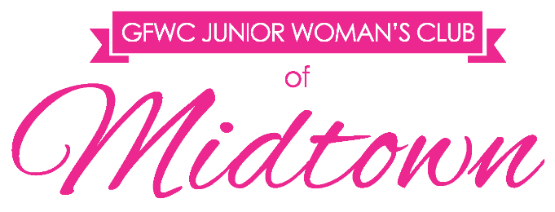
2019 CRAWL FOR A CAUSE APPLICATION

Organization:

1. If selected by the JWCM as our charity of choice, please explain how the funds will be utilized and how they will directly affect Leon County?

2. Why is your organization best suited for this opportunity?

3. Should your organization be selected, how could the JWCM work with you in the future by actively participating in events or other volunteer opportunities, preferably where the funds will have been utilized?

4. Please let us know if there is any other information you think is important for us to know during the selection process:

Please feel free to allow your answers, and the below portion to extend on to additional pages.

Applications must be submitted by
Monday, August 3, 2018 at 5 p.m. via e-mail to midtownjuniors@gmail.com.
Include a copy of your 501(c)3 form with your application.

GFWC Junior Woman’s Club of Midtown | PO Box 14643 | Tallahassee, FL 32317 | gfwcmidtownjuniors.org | midtownjuniors@gmail.com | facebook.com/JWCMidtown

