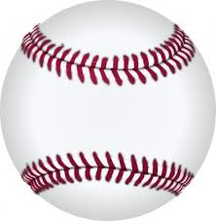
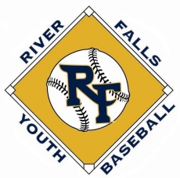
RIVER FALLS CLASSIC #3
June 17-18, 2017
13AAA DIVISION

 | American League | Win | Loss | Tie | Total Points
A1 | River Falls
A2 | Stillwater
A3 | La Crosse
A4 | Minnetonka

 | National League | Win | Loss | Tie | Total Points
N1 | East Ridge
N2 | North St. Paul
N3 | Eau Claire
N4 | Chisago

Pool Play

Saturday | Field | Team | Score | Team | Score
9:00 | Hoffman 1 | River Falls |  | Stillwater
11:15 | Hoffman 1 | La Crosse |  | Minnetonka
1:45 | Hoffman 1 | Stillwater |  | La Crosse
4:00 | Hoffman 1 | River Falls |  | Minnetonka
Sunday
9:00 | Hoffman 2 | La Crosse |  | River Falls
11:15 | Hoffman 2 | Stillwater |  | Minnetonka

Saturday | Field | Team | Score | Team | Score
9:00 | Hoffman 2 | East Ridge |  | North St. Paul
11:15 | Hoffman 2 | Eau Claire |  | Chisago
1:45 | Hoffman 2 | North St. Paul |  | Eau Claire
4:00 | Hoffman 2 | East Ridge |  | Chisago
Sunday
9:00 | Hoffman 1 | Eau Claire |  | East Ridge
11:15 | Hoffman 1 | North St. Paul |  | Chisago

Championship Bracket

Sunday | Field | Team | Score | Team | Score
1:45 | Hoffman 1 (Semi 1) | National #1  ___________ |  | American #2  ___________
4:00 | Hoffman 1 (Champion) | Winner (Semi 1)  ___________ |  | Winner (Semi 2)  ___________

Sunday | Field | Team | Score | Team | Score
1:45 | Hoffman 2  (Semi 2) | American #1  ___________ |  | National #2  ___________
4:00 | Hoffman 2  (3rd Place) | Loser (Semi 1)  ___________ |  | Loser (Semi 2)  ___________

2017 MBT Qualifier Rules Apply

Pool Play Time Limits (no limit for bracket play):
9U-12U: Time limit: 6 innings/1 hr 45 mins No new inning shall begin after 1 hr 45 mins 4 innings minimum required
13U-15U: Time limit: 7 innings/2 hours No new inning shall begin after 2 hours 5 innings minimum required

POOL PLAY TIE BREAKER METHODS:
1. Won-Loss-Tie Record
2. Head to head
3. Least number of runs allowed against tied teams
4. Run differential against tied teams (maximum plus or minus 10 run)
5. Least number of runs allowed in total pool play
6. Run differential in total pool play (maximum plus or minus 10 run)
7. Coin toss

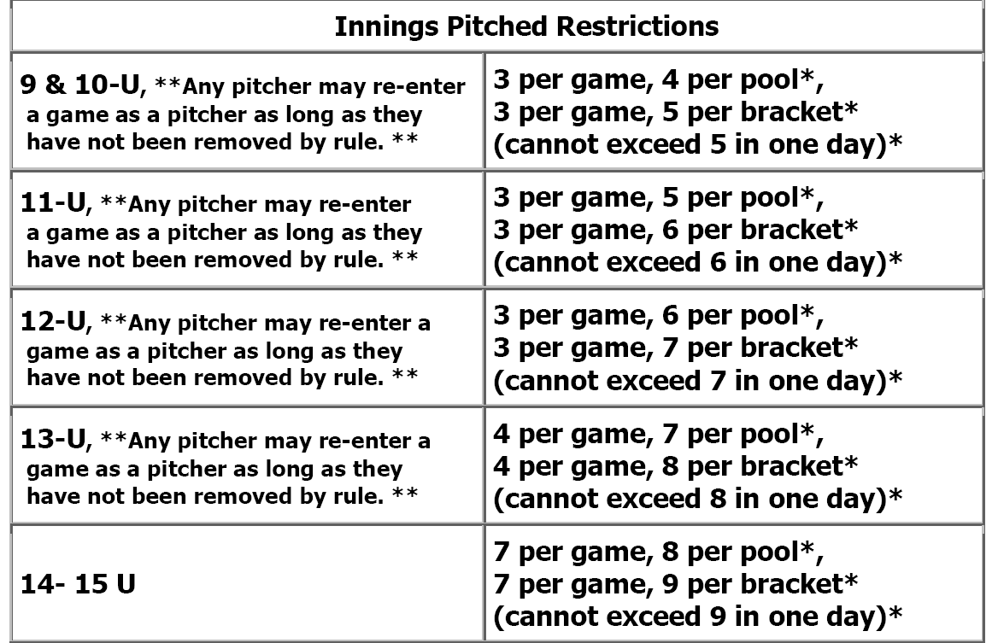

ALL GAMES AT HOFFMAN PARK IN RIVER FALLS
www.riverfallsyouthbaseball.org

