Ticket Sales
- Extra Rehearsals Schedule
- PICTURE DAY
- Stage Rehearsal Schedule
- RECITAL ARRIVAL DAY INFO

ORDER OF PERFORMANCE
- DVD | FLOWERS | TEDDY BEAR SALES
- DANCERS SHOUT OUTS
- N’FERNO ATTIRE ORDERS

TICKETS SALES
Each student family will receive one (1) ticket at half price $7.50. Families with multiple children enrolled with us will receive up to two (2) discounted tickets. This discounted ticket can only be purchased at the front-desk on or before June 15th by 7:00pm.

NO EXCEPTIONS!!

Tickets go on Sale Monday, May 14th
$15.00 per person Ages 3yrs and Under FREE

~ See Front Desk ~

ON- LINE TICKETS or CREDIT CARD - $17.00
On Line - Tickets - See "Will Call" for pick up
Visit www.nfernodance.com “N’FERNO STORE”

Saturday, June 16th – Randallstown High School

4:30 PM – NEW SHOWTIME
DOOR TICKETS $20.00 per person

- Student Assessment Week
  - May 29th – June 4th

- IF YOU NEED TO ORDER Tights, Foot-mittens, ballet shoes, N’Ferno leggings, or T-shirts FOR THE RECITAL PLEASE DO SO
NO LATER THAN
SATURDAY, June 2nd

PICTURE DAY AT N’FERNO STUDIO
Sunday, June 10, 2018

All modern/ballet classes arrive in Ballet costume first.

Please BRING your modern costume with you.
Expect to be there for about an hour.

GROUP | TIME | Things to Remember
➢ Intro to Dance  ➢ Tiny Hip Hop  ➢ Modern/Ballet 1A  - Intro to Jazz | 2:00pm | All modern/ballet wear ballet pink conversion tights and ballet pink ballet shoes and footmittens. All Hip Hop wear black shoes and white socks. Jazz wear your fishnets tights and jazz shoes.  Hair: Nice and Neat and pulled away  – Any Style
Modern/ Ballet  ➢ 1A- Intermediate  ➢ 1B  ➢ 1B- Intermediate | 3:30pm | All modern/ballet wear NUDE conversion tights and ballet pink ballet shoes and footmittens.  Hair: Nice and Neat and pulled away from face – Any Style
➢ Hip Hop 1 Beginner  ➢ Hip Hop 2 Inter/ Adv.  - Boys Hip Hop | 5:00pm | Hip Hop wear black shoes and white socks. Hair: Nice and Neat and pulled away from face – Any Style
Modern/ Ballet  ➢ 2A and 2B  ➢ Jazz 1 | 6:00pm | All modern/ballet wear NUDE conversion tights and ballet pink ballet shoes and footmittens  Hip Hop wear black tennis shoes and white socks  Jazz wear your fishnets tights and jazz shoes.  Hair: Nice and Neat and pulled away from face – Any Style

ORDER OF PERFORMANCE
Jazz 1 (Competitive)
Kanyon & Khyle Duet (Competitive)
Amaris & Aniya (Competitive)
Intro to Dance
Intro Ballet 1A
Ballet 1A Intermediate
Ballet 1B
Dawnell Solo (Competitive)
Ballet 1B Intermediate
Ballet 2A
Ballet 2B & Pre-Pointe
Intro to Jazz
Jazz 1
Rayne & Jazmin (Competitive Tap)
Kam’Ryn Solo (Competitive)
Amaris Solo (competitive)
Acro (competitive)
SPECIAL PRESENTATION - Dancers
Musical Theater (Competitive)
Momma’s Get Down

* INTERMISSION – 15 minutes *
PRODUCTION – COMPETITIVE DANCERS
SPECIAL PRESENTATION - Teachers
Tiny Hip Hop (Intro)
Hip Hop 1- Beginners
Hip Hop 2 – Intermediate/ Advance
Petite Hip Hop (Competitive Team)
Hip Hop 1 (Competitive Team)
Hip Hop 2 (Competitive Team)
Hip Hop 3 – (Competitive Team)
Boys Hip Hop
Daddy / Daughter Dance
Lyrical 2 – (Competitive Team)
Kanyon Solo (Competitive)
Modern 1A
Modern 1A - Intermediate
Modern 1B
Modern 1B Intermediate
Modern 2A
Modern 2B
** ABSOLUTELY NO VIDEO TAPING OR FLASH PHOTOGRAPHY **

STAGE REHEARSAL – ARRIVAL TIMES

FRIDAY, JUNE 15, 2018

RANDALLSTOWN HIGH SCHOOL
PLEASE ARRIVE ON TIME OR YOU WILL MISS YOUR STAGE TIME
Expect to be there for an hour

Class | Arrival Time
Intro to Dance Modern/Ballet 1A  Tiny Hip Hop | 6:00pm
Modern/ Ballet 1A Intermediate  Intro to Jazz and All Boys Hip Hop | 6:30pm
Modern/ Ballet 1B and 1B Intermediate and Hip Hop 1 | 7:00pm
Modern/Ballet 2B and  Jazz 1  Modern/ Ballet 2A  Hip Hop 2 | 7:30pm
Competitive Team Members Only those not involved in the above performances | 8:00 pm

RECITAL DAY – ARRIVAL TIMES

SATURDAY, JUNE 16, 2018

RANDALLSTOWN HIGH SCHOOL
PLEASE ARRIVE ON TIME OR YOU WILL MISS YOUR STAGE TIME

Class | Arrival Time | Attire, Hair, Other
Modern/Ballet 2B and  Jazz 1  Modern/ Ballet 2A  Hip Hop 2 | 1:00pm | Hair: Bun Center of Head  Shoes: ballet pink ballet shoes and foot mittens  Hip Hop Only: Black tennis shoes  Other: Nude conversion tights
Modern/ Ballet 1B and 1B Intermediate and Hip Hop 1 | 1:30pm | Hair: Bun Center of Head  Shoes: ballet pink ballet shoes and foot mittens  Other: Nude conversion tights
Modern/ Ballet 1A Intermediate  Intro to Jazz and Modeling  Boys Hip Hop | 2:00pm | Hair: Bun Center of Head  Shoes: ballet pink ballet shoes and foot mittens  Hip Hop Only: Black tennis shoes  Other: Nude conversion tights
Intro to Dance Modern/Ballet 1A  Tiny Hip Hop | 2:30pm | Hair: Bun Center of Head  Shoes: ballet pink ballet shoes and foot mittens  Hip Hop Only: Black tennis shoes  Other: Ballet Pink conversion tights
Competitive Team Members Only those not involved in the above performances | 3:00 pm | All Team Members wear a Bun –  NO HAIR CHANGES – Light Make Up

DOORS OPEN at 4:00pm

** EARLY SEATING **
If you have a person with a disability that may need earlier seating please email info@nfernodance.com

YOU ARE CORDIALLY INVITED TO
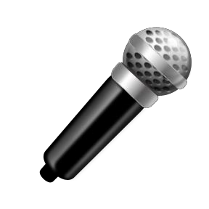
SHOUT OUT LOUD!!

N’Ferno Performing Arts Center

N’Ferno’s 2018 Recital
Saturday, June 16, 2018 Randallstown High School

Want to show your Special Performer even more support?
SHOUT IT OUT and let your talented star know how GREAT they are!
N’Ferno is offering you a chance to have the MC announce a special message to your special performer during the concert.

Over the Mic- $1.00 per shout out (Max. 2x’s) Program Print - $3.00 per message (50 characters)
5:30pm
All SHOUT OUT orders must be purchased by Saturday: June 2nd, 2018

Place your orders NOW – SHOUT OUT your Support!!!!

Email info@nfernodance.com or visit the front desk to place your

N’Ferno Performing Arts Center Shout Out Form
Questions? Contact N’Ferno 410-655-1427 or INFO@nfernodance.com.
 | From/Given By:
 | Email Address:
 | Phone Number:
 | For/Student Name:
 | Student Class:
 | Voice Shout out: | $1.00 per shout out  How many times would you like your message heard? (2x max)
 | Print Shout out: | Up to 50 Characters $3.00, $.50 for every 15 additional character
 | Message:
 | Paid: | Yes No Total:
 | Representative Signature:
Thank you for your Business. We appreciate your support!

SEE FRONTDESK FOR MORE ORDER FORMS
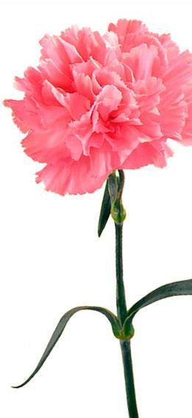
TEDDY BEARS AND CARNATIONS
For your Lovely Dancer

PRE-ORDER BY June 2nd

Pick Up your order at the Gift Table
$1.50 per Carnation 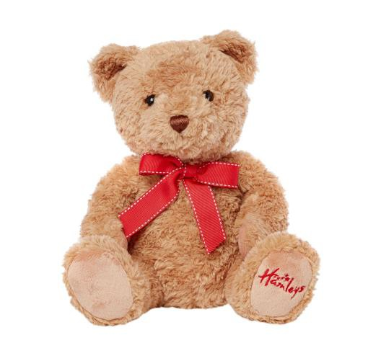
$5.00 Carnation Bundle w/ a Ribbon and a Card (6 Carnations)
$8.00 Teddy Bear w/ a card
$15.00 Carnation / Teddy Bear Bundle

(5 carnations and 1 Teddy Bear with a Ribbon and card)

VIDEO Sales
** All videos will be on a USB drive for better quality and downloading purposes.
$35 Entire Show (1 USB) CUSTOM VIDEOS

$55 Bundle (2 USB) $20 – for 2 performances
PRE-ORDER ON-LINE $25 – for 3 performances

Or at buy at front-desk $30 – 4 or more

N’FERNO INCLEMENT WEATHER MAKE UP
CLASS & EXTRA REHEARSAL SCHEDULE

We are drawing near to the recital and want to assure that every dancer is properly prepared.

Mondays: June 4th and June 11th ** This class will stay longer
7:15 - 9:15pm Ballet 2A (TJ)

Wednesdays: June 6th and June 13th NO Ballet variations or Jumps and Turns on these days
6:00 - 6:45pm Pre-Pointe (CW)

Thursdays: June 7th and June 14th ** This class will arrive early ** NO Ballet Variations/ Jumps & Turns
6:00 - 6:45pm Modern 2A (SH)

Sunday, May 27th
1:30 - 2:30Pm Modern 1A (CW)
2:30 - 3:30pm Intro to Jazz (CW)
3:30 - 4:30pm HH1 (JB)

Friday, June 1st
6:00 - 6:45 Tiny HH (KR)
6:00 - 6:45pm All Boys HH (FD)
6:45p - 8:00pm Modern 1B Int. (CE)
6:45 - 7:45p Modern 1A (CW)
7:45 - 9:00pm Modern 1B (CW)
8:00- 9pm HH2 (FD)

N’FERNO INCLEMENT WEATHER MAKE UP
CLASS & EXTRA REHEARSAL SCHEDULE

We are drawing near to the recital and want to assure that every dancer is properly prepared.

Saturday, June 2nd
9:00 - 10:00am HH1 (FD & KR)
10:00 - 11:30a Jazz (SB)
10:00 – 11:30am Ballet 1A (KR)
11:30 - 1:00pm Ballet 1B (CE)
11:30 – 1:00pm Modern 1A Int. (KR)
1:00- 2:30pm Ballet 1B Int. (CE)
1:30 - 3:00pm Ballet 1A Int. (KR)
2:30 - 3:45pm Modern 2B (CE)
3:00 - 4:15pm HH2 (TP)
4:00 - 5:15pm Ballet 2B (CE)

Sunday, June 3rd
1:00- 2:00pm Tiny HH (KR)
2:00 - 3:00pm Intro to Jazz (KR)

Friday, June 8th
6:15 - 7:30p Modern 1A Int. (KR)
7:30 - 8:45pm Modern 2B (KR)

Saturday, June 9th
10:00a - 11:30am Jazz 1 (SB)
11:30 - 12:30pm Ballet 1A (KR)
12:30 - 1:30pm Modern 1B (KR)
1:30 - 2:30pm Ballet 1A Int. (KR)
2:30 - 3:30pm Ballet 1B (CE)
2:30 - 3:30pm All Boys HH (TP)
3:30 - 4:30 Ballet 2B (KR)
3:30 - 4:30 Ballet 1B Int. (CE)

