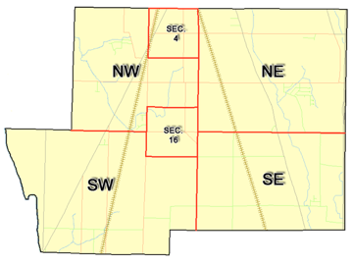 | Pleasant Township  Zoning Commission Minutes  1035 Owens Rd W.  Marion, Ohio 43302
Meeting called by: | Scheduled | Type of meeting: | Regular Monthly
Chairperson: | Mr. Holler | Secretary: | Tim Michael
Timekeeper: |  | Date: Feb. 20, 2020 | Time 7:30 pm
Call to Order by: | Mr. Holler Moment of silence followed by the pledge to the flag.
Roll Call: | Scott Ballenger, Jack Dean, Harry Holler, Tom Leib, Dwight Williams  Tim Michael Secretary / Alternate
Minutes: | Read and approve minutes from previous meeting. (May pass out earlier)  Motion to approve minutes by: Mr. Leib Seconded by: Mr. Dean Roll call: All approved
Attendees Address Board: Have sign in sheet on desk by door.
Type in attendees and addresses:
.
----- Agenda Topics -----
Business
Zoning Reports: | Zoning Inspector goes over reports and provides copy to board.
Unfinished:
New:
Announcements: | Next meeting will be: March 19, 2020
Adjournment: | Motion to adjourn by: Mr. Williams Seconded by: Mr. Dean all in favor: all approved
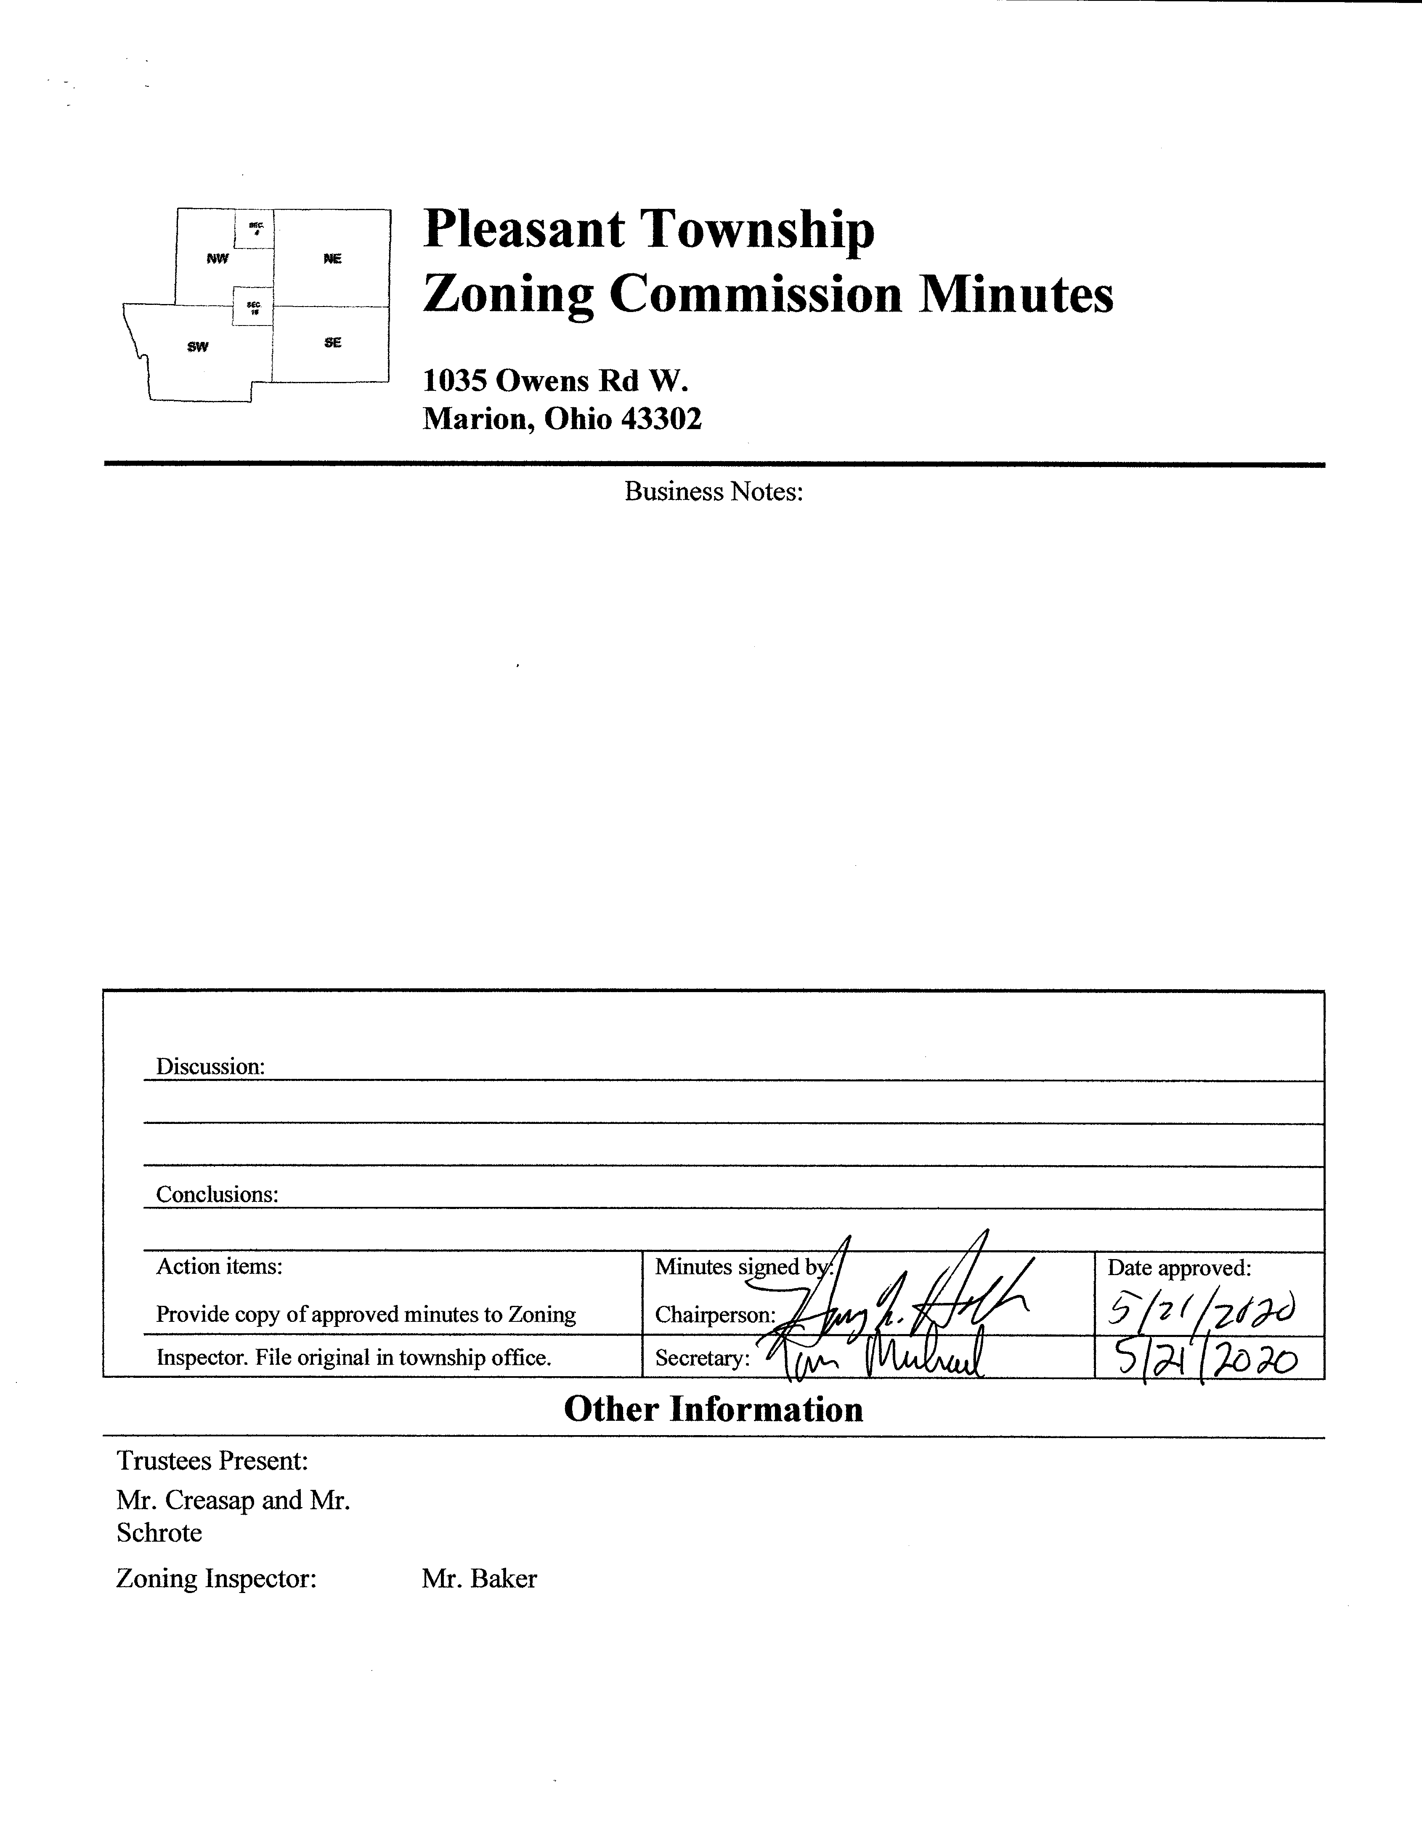

Minutes
- The Pleasant Township Zoning Commission met for their regularly scheduled monthly meeting on February 20, 2020 at the Pleasant Township Trustee Office. Zoning Commission Board members present were: Mr. Ballenger, Mr. Dean, Mr. Leib, Mr. Williams, Chairperson Mr. Holler, and Secretary Mr. Michael. Township Trustees Mr. Creasap and Mr. Schrote, and Township Zoning Inspector Mr. Baker.
- Minutes were read from the January 16th regularly scheduled Zoning Commission Meeting and the February 13th 2020 Special Zoning Commission Meeting. There being no stated corrections a motion to approve the minutes for these meetings were made by Mr. Williams and seconded by Mr. Dean (January 16th meeting) and Mr. Williams seconded by Mr. Ballenger (February 13th special meeting). All members present agreed to passage of the minutes as read.
- Mr. Tom Baker Pleasant Township Zoning Inspector submitted the following inspection report for the month of January 2020: there were 2 permits for new homes, 2 permits for additions, and 1 permit for a fence. Dollar amount for new construction totalled $274,321.00, with income from permits totalling $633.40.
- The Zoning Board discussed the latest proposed revisions to the Pleasant Township Zoning Resolution produced by the Marion County Regional Planning Commission dated 2/19/2020. Two issues for clarification by Mr. Robert Morris of the Marion County Regional were requested; clarification on the issue concerning reduction of setback by 50% (from page #3 of the document) and a general question concerning the tax benefits/consequences of a solar farm facility such as the one being proposed. Note: issues were relayed to Mr. Morris for his input at a future Zoning Commission meeting.
- There being no additional business for discussion Mr. Williams made motion to adjourn seconded by Mr. Dean all Zoning Board Members in attendance agreed and the meeting was adjourned. The next scheduled Zoning Board Meeting will be held on March 19, 2020 at 7:30 PM.

