**Market Vendors**

**Policies & Procedure Guide**

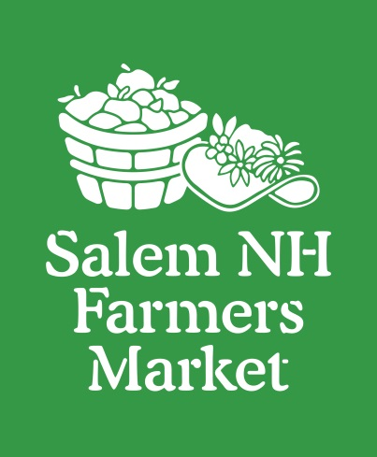

Salem NH Farmers Market

Table of Contents

Purpose 3

Mission Statement: 3

Criteria for Vendor Consideration & Selection 3

Vendor Booths 3

Vendor Responsibilities 4

Market Tokens 5

Credit & Debit Tokens 5

EBT Tokens 5

EBT Matching Tokens 5

Tokens 5

Market Purchases 6

Gift Certificates & Coupons 6

Tokens Varieties 6

Vendor Responsiblities 7

Vendor Reimbursement 7

Products/Commodities that Can Be Sold 8

Examples of categories of items that can be sold 8

Examples of Crafts from vendors and artisans 8

Items NOT Permitted for Sale at the Market 8

Market Cancellations 9

# Purpose

This document has been created to properly define the policies and procedures for the operation of the Salem NH Farmers Market, (SNHFM) as well as to establish the guidelines and responsibilities for vendors, permitted items that can be sold, and overall operating guidelines for Market operations.

## Mission Statement:

Provide communities with a wide variety of fresh, local, and specialty foods, goods and products. Through community involvement, we strive to educate all about the nutritional, economic, environmental and social implications of eating seasonally and locally

## Criteria for Vendor Consideration & Selection

Vendor refers to all vendors, artisans or persons selling or distributing items at the Salem NH Farmers Market. (SNHFM)

* All prospective vendors must submit a completed application three (3) weeks in advance of opening market for review and subsequent approval.
* Copies of all relevant licenses and permits must be included with the application.
* Once approved, all vendors must, at their own expense, procure and meet the following standard insurance/coverage requirements:
  + Commercial General Liability in the amount of at least $1,000,000 per occurrence naming Salem NH Farmers Market, Salem School District and Salem Market Place as additionally insured. *

*Note: these names must be listed as *Additional Insured* when speaking with your insurance rep please use that wording to insure that the documents will be correct.

You will be notified once your application is approved. (Vendors cannot be approved until all paperwork has been completed and submitted.)

# Vendor Booths

* All vendors must check in with the Market Representative upon arrival and/or prior to setting up.
* Booths/spaces are assigned at the discretion of the Market Representative. Factors that may contribute to booth assignments shall include seniority, regular attendance, purchasing multiple booths/spaces, setup and breakdown logistics, and other factors determined by the Market Representative.
* Vendors are not permitted to share booths.
* Vendor setup times will be determined by the Market Representative.
* The Market must be notified 48 hours in advance should a vendor change or add products/items to their venue. Vendors cannot add new items without prior Market approval.
* All vendors will maintain a clean, attractive, and professional display at all times in their booth(s).
* Vendors are responsible for providing their own tables, chairs, canopies, equipment, etc., and must fit within the confines of the designated space as predetermined by the Market Representative. It is important to note that all canopies, umbrellas, and/or shade protection utilized on the Market site must be safely and properly anchored to the ground at all times.
* As this is an open market forum, there may be duplication from other vendors/artisans selling similar products or commodities. The Market reserves the right to limit vendors and/or particular products/items. This will be done solely to prevent market saturation and intentional and unfair price undercutting. All vendors must agree to abide by fair business practices.
* Vendors are not permitted to breakdown before the Market officially closes for the overall safety and integrity of the event.

# Vendor Responsibilities

* Vendors will respect their fellow vendors and customers at all times, conducting themselves in a proper, professional demeanor. Discourtesy to anyone will not be tolerated.
* Vendors must be prepared and completely setup 15 minutes before the Market officially opens.
* Vendors must inform that Market within 24 hours if they will not be attending the Market on a given day. Vendor will still be responsible for the Vendor fee if they do not give at least 24 hours’ notice.
* Vendors must stay within the Market to sell their own items.
* Vendors must provide their own change, purchase bags, and other independent promotional materials.
* Each vendor is responsible for maintaining the cleanliness in his/her designated booth and the surrounding grounds within the Market. Vendors should provide their own trash receptacle. Vendors are responsible for removing trash and/or waste at the conclusion of the Market. There are no trash related services available, so all vendors must independently take his/her trash with them.
* Vendors are responsible for establishing their own prices; however, price undercutting and end of sale price reductions will not be permitted. Prices must be clearly marked and visible to all potential buyers.
* Vendors are not allowed to smoke within the confines of the designated market area. Smoking may also be limited by the venue itself, for example there is no smoking allowed on school property this includes smoking in private vehicles on school property. In cases where there is no smoking on the property vendors must go off property to smoke.
* Vendors are not allowed to consume alcoholic beverages within the confines of the designated market area. (With the exception of vendor wine samplings)
* Any disputes amongst vendors and/or patrons, must be brought to the attention of the Market Representative immediately.
* The market allows domestic animals but we are limited by the location. For example, School properties only allow service animals in the buildings. If you are not sure what is allowed at a specific location then please contact the Market. Also if animals are allowed it is expected that they will be controllable by the owner.
* Additionally any restrictions that the location puts on the market must also be followed by the vendors. For example access times and doors that can be used. Any additional restrictions will be sent by email to vendors.

# Market Tokens

The Salem NH Farmers Market uses a Token system to allow the use of EBT, Credit and Debit cards. The token program is intended as a benefit to both vendor and customer. Managed by Salem NH Farmers Market volunteers, the program provides additional purchasing power for the customer and helps increase vendor sales while reducing vendor credit card fees. Credit and EBT tokens are available at each market from the token clerk. The value of the token is good from week to week.

## Credit & Debit Tokens

Credit tokens are green and have a $5 value. All vendors must accept Credit & Debit tokens as payment. Credit tokens should be treated like cash. The vendor will provide change in cash for a purchase made with a token.

## EBT Tokens

EBT tokens are black and have a $1 value. Acceptance of EBT tokens is dependent on what you are selling, vendors are responsible for verifying if they can accept EBT tokens. Please review the “What can I Buy” link on the USDA Site for more information.

<http://www.fns.usda.gov/snap/mobile/benefits/what-can-i-buy.html>

For example: you are a vendor that sells frozen meats but you also sell sandwiches with the meat cooked. The EBT tokens can be used to purchase the frozen meat but cannot be used to purchase the sandwich. (See link above EBT cannot be used to purchase hot food, or food to be eaten at the store.)

## EBT Matching Tokens

A one to one match for customers using SNAP/EBT will be provided at the Market token table (availability is based on funding). Customers can purchase tokens using both Credit and EBT card. If a customer uses both a credit card and EBT card, credit tokens and EBT tokens will be provided based on the value of each purchase. (Ex.: Credit card for $20 = 4 green credit tokens, EBT card for $30 dollars = 30 black $1 tokens and $30 black $1 EBT tokens for the match if funding is available.

## Vendor Token Reimbursement

Each vendor will be provided a bag for token collection and a Token Receipt form at the beginning of each market. At the end of each market, put all tokens into the bag and completely fill out the enclosed form making sure to note the NUMBER of Credit and EBT tokens you took in and the combined dollar value of both tokens. It will help the token clerk if you write both your business and payee name on the form if they are different. Filling out the form completely before approaching the token table with your business/payee name and token values will expedite your time and reimbursement. The clerk will verify your token count and you’re your receipt. Please keep the half of the form identified as **Vendor /Farmer**, it functions as your receipt and insures proper token reimbursements.

Below is a sample of the Token Reimbursement form. There are 2 halves to this form and they are identical except for who the copy is intended for, Vendor/Farmer or Market/Clerk. Please fill out both halves. The following is an example:

|  |  |
| --- | --- |
|  | Vendor/Farmer Token ReceiptDATE: -______________________________________________________________Vendor Name: __( Businees name and payee name if different )_______________ **Number of Credit Tokens:** __________________________________________  **Number of EBT Tokens: _**______________________________________________  **Market Purchase: __ (** Dollar amount on your receipt )**______________________**  **Total Dollar Value of All Tokens/Receipts: _________________________________**  **Token Clerk Signature: _________________________________________________** |

## Market Purchases

There will be occasions when a market representative will make purchase from you. The representative will give you a receipt. The receipt will function like a token. The dollar value of the receipt should be added to your market token form on the Market Purchase line. Put the receipt in the token bag like you do the tokens. Keep your half of the Vendor/Farmer token receipt form to insure correct payment in your reimbursement check. Reimbursements for Market Purchases will not be honored without the receipt.

## Gift Certificates & Coupons

SNHFM gift certificates and coupons **must** be exchanged at the Token Table for tokens. If a customer presents a coupon to you, inform them that they must exchange them for tokens at the Token Table.

## Tokens Varieties

All tokens created by the Salem NH Farmers Market will have our name and logo on them; including EBT tokens. These tokens are acceptable based on criteria above. No other types of tokens are redeemable.

Here are examples of some of the tokens we are currently using. **Please note these are only some of the tokens that are currently in circulation, if you are unsure about a token, please talk to a market representative.**

**Credit/Debit Tokens:**

Old Version: 2014 Dated Version:

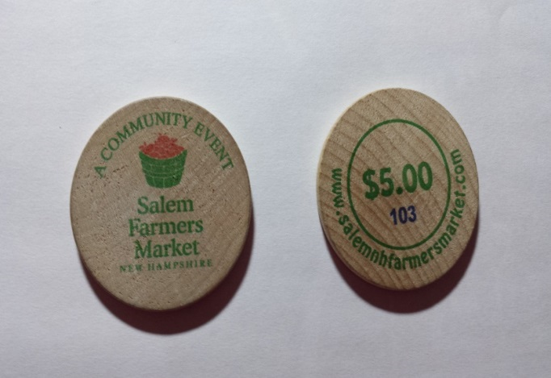

**EBT Tokens:**

Old Version: 2014 / 2017 Dated Version:

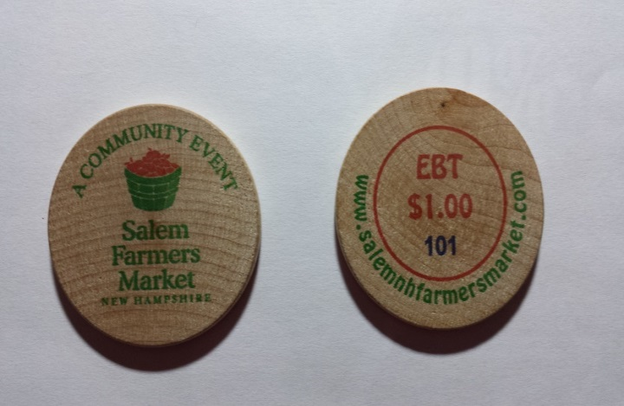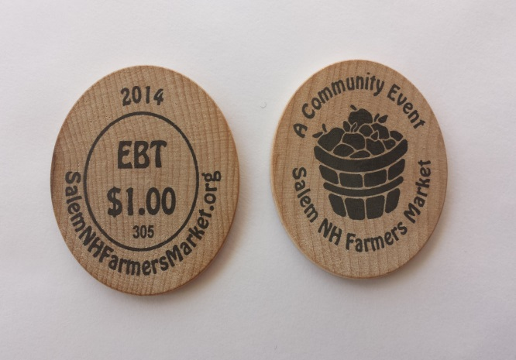

## Vendor Reimbursement

SNHFM will reimburse Vendors for accepting tokens and market purchase receipts every two weeks or sooner if possible. Please make sure SNHFM has your proper business name and address on file. Reimbursements checks will be made out to the “Payee Name” as indicated on the Market Application submitted by the vendor. The Payee name may be the vendor’s personal name or their business name. It is vital to proper reimbursement that the “Payee Name” be the same as the Vendor Name on the Token Reimbursement Form in the bag.

# Products/Commodities that Can Be Sold

* All products or items sold at the Salem NH Farmers Market must be pre-approved by the Market board.
* The Salem NH Farmers Market strives to be a producers’ only market. This means that all items sold need to be locally grown, baked, prepared, and/or hand make by the vendor.
* Special permission must be received to sell out-of-season or non-local products at the market.
* Produce cannot be advertised as “certified organic” unless it has been certified organic with the Department of Agriculture. A current organic certification must be attached to the vendor’s application and properly displayed at the Market.
* All items must be sold in accordance with applicable Town of Salem Health Department and State of New Hampshire regulations.
* All food items for sale must be displayed properly at least six (6) inches above the ground and in sealed, waterproof containers.
* All permits, food licenses, scale certifications, etc., should be displayed at vendor tables.

# Examples of categories of items that can be sold

* Fresh product (fruits, vegetables, herbs, spices)
* Fresh cut Flowers
* Honey, maple syrup
* Jams and jellies
* Natural fibers
* Meats
* Assorted Seafood
* Local dairy products, such as eggs, cheese, etc.

# Examples of Crafts from vendors and artisans

* All items must be prepared and/or created by the vendor
* Acceptable artistic genres include: painting, sculpture, wood working, pottery, spinning, weaving, blacksmithing, candle making, quilting, etc.

The Salem NH Farmers Market strives to be a Farmers Market first and will limit the number and type of craft/artisan vendors that it allows.

# Items NOT Permitted for Sale at the Market

* Livestock/animals
* Wild game meats (this excludes free range farmers)
* Spouts
* Canned fruits and preserves
* Flea market / yard sale items/antiques
* Craft items or models made from kits
* Any mass produced or manufactured item

# Market Cancellations

The Market reserves the right to cancel any given scheduled Market Day in the event of inclement weather and/or any unforeseen circumstances. Cancellation notification will be made by email.