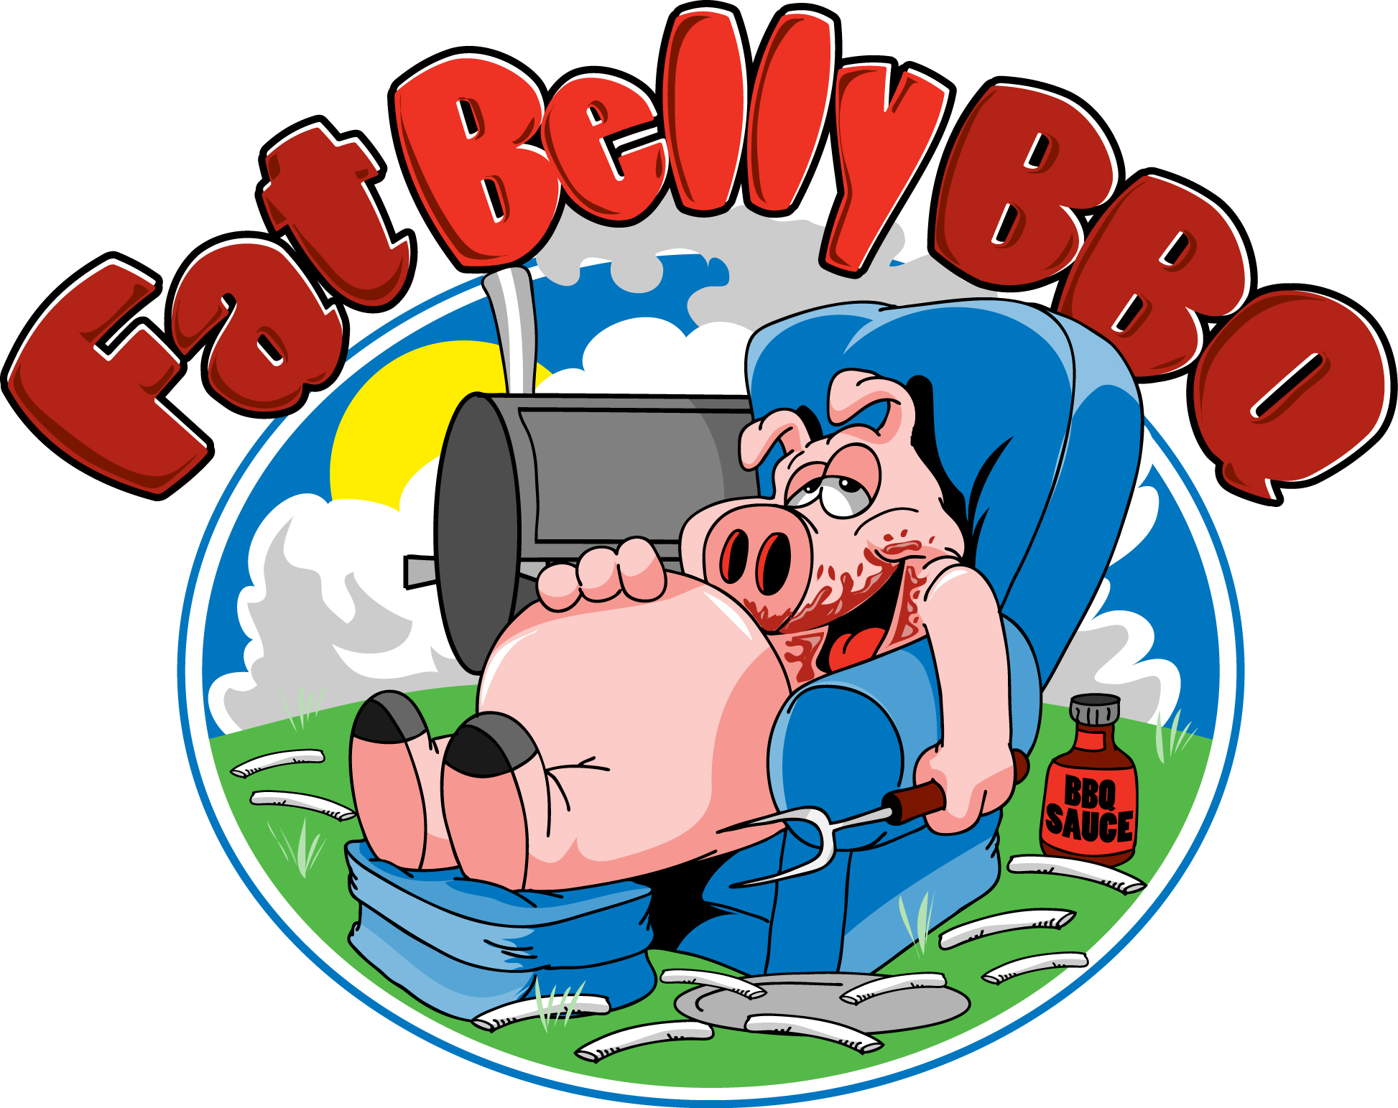
Sandwiches

Pulled Pork………………...…$5
Pulled Chicken…………….....$5
Beef Brisket……………….…$5
BBQ Smoked Sausage.……....$5
Sandwich Combo.....................$8
Choice: Pork, Chicken, Beef, or Sausage Sandwich, Chips, Soda, Side
Combination Plates
2 Meat…………………...….$14
Choice: Pork, Chicken, Beef, or Sausage, Chips, Soda, and 2 Sides
3 Meat………………………$17
Choice: Pork, Chicken, Beef, or Sausage, Chips, Soda, and 2 Sides

BBQ Sundae….….…………..$7
Choice: Pork, Chicken, Beef, or Sausage, BBQ Beans, Coleslaw
BBQ Nachos……................... $6
Choice: Pork, Chicken, Beef, or Sausage
Nachos……………..…..……..$3

From the Grill

Hamburger……………….......$4
Add Cheese $.50
Add Bacon $1.00
Burger Combo..........................$5
Choice: Hamburger, Soda, and Chips
Add Cheese $.50
Add Bacon $1.00
BBQ Cheeseburger........……..$8
Choice: Pork, Chicken, Beef, or Sausage, caramelized onions and bbq sauce on a cheeseburger
Add Bacon $1.00
Hot Dog……………….…......$3
Hot Dog Combo………..…....$4
Choice: Hot Dog, Soda, and Chips
Grilled Cheese..……………...$3
BBQ Grilled Cheese………....$6
Choice: Pork, Chicken, Beef, or Sausage on a grilled cheese

From the Fryer

Chicken Fingers…………..… $4
Chicken Finger Combo………$5
Choice: Fingers, Soda, and Chips
Buffalo Chicken Fingers.....$4.50
French Fries……………..…...$4
Cheese Fries……………….…$5
BBQ Cheese Fries...………….$7

Sides

Coleslaw…………….…….....$2
BBQ Beans……………….….$2
Cornbread……………………$2
Chips………………..……..$.50

Drinks
Soda & Water…………………$1
Fresh Lemonade……….………$2

*Tell your server about any food allergies*
*Consuming raw or undercooked meats, poultry, seafood, shellfish, or eggs may increase your risk of foodborne illness*
*All food is cooked to well-done*
Kitchen Local, LLC is used as a base of operation

