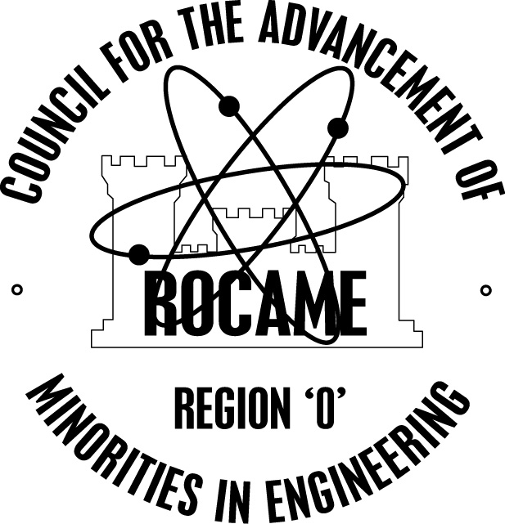

Region ‘O’ Council for the Advancement of

Minorities in Engineering

2018 ROCAME SCHOLARSHIP

The ROCAME organization plans to award $1000 scholarships to outstanding ROCAME graduating seniors who plan to pursue careers in a technical field of study. The purpose of the ROCAME scholarship is to encourage talented minority students to enter technical fields of study. The scholarship process will be administered by the ROCAME scholarship committee.

Eligibility Criteria
Students must meet the following criteria in order to apply for the scholarship:
- Must be a graduating high school senior
- Must be in the top quartile of the graduating class
- 3.0 or greater GPA
- Must be an active member of ROCAME with evidence of participation in one or more regional ROCAME events (Jamboree, Electrogames Training, Robotics, etc.).
- Planning to major in a technology discipline (i.e. engineering, math, science, technology).
- Accepted into an accredited college or university with an associated discipline.

Deadline
Completed applications must be submitted to the ROCAME school system coordinator for review by March 30, 2018. The school system coordinator must submit applications to the ROCAME Board by April 6, 2018.

Applicants must submit a complete application package. The application will not be considered unless the application is completed in its entirety.

2018 SCHOLARSHIP APPLICATION

Applications must be typed or written legibly in black ink.
Personal Information (Please complete the entire application)

Name: ______________________________________________________________________
Last First Middle Initial

Present Mailing Address: __________________________________________________
__________________________________________________
Telephone ____________________________
Permanent Mailing Address: __________________________________________________
__________________________________________________

Name of person at permanent address who will know how to contact you in the future:

____________________________________ Relationship ________________

Academic Information:

High School: _______________________________________________________

Address: _________________________________________________________

What is the size of your high school class? __________

What is your academic rank in that class? ____________________

What university are you planning to attend?_______________________________

Academic Major? ___________________________________________________

Employment History
Please list your employment experience (full-time, summer or part-time) with the most recent experience first.

Date employed Company Name/Address Position Title Salary

2018 ROCAME SCHOLARSHIP

About Yourself
Specify your ROCAME activities from grades 6-12 detailing your participation in regional ROCAME events, school-level ROCAME events , ROCAME offices held, and ROCAME awards received (attach an additional sheet if necessary).

What are your career plans (e.g. professional interests and goals)?

What do you feel are your most significant accomplishments so far in your life?

Personal and Business References:
Please list at least two references in the space provided. Include at least one faculty member who knows you well and/or past supervisors. Names, titles, business address and phone number are required.

Name: ___________________________________ Title ____________________________

Address:__________________________________________ Telephone ________________

Name: ___________________________________ Title ____________________________

Address:__________________________________________ Telephone ________________

Student's Personal Statement
Please attach a minimum 250 word essay (typed) on why you would like to pursue a career in a technical field. Also include an official transcript with the application. Deadline for application: March 30, 2018 to your ROCAME school system coordinator for review and submission to ROCAME Board. The school system coordinator must submit applications to the ROCAME Board of Directors by April 6, 2018.

2018 ROCAME SCHOLARSHIP
Certifications

I certify that all of the information included in my application for this award, including listings of activities and awards, and personal statements, are my own work and are accurate and honest to the best of my knowledge.

______________________________ ___________________________ ____________
Student Name Student Signature Date

Signatures

If the applicant is under the age of 18, following statement must be reviewed and signed by the parent:
I, parent/guardian of the above named student, grant permission for the ROCAME Board of Directors to use my child’s biographical information and photograph to publicize receipt of this scholarship. I also consent to have a copy of my child’s application and all supporting materials retained by the ROCAME Board of Directors and understand that information may be made available to scholarship donors, and potential donors.

______________________________ ___________________________ ____________
Parent Name Parent Signature Date

OR
I DO NOT give my consent

______________________________ ___________________________ ____________
Parent Name Parent Signature Date

If the applicant is over the age of 18, the applicant should review and sign the following statement:
I grant permission for the ROCAME Board of Directors to use my biographical information to publicize receipt of this scholarship. I also consent to have a copy of my application and all supporting materials retained by the ROCAME Board of Directors and understand that it may be made available to scholarship donors, and potential donors.

______________________________ ___________________________ ____________
Student Name Student Signature Date

OR
I DO NOT give my consent
______________________________ ___________________________ ____________
Student Name Student Signature Date

