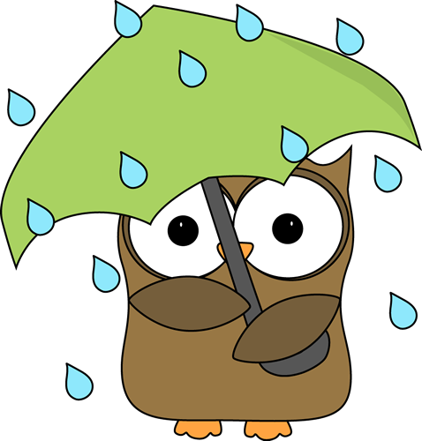

The Green Level Open was a rain out.
If rescheduled we will post it here on the website.

