LANCASHIRE PLACE NAME SURVEY

2018 Annual lecture

Tuesday 9 October 7.00pm
Lancashire Archives, Bow Lane Preston, PR1 2RE

Emeritus Professor Diana Whaley
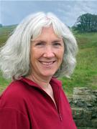

From Botany Bay to Seldom Seen: classifying minor names in Lancashire and Northumberland.

Booking form

Tickets cost £5each and must be purchased in advance

Name:
Address:

Email:

Please send this order form and a cheque payable to Lancashire Place Name Survey to:
LPNS, Jennifer Holt, 258 Blackburn Road, Haslingden, BB4 5JF by Friday 5th October
(Tickets will only be sent out by second class post where it is not possible to confirm by email)

