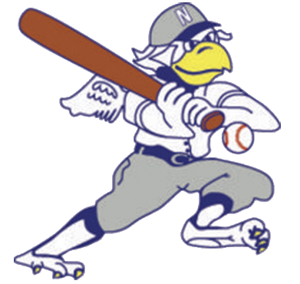
Nevada Griffons
2023 Youth Baseball Camp
The 2023 Youth Baseball Camp hosted by the Nevada Griffons will soon be at Lyons Stadium! Kids, ages 5-14, will receive instruction, drills & games with the players during their age session, so bring a glove & bat if they have one! All participants will receive a Nevada Griffon camp t-shirt & participation certificate at Camp Graduation, where they will also get to join the Griffons out on the field during the National Anthem.
Ages 9-14
Friday, June 16th 9:30am - 12:00pm
Ages 5-8
Monday, June 19th 10:00am - 12:00pm
Camp Graduation
Sunday, June 25th Sign in at 6:15pm
*In the event of rain, listen to KNEM/KNMO radio or check the Nevada Griffons FB page*

Registration Fee: $10.00 Cash or checks payable to Nevada Griffons.
Please complete the following in print.
Name: _______________________________________________________________________
Age Group (please check one): 5-8 ______ 9-14 ______
Phone # in case of emergency _____________________________________________________
Parent/Guardian Name ___________________________________________________________
T-shirt Size (shirts run small): YS YM YL AS AM AL AXL
Registration forms may be turned in at camp on the day of, or ahead of time at either:
Rinehart Jewelry, 120 S Cedar or Nine Patch Quilts, 129 E Walnut

