Kennedy High School
Advisor: Barry Wilson
Crew Chief: Hunter Torrey-McAdam (12th Grade)
Driver: Unknown
Documentation Writer: Julia Hefel (11th Grade)
4545 Wenig Rd. NE, Cedar Rapids, IA 52402
319-784-7697
BWilson@cr.k12.ia.us
2/1/17-2/28/17
20 Car, Class 1
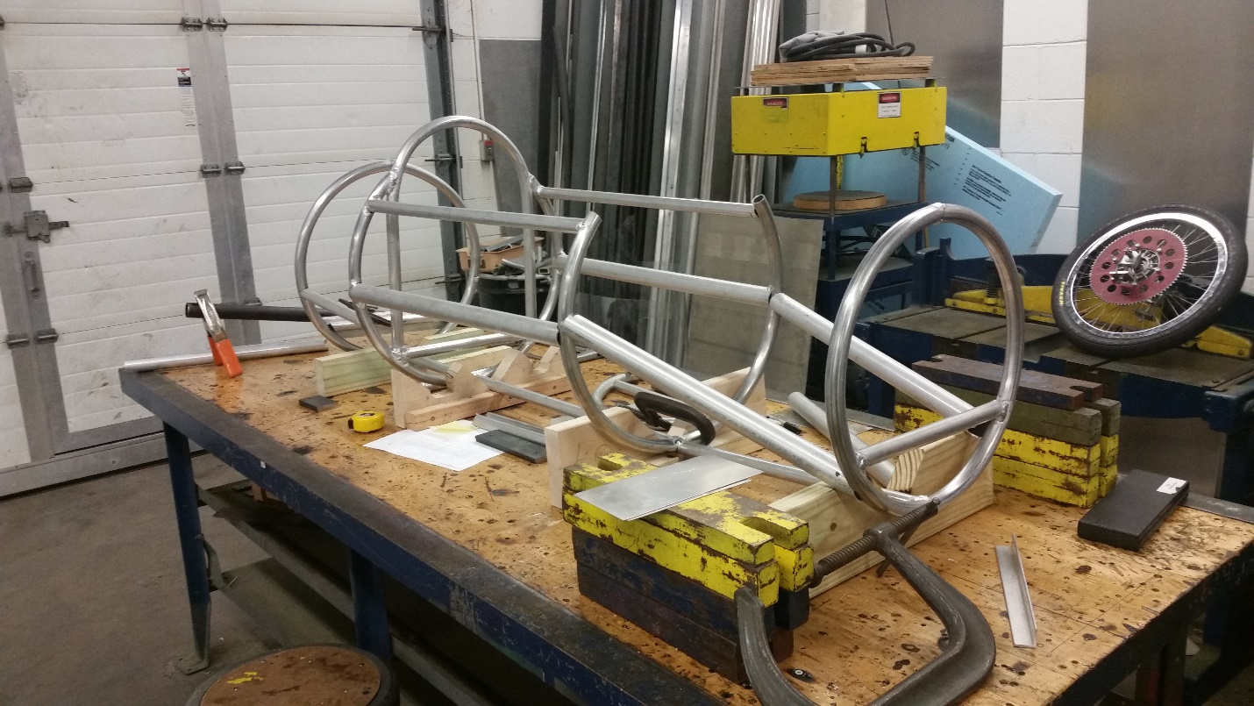
Over the month of February, Hunter completed bending all the aluminum pipping into circles for the chassis of the 20 car. He also constructed the roll bar for the chassis. It took a week or so to construct this roll bar because it is welded to one of the circles of aluminum piping that he bent. Currently Hunter is working on cutting the aluminum pieces that connect each one of the circles to complete the chassis shape. The progress is slow and steady for this aspect of construction because he does not want to waste aluminum by making mistakes. Next month, the goal is to have the chassis done and complete the axle. Hopefully after construction, electrical and body work will be completed a lot faster.

Kennedy High School
Advisor: Barry Wilson
Crew Chief: Jamie Voorhees (11th Grade)
Driver: Julia Hefel and Jamie Voorhees
Documentation Writer: Julia Hefel (11th Grade)
4545 Wenig Rd. NE, Cedar Rapids, IA 52402
319-784-7697
BWilson@cr.k12.ia.us
2/1/17-2/28/17
30 Car, Class 2
Over the month of February, Jamie completed the frontal impact bars which she had started in the end of January. All they needed was to be welded in, so that was finished in a short amount of time. The big project for this month was adding hand and knee guards to the chassis. These guards are needed to insure that Jamie and Julia’s hands and knees are in the chassis. Jamie took a lot of time bending pipping for these guards so that they were symmetrical on each side of the chassis. After the guards were welded on, the chassis was complete. Her next step was doing all the electrical work for the car. Once everything was wired, she hooked batteries up to the car and everything worked smoothly. The last thing Jamie was working in February was adding foam pipping to the bars of the chassis for the safety rule.
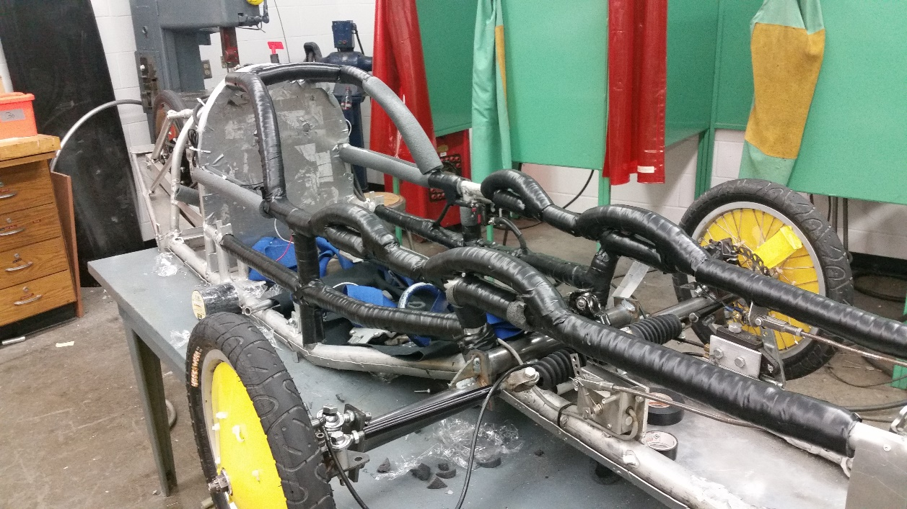
For the month of March, Jamie plans on finishing all the safety aspects of the car and working on constructing a new tail.

Kennedy High School
Advisor: Barry Wilson
Crew Chief: Derek Severson (10th Grade)
Driver: Molly Sullivan and Hance Throckmorton (12th Grade)
Documentation Writer: Molly Sullivan (11th Grade)
4545 Wenig Rd. NE, Cedar Rapids, IA 52402
319-784-7697
BWilson@cr.k12.ia.us
2/1/17-2/28/17
40 Car, Class 1
During the month of February, Derek has made modifications to the axle from last year so that it works with this year’s car design. Upon finishing this, he was able to take it off of the table with mounts, and put it on a regular metal table to finish construction. Once the axle was in, he was able to put in the steering mount and figure out where the mounts for brakes and throttle can go. We ran into problems when it came to installing the brakes due to the cords getting caught on components of the steering rack and kinking because of the length of the brakes cables. Next month we will work on finishing the structure of the chassis including the frontal impact bar.
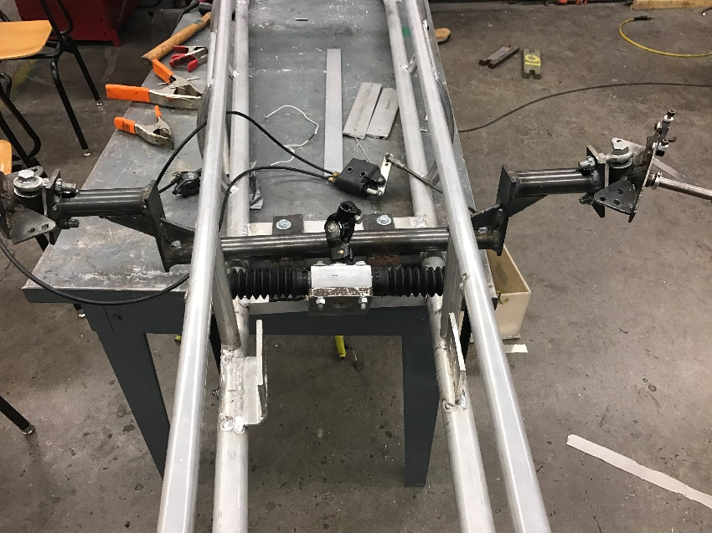

Kennedy High School
Advisor: Barry Wilson
Crew Chief: Ian Carlson (12th Grade)
Driver: Natalie McAllister (11th Grade) and Ian Carlson
Documentation Writer: Julia Hefel (11th Grade)
4545 Wenig Rd. NE, Cedar Rapids, IA 52402
319-784-7697
BWilson@cr.k12.ia.us
2/1/17-2/28/17
50 Car, Class 1
Over the month of February Ian completed the steering column and swing arm as planned. The biggest issue with the swing arm was setting it so the back end of the car did not sit too high or too low. Ian spent over a week trying different shocks to get the height of swing arm just right. Bolting the steering column in the chassis was a day project with no mentionable issues. Also this month Ian enlisted the help of some of the newer students of Cougar Electric Car to shape and rivet the belly pan on to the chassis. One issue that arose during this project was finding a faster way to cut the sheet metal because using sheers was taking too much time. So, Ian took the sheet metal to a plasma cutter and the sheet metal was cut in less than 10 minutes. Once the belly pan was placed underneath the car, riveting it to the chassis took only a couple of days.
The goal for the month of March is to have the car completed and ready to start testing before racing begins in April. For the 50 car, this means that the car needs wheels, a body, and foaming completed.
