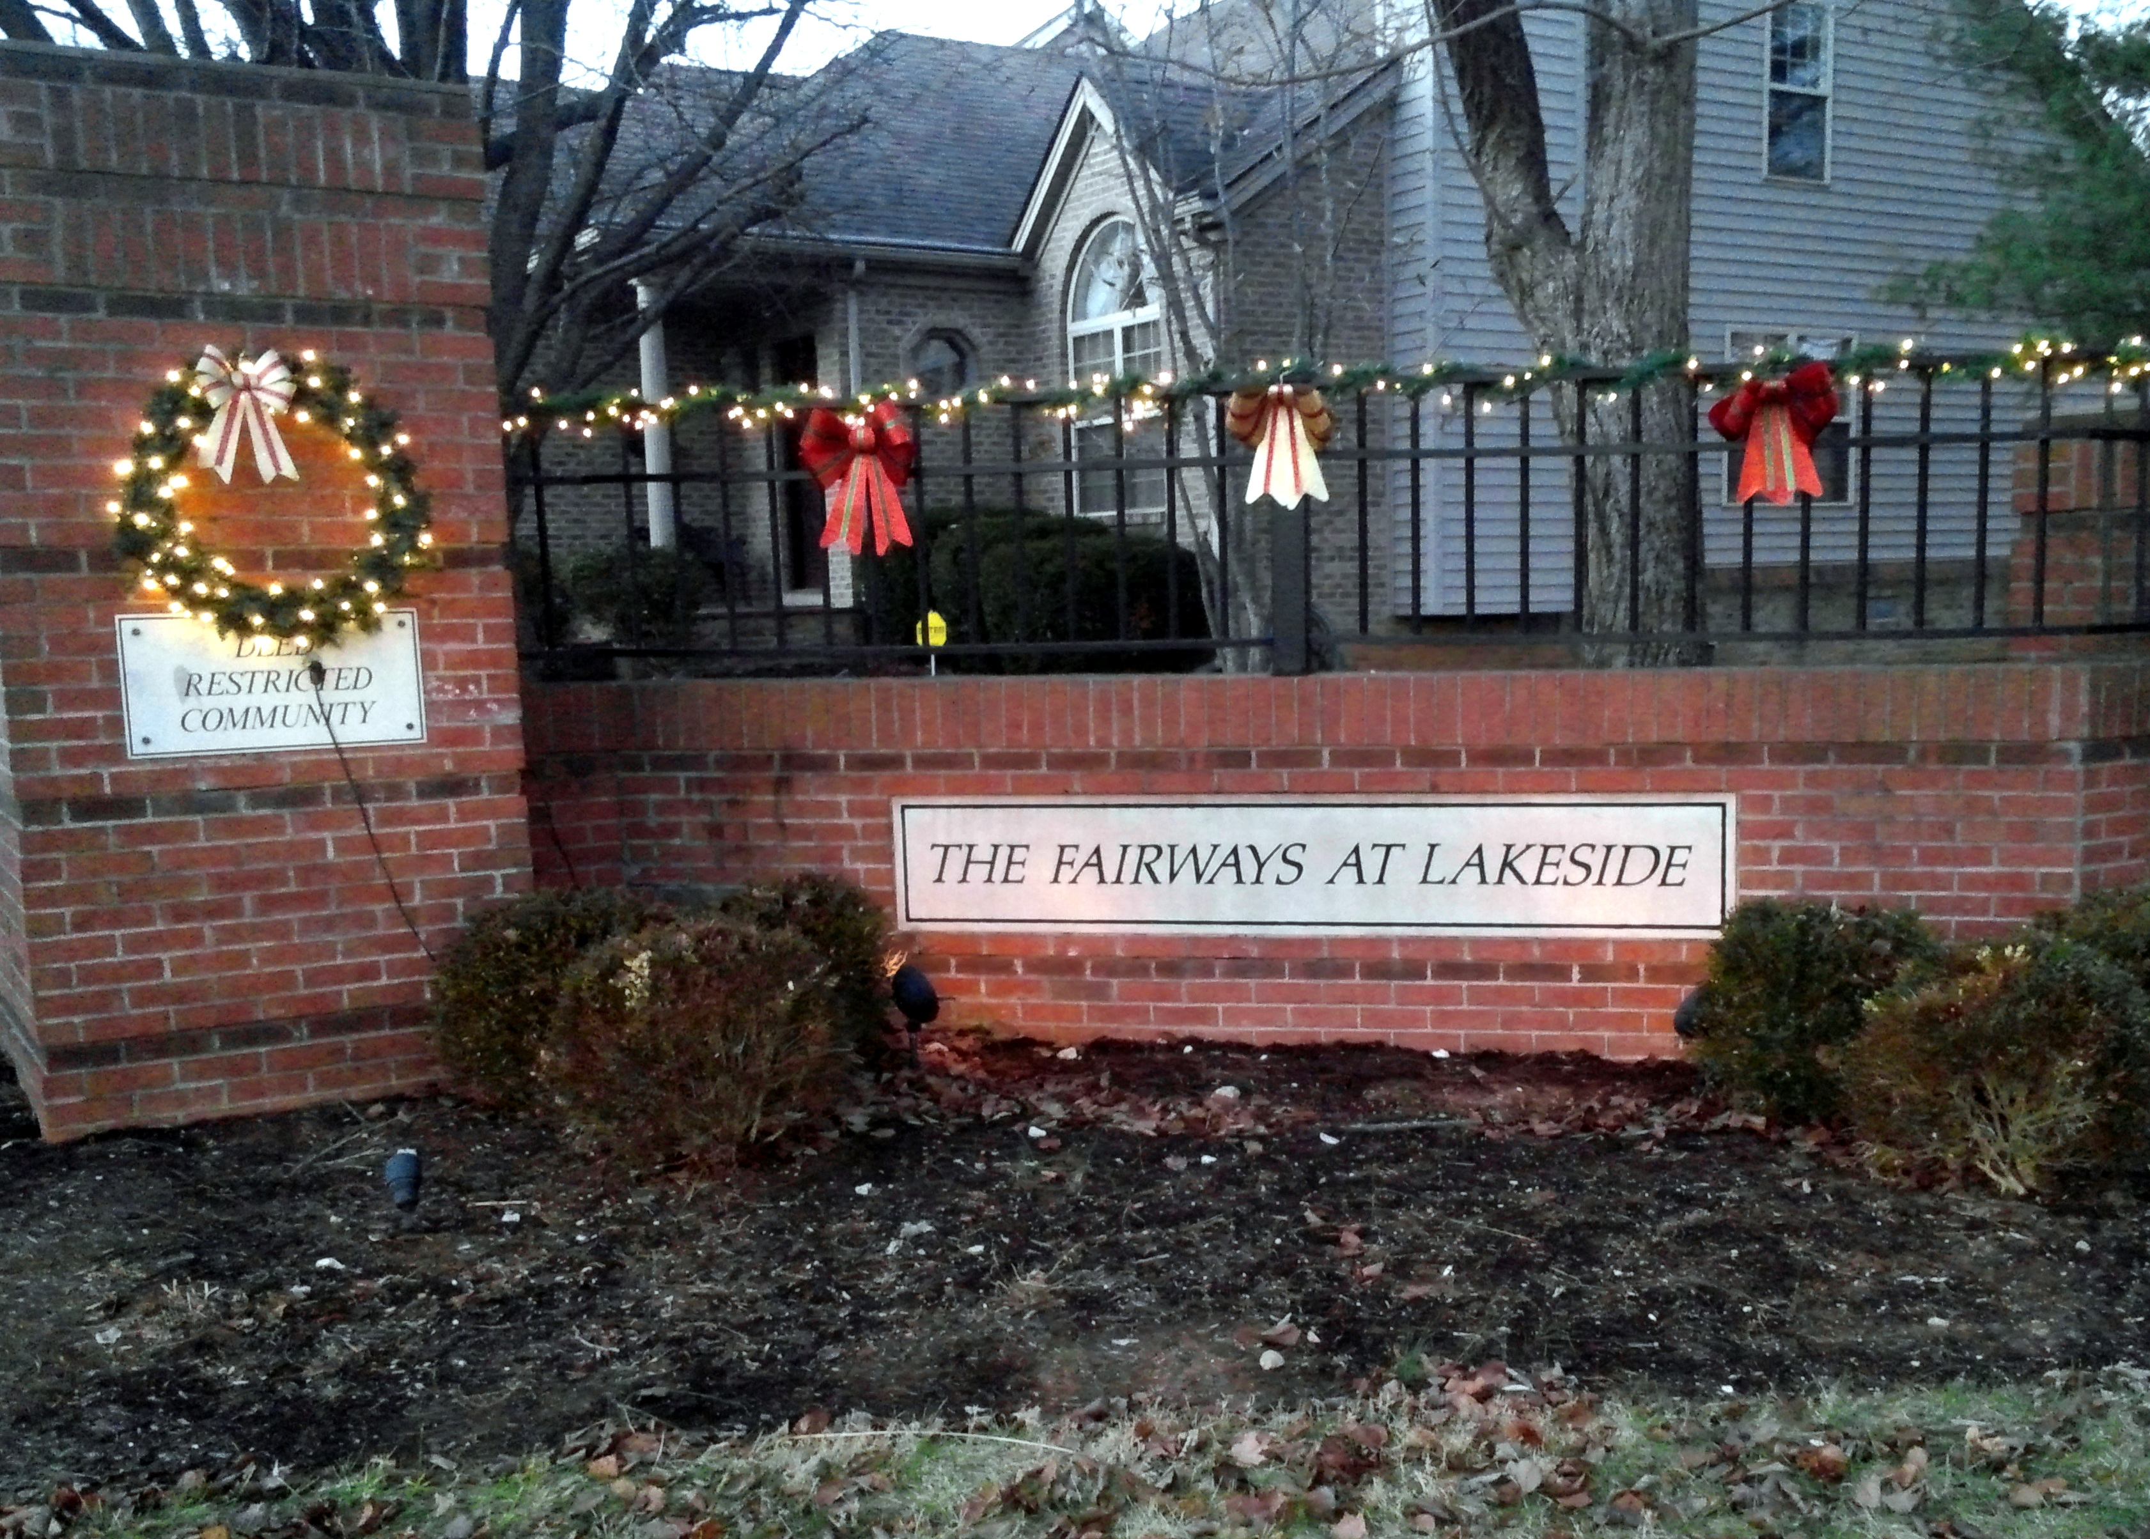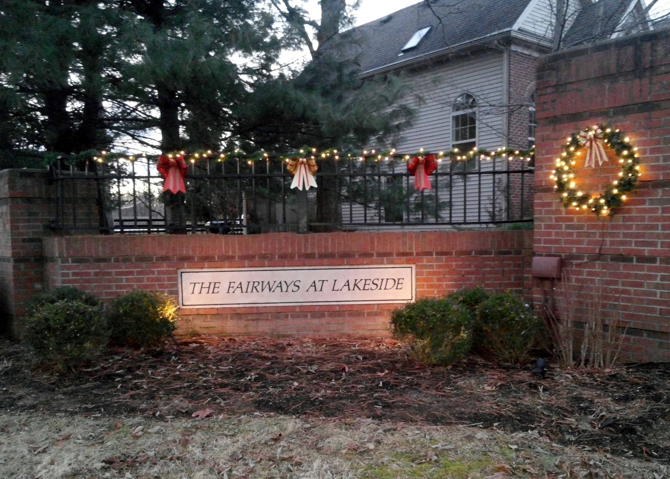
Fairways at Lakeside Community Association Newsletter
January 2019

A Word from Our President

Happy New Year 2019!! I hope everyone had a great end to 2018.

I want to send a BIG THANK YOU to Gary Renner, John Kreitzman, Jonathan Groth, Kevin Wilder, Jennie Hale and Tiffany Compton – the 2018 Officers and Board, for all your help and support throughout the year.

Thank you also to Marty Surbaugh for stepping up to be a Board Member again starting 1/1/19 for 3 years and to all the Officers that agreed to serve again in 2019.

We are in serious need of additional homeowner support and participation. Many of the current Board and Officers have served for a number of years and would like to start phasing out of service. It is time for new participation on the Board. As a homeowner, you should want to be involved in how our homeowner association is run and in protecting the unique nature of our neighborhood.

Faced with lack of participation from additional homeowners we are seriously considering outsourcing some of the administrative duties of the Treasurer. What does that mean to each homeowner – increased annual fees!! If we cannot get additional support from homeowners, we may be forced to raise annual fees to cover the outsourcing costs. Please contact me or John Kreitzman if you are able to help.

Please be sure to take the time to thank your past and current Board and Officers when you see them for volunteering their time. Our neighborhood is small and special and the Board and Officers try to make decisions that will keep it special for all.

Robin C. Gall
President
Treasurer’s Report

As of November 30, 2018, John Kreitzman reports the following FALCA account balances:

Checking Account: $10,203.48
Certificate of Deposit #1: $ 6,119.33
Certificate of Deposit #2: $ 4,225.94
Certificate of Deposit #3 $ 5,097.77
Total FALCA Funds: $28,192.49

John reminds us that Annual Fees are due by January 31, 2019. Your fee invoice is enclosed with this newsletter.

2018 Association Annual Meeting Recap

The 2018 Association Annual Meeting was held on December 4, 2018 at Morning Pointe of Lexington East. We had 13 homes represented (16 people) at the meeting.

Robin Gall reviewed the Board’s activities in 2018 and John Kreitzman presented the 2018 Treasurer’s Report and 2019 Proposed Budget. After discussion, the Association approved the 2019 Budget.

Marty Surbaugh was elected to a 3-year Director position. The following officers were voted in for 2019:
Robin C. Gall President
Gary Renner Vice President
John Kreitzman Treasurer
Jonathan Groth Secretary

In addition to reviewing expenses for 2018 and approving the proposed budget for 2019, a couple of homeowners voiced concerns with the following issues:
- MetroNet’s placement of boxes in homeowners’ backyards, future issues with the boxes and responsiveness from MetroNet regarding said boxes. Alisha Kamran at 3612 Green Park Court has spoken with Council Member Worley and Advocate Amber Dietz. Contact Alisha if you also have concerns.
- Issues with neighborhood kids being unsupervised during snow days, breaks and summer vacation and causing mischief.
- Safety concerns were voiced with regard to cars parked in the street, in front of mailboxes and parking over the sidewalk causing children and walkers to have to walk in the street.
- Recommendation was made to have video cameras installed at the entrance to record all vehicles coming in and out of the neighborhood due to increase in neighborhood crime.

Thank you to everyone who attended and participated in the meeting. We welcome any and all homeowners to join us for our monthly meetings. Please see the 2019 Board Meeting schedule listed in this newsletter or the website.

Please welcome the following new homeowners:
- 3648 Fair Ridge: Andrea Lynn Lewis
- 3644 Green Park Court: Elijah & Alexandria Zimmerman
- 3601 Green Park Court: Chad Pelfrey
- 3628 Green Park Court: Gopal & Padma Nepal
- 3633 Park Pointe Drive: Raymond & Shelley Goodearl

Just a reminder, our Snow Removal Policy is to have our community automatically added to the snow removal contractor’s list if 4 or more inches of snow are projected at one time. If less than 4 inches is projected, the Board will still require 3 or more Directors to approval snow removal.

Please be sure to shovel your sidewalks in addition to your driveway. LFUCG ordinances requires homeowners to clear sidewalks.

2019 Fee Notices are included with this newsletter. Please be sure to make your payment before 1/31/19 to avoid late fees.

As a reminder, please do not park your vehicles or allow guests to park their vehicles in front of mailboxes. The postal service will not deliver mail when there is a car parked in front of the mailbox.

Thank you to Gary Renner for putting up all of our decorations at the entrance to the community over the past year. The lights, wreaths and bows sure brighten up our entrance. Thank you for all your work in keeping our community festive.

2019 Board Meeting Schedule

The following is the proposed Monthly Board Meeting Schedule for 2019. Dates are subject to change. If you would like to come to meetings or be advised of changes please contact Robin Gall at rgall30539@aol.com.

January 15, 2019 7:00 pm
February 19, 2019 7:00pm
March 19, 2019 7:00 pm
April 16, 2019 7:00 pm
May 21, 2019 7:00 pm
June 18, 2019 7:00 pm
July 16, 2019 7:00 pm
August 20, 2019 7:00 pm
September 17, 2019 7:00 pm
October 15, 2019 7:00 pm
November 19, 2019 7:00 pm
December 17, 2019 7:00 pm

Meetings are held at Robin Gall’s home, 3693 Park Pointe.

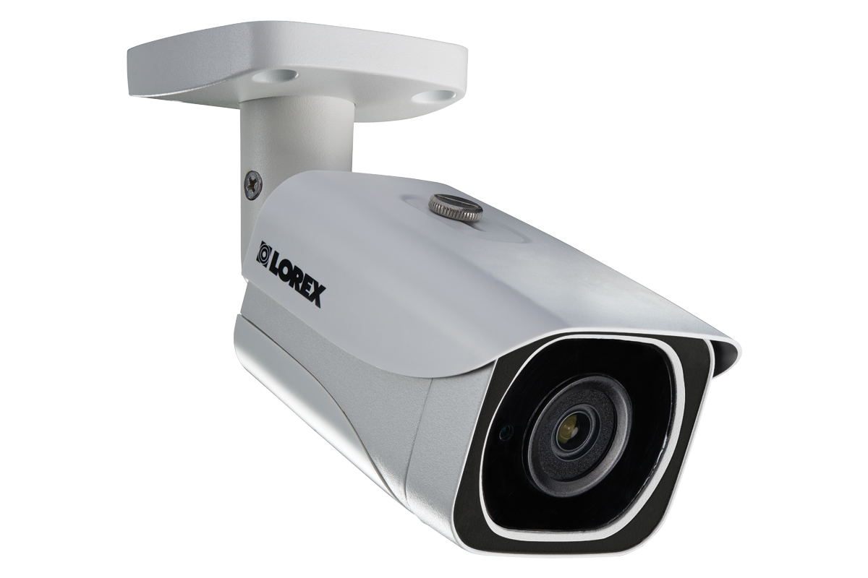
The Board is considering installing security cameras at the entrance to the neighborhood to record all vehicles entering and leaving the community.

All non-resident homeowners, please notify the Board when you rent your home by emailing your renter’s information to rgall30539@aol.com. Renters are subject to the same rules as homeowners. It will help the Board to reach out to renters if we know their names and contact information. We will only contact renters if there is a problem or if there is a neighborhood emergency.

Do you have a management company taking care of your property? Please let us know this information as well.

FALCA Homeowner Alerts

Are you part of the emergency alert email system we have established for the neighborhood? This past year we had 2 Homeowner Alerts issued due to robberies in and near the neighborhood. Please be sure to complete and return the annual homeowner information sheet and let us know if you want to be included. All contact information is held in confidence by the Board and is not released to other homeowners without your permission.

Did you know…

- If a holiday occurs or is observed on a Friday, trash pickup is the Wednesday before the holiday!!
- The Fire Department’s Fire Prevention Office will come to your house and install smoke alarms for FREE. Call 859-231-5668 to make an appointment.
- Contact LexCall 311 with request for special garbage collection needs, dead animal pickup, to report potholes, to contact the Mayor’s office or Council Office.
- The Fire Department has a Car Seat Education Program. Call 859-455-7928 to schedule a class on correctly installing a car seat.

Contact information for Officers and Board Members: Please always feel free to contact a Board Member or Officer when you have a question or concern. The Board and Officers will do their best to resolve any issues or answer questions that are brought directly to their attention. It is hard to know how to handle situations that we hear about indirectly. Please remember that your Board Members and Officers are volunteers who give freely of their time to help keep our neighborhood a wonderful place to live. We need your input and your support.

Director/President: Robin C. Gall 806-8843 rgall30539@aol.com
Vice President: Gary Renner 264-0069 garyrenner@windstream.net
Treasurer: John Kreitzman 272-1524 johnbkreitzman@gmail.com
Secretary Jonathan Groth 480-310-1108 jrgroth@gmail.com
Director: Kevin Wilder 227-5323 kwilder701@gmail.com
Director: Tiffany Compton 606-422-5712 tcompton0427@gmail.com
Director: Jennie Hale 327-9621 jennie.hale02@gmail.com
Director Marty Surbaugh 278-8728 msurbaugh1@gmail.com

