Kennedy High School
Advisor: Barry Wilson
Location: 4545 Wenig Rd. NE, Cedar Rapids, IA, 52402
Phone Number: 319-784-7697
bwilson@cr.k12.ia.us
John Tedesco, Grade 12, Crew Chief/ Driver
Collin Flannagan, Grade 9 Assistant Crew Chief
Brian Stubblefield, Grade 9 Documentation Writer

983 or A983 February Monthly Report
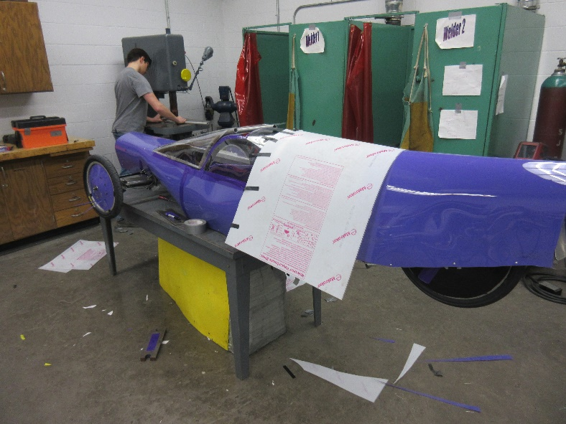
John Tedesco and Colin Flannagan have been working overtime for the past month to get the 983 on wheels by March 1st. In the past month, they have successfully put a plastic exterior on the car, made a new tail from scratch, put all the wheels on the car, and made his new canopy. They also made yet another new nose.
The graphics team has made our shirt design for the year and is getting ready to mass-produce them over the coming weeks. Rodrigo Sagastume, our graphics person, also took time to make the 983’s number board at short notice for our Incoming Freshman Orientation. Orientation went well, and we think we have recruited several new members for the upcoming 2020 season.
The batteries team has successfully set up the dyno tester and is running battery tests on our old A and B battery sets to see how well the batteries would perform in the upcoming racing season.
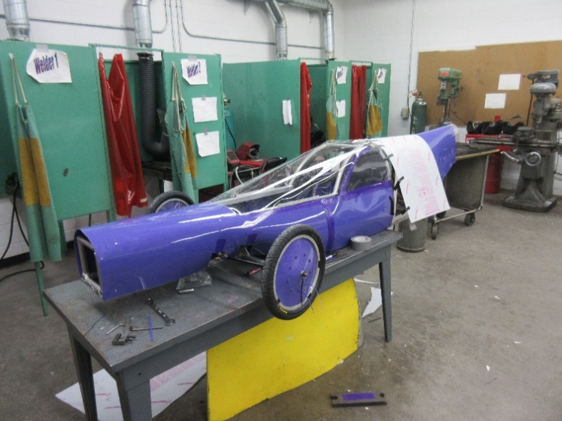
Telemetry has run into a series of problems that were not explained in the documentation they received and are working their hardest to fix them.
Following several changes between semesters 1 and 2, Dennis Davis from documentation has moved to the battery team which was down to one person. Brian Stubblefield moved from telemetry to documentation and will be assisting telemetry when he can.

