Kennedy High School
Advisor: Barry Wilson
Crew Chief: Jamie Voorhees (11th Grade)
Driver: Jamie Voorhees
Documentation Writer: Natalie McAllister and Molly Sullivan (11th grade)
4545 Wenig Rd. NE, Cedar Rapids, IA 52402
319-784-7697
BWilson@cr.k12.ia.us
3/1/17-3/31/17
30 Car, Class 2
During the month of March, Jamie has worked on designing and constructing a new tail for her car with the help of Collin Wheat. The new tail was needed to fit the new design of the car and be more aerodynamic than if she had kept the previous tail. Jamie has also cut out panels for the body of the car and has gotten most of them attached to her car.
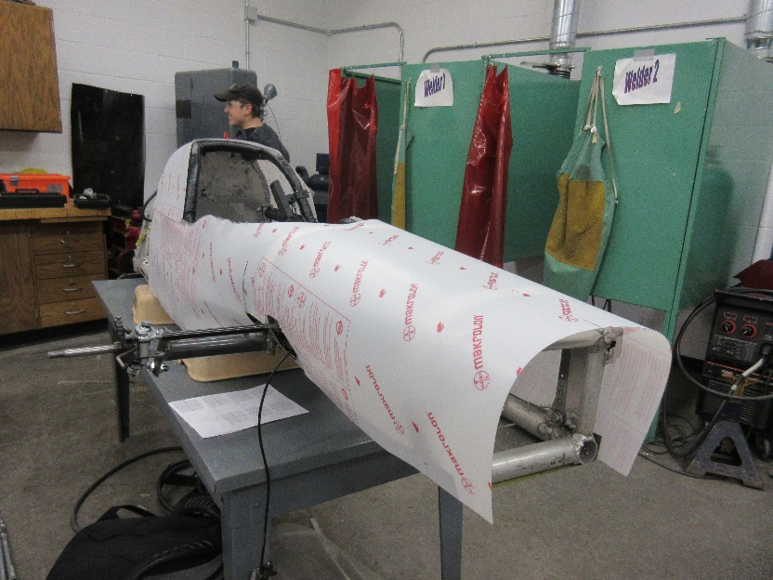
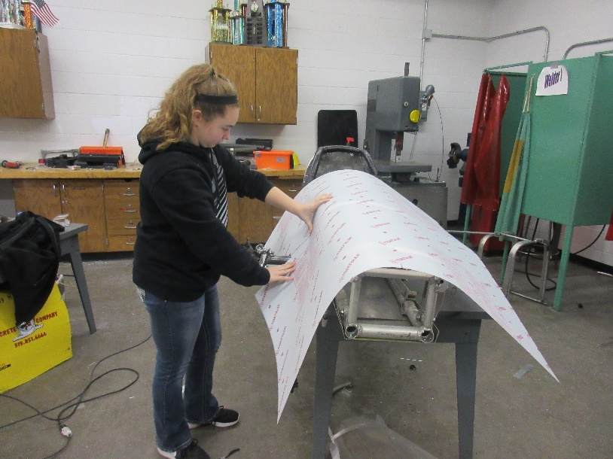
The goal for the remainder of the month is to get the panels painted, which should not take much time. After that, it is just final testing to make sure the car is running the way we would like for racing.

Kennedy High School
Advisor: Barry Wilson
Crew Chief: Barry Wilson, Joey Shoemaker (11th grade)
Driver: Unknown
Documentation Writer: unknown(11th Grade)
4545 Wenig Rd. NE, Cedar Rapids, IA 52402
319-784-7697
BWilson@cr.k12.ia.us
3/1/17-3/31/17
20 Car, Class 1
During the month of March, we had a week long break for classes which Barry used to finish the construction of the car. We changed crew chiefs due to another crew chief needing Hunter’s help to complete his car. The car now has a completed chassis, along with steering and pedals installed. The main complication faced is that Barry is in high demand among the cars for welding, limiting the time he has some days to work on the 20-car.
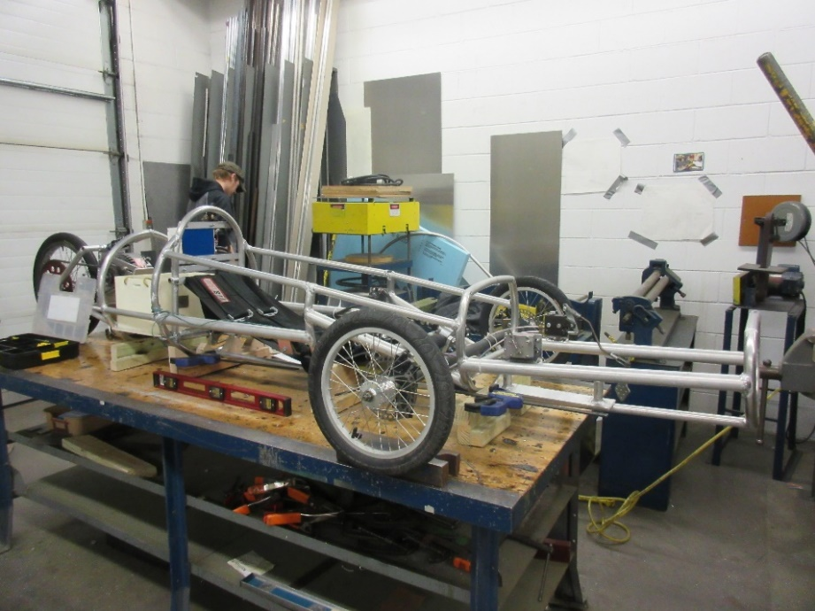
The remainder of the month will be spent getting the final electrical components set up as well as all the safety elements (foam and harness). The car will then undergo testing to make sure everything works before the car races.

Kennedy High School
Advisor: Barry Wilson
Crew Chief: Derek Severson (10th Grade)
Driver: Molly Sullivan
Documentation Writer: Molly Sullivan (11th Grade)
4545 Wenig Rd. NE, Cedar Rapids, IA 52402
319-784-7697
BWilson@cr.k12.ia.us
3/1/17-3/31/17
40 Car, Class 1

During the month of March, Derek has remade his axle so that it is the right height for the car and gotten the pedals installed where they need to be. He has also gotten all of the electrical components of his car installed and working. Regarding the structure of the car, he cut out the belly pan and has attached it to the car.
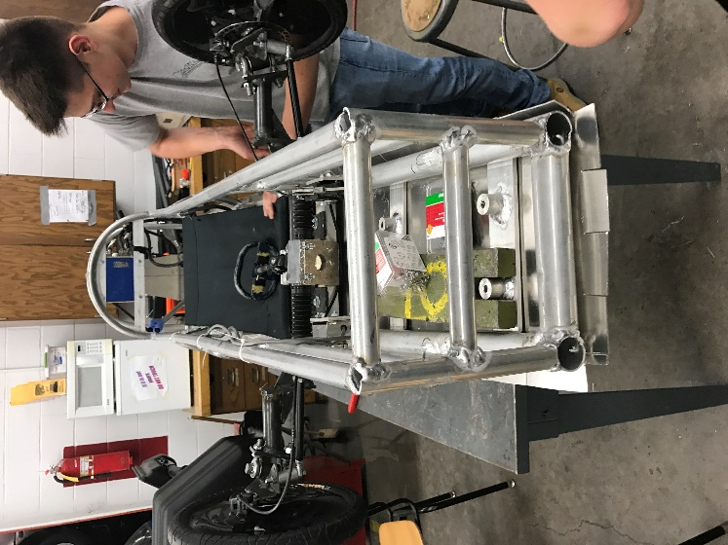
The remainder of March and first week of April will be spent installing seat belts, installing the foam, and cutting out and attaching the plastic body of the car. We will hopefully be able to test the car soon and make sure it drives.

Kennedy High School
Advisor: Barry Wilson
Crew Chief: Ian Carlson and Hunter Torry-Mcadam(12th Grade)
Driver: Natalie McAllister (11th Grade) and Ian Carlson
Documentation Writer: Natalie McAllister (11th Grade)
4545 Wenig Rd. NE, Cedar Rapids, IA 52402
319-784-7697
BWilson@cr.k12.ia.us
3/1/17-3/31/17
50 Car, Class 1
During the month of March, the 50-car team has been putting final touches on the car before the body can go on. This has included putting the foam around all of the metal tubing exposed to the driver. Before doing this, they had to get the pedals attached to the car and finish hooking up the brakes. Along with the work to the chassis, the fiberglass nose that they have been working on is in its final stage.
The rest of the month and start of April before racing will be spent getting the body cut out and put on the car as well as testing to ensure the car runs right.
