Community Talent Show
Come celebrate 50 years of performances with us!
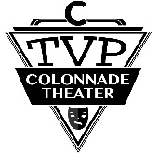Twin Valley Players (since 1970) 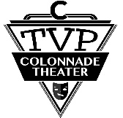
All proceeds will be donated to Randy Geyer and family. Randy has been a hardworking volunteer for Twin Valley Players for many years, but suffered a severe Stroke in September of 2019. He is working hard toward a recovery.
Drop off completed forms at the Colonnade Theater or mail to 269 Center Street, Millersburg, PA 17061. ENTRIES MUST BE RECEIVED NO LATER THAN DECEMBER 27, 2019.
*Singing with music accompaniment is allowed, but there must be no voice on the accompaniment. If you are singing or performing to music, you must include a CD of your backing track at first rehearsal or before.
WHEN: Show night January 18, 2020 at 7:00pm. Rehearsals January 6th and 13th at 6:00pm
WHERE: TVP Colonnade Theater, Millersburg PA
WHO: Everyone welcome
$5 registration fee per act
Prize awards decided by audience vote. Silent Auction. Bake sale.
_____________________________________________________________________________________
Name of participant: ___________________________________________________________
Name of parent if under 18:______________________________________________________
Address: _____________________________________________________________________________
Phone: ______________________ Talent: __________________________________________________ Selection: ____________________________________________________________________________ (Not to exceed 5 minutes, on stage and off included)
List any special equipment needed for your act:______________________________________________
Tell us a little about yourself; occupation, school, interest, hobbies, etc. __________________________________________________________________________ __________________________________________________________________________ __________________________________________________________________________

