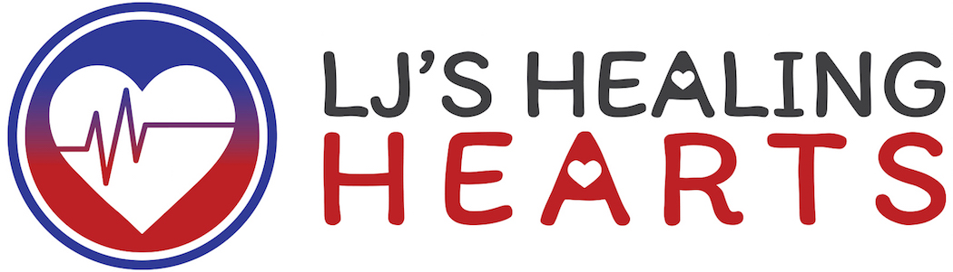

6th Annual “Have a Heart” Sponsorship Opportunities
*sponsorship must be confirmed by 6/15 to appear on event invitation

Elite Sponsor - $5,000
- Full page advertisement in program
- Logo placement on website – home page
- Logo on event invitation and event signage
- Logo on email blast regarding event
- Acknowledgement on Social media
- 10 tickets to event with reserved table
- Logo on wine tote
- Opportunity to provide promotional item with your logo in goodie bags
- LIMITED OPPORTUNITY! Signature Have a HEART crafted cocktail
(available to first paid sponsor only)

Platinum Sponsor - $3,500
- Full page advertisement in program
- Logo placement on website-home page
- Logo on event invitation and event signage
- Logo on email blast regarding event
- Acknowledgement on Social media
- 8 tickets to event with reserved table
- Opportunity to provide promotional item with your logo in goodie bags

Gold sponsor - $2,500
- Half page advertisement in program
- Logo placement on website – event page
- Event signage at Silent Auction table
- Acknowledgement on Social media
- 6 tickets to event
- Opportunity to provide promotional item with your logo in goodie bags

Silver sponsor - $1000
- Logo placement in program
- Logo placement on website-event page
- Event Signage at raffle table
- Acknowledge on Social media
- 4 tickets to event
          - Opportunity to provide promotional item with your logo in goodie bags

Bronze sponsor - $500
- Company name on website-event page
- Company name listed in program
- Acknowledgement on Social Media
- 2 tickets to event
- Opportunity to provide promotional item with your logo in goodie bags

