The Pickerington Senior Center

150 Hereford Drive

Pickerington, Ohio 43147

**Return Service Requested**

**BOARD OF TRUSTEES**

**Annabelle Marion / President**

**Jeanne Carroll Karen Edwards**

**Linwood Connell Larry Frazee**

**Bill Cook Jim Schumacher**

**Ed Drobina Vickie Witten**

---------------------------------------

NON-PROFIT ORGANIZATION

U.S. POSTAGE PAID

PERMIT NO. 4709

PICKERINGTON, OH 43147

---------------------------------------

**DECEMBER**

**2024**



**PICKERINGTON SENIOR CENTER**

**TELEPHONE: (614) 837-3020**

**FACSIMILE: (614) 833-6471**

**HOURS: MONDAY - FRIDAY**

**8:30 am - 4:30 pm**

**WEB PAGE:**  [**http://pickeringtonseniorcenter.org**](http://pickeringtonseniorcenter.org)

**DECEMBER CLOSURES**

Our Center will be closed on the following dates:

December 24th / Tuesday Christmas Eve

December 25th / Wednesday Christmas

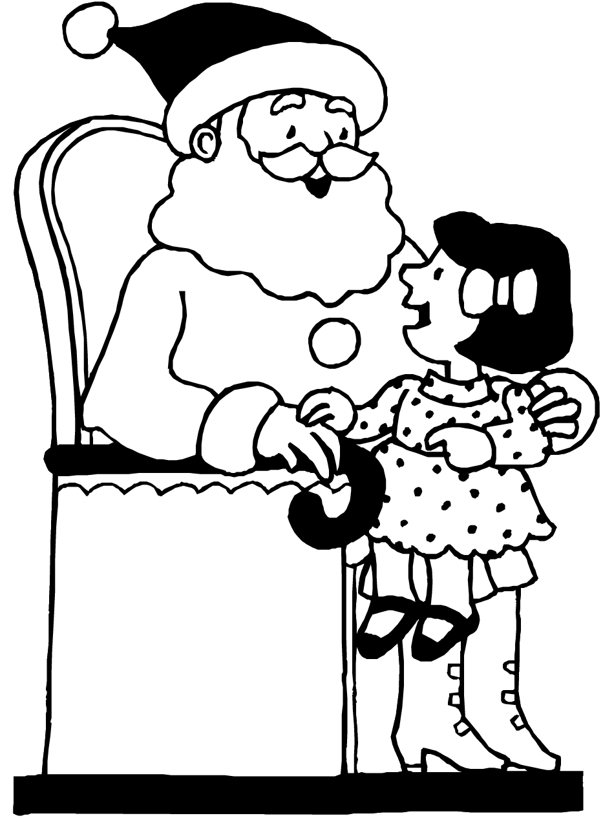

**ANNUAL BREAKFAST WITH SANTA**

**Saturday / December 7th**

Tickets for Breakfast with Santa are being sold by the Parks & Recreation Department at City Hall. There will be three seating times: 8:00 am, 9:30 am and 11:00 am. Tickets go fast! **No tickets will be sold at the event.** We will have the pancake breakfast and a Secret Santa Gift Shop run by our Craft Ladies. The Parks & Recreation Department will be helping the children make a craft item to take home.

Our staff and Board of Trustees wish Seasons Greetings to everyone - Merry Christmas, Happy Hanukkah, Happy Kwanzaa and Happy New Year!

**BOARD OF TRUSTEES ELECTION**

We will be electing three members to our Pickerington Senior Citizens Board of Trustees. The following Board member is up for re-election: Annabelle Marion.

In addition to Annabelle Marion, we have five members who have expressed a desire to join the Board: Patty Bond, Pat Carroll, Faith Hoek, Craig Kidwell and Marilyn Morgan. Their names will be on the ballot.

Linwood Connell and Larry Frazee are retiring from our Board. We thank them both for all the years they have served on our Board of Trustees.

The election will be held Tuesday, December 17th. Voting will occur from 9:00 am to 2:00 pm. Members who are unable to vote on Tuesday, December 17th, will have the opportunity to vote at our Center’s front office from 10:00 am to 1:00 pm Wednesday/December 11th, Thursday/December 12th, Friday/December 13th & Monday/December 16th. ***You must vote in person, your name will be checked off against a list of paid members, and your signature is required. You may not fill out a ballot for anyone else (spouse, parent, sibling, friend, etc.).*** The winners will be announced at the end of our Christmas Luncheon on December 17th.

**CHRISTMAS LUNCHEON**

**Tuesday / December 17th / noon – 3 pm**

Sign up in our office for our Christmas luncheon. It’s being sponsored by Amber Park, Brookdale and Embassy. The menu will consist of ham, scalloped potatoes, green beans, rolls, holiday punch and Christmas cookies. The entertainment will be provided by the talented Pickerington Central High School Chorale. **Please notify our office if you have signed up for this luncheon and then find you are unable to attend. We have a waiting list of members who would like attend.**

**VOLUNTEER OF THE MONTH**

We’d like to honor Faith Hoek as the volunteer of the month for December. She does our monthly newsletter, runs our Classic Movie, assists with running our Book Club, creates flyers for our Center, photographs our luncheons and volleyball tournaments, and makes up the photo posters we display on an easel in our main room. As a thank you, she will receive a $15 gift card and a reserved parking space for the month of December.

**BUILDING SUPERVISORS NEEDED**

We’re looking for members who would like to be a building Supervisor when we rent out our facility for a party or a meeting. They would open our building, make sure the renter has put away all tables & chairs and has cleaned up after their event before they leave our premises.

The Supervisor would stay in our building during the event and lock up after everyone has left. The pay is $15 per hour. If you’re interested, call our office at (614) 837-3020.

**HEAL2TOE FOOT CARE SERVICES**

**Thursday / December 19th / 9:00 am – 2:00 pm**

Tonia is a State of Ohio registered nurse.She charges $35.00 for the following:

30-minute treatment

Expertly trim, thin and file nails

Corns & callouses are filed and buffed smoothly

*All* tools are sterilized for each patient.

Payment is due at time of service. Self-pay only. Medicare and/or Insurance are not accepted. To schedule an appointment at our Center call Tonia at (614) 686-3646.

**NOODLES**

Our noodles are back! Both thick and thin noodles can be purchased in our office for $2.00 a bag.

**FAIRFIELD COUNTY CONGREGATE RESTAURANT**

**Mondays - Fridays / 11 am – 2 pm**

Bob’s Backyard BBQ, 80 West Church Street, Pickerington, has partnered with Meals on Wheels to open a new congregate restaurant site. To participate you must be a Fairfield County senior over the age of 60. If you’re interested in signing up to eat at this new congregate restaurant site, please call (740) 681-5050.

**2025 MEMBERSHIP DUES**

Please pay your 2025 yearly dues by January 1, 2025. Dues: Residents . . . . . . . . $15.00.

Non-residents . . . . $20.00.

If you turned 90 before January 2025, your membership is free.

If you have had a change of address or telephone number tell our office so that we can correct our records and you will continue to receive our newsletters.

**BOOSTER CLUB**

All donations, of any amount, are greatly appreciated. The donations are used for office & kitchen supplies and for activities not covered in our yearly budget.



We welcome the following new members to our Center and hope they’ll join us for some our activities: Carol Christy, Melanie & Timothy Debus, Sharon Jackson, Terry & Adrienne O’Deens, Denise Sayre, Vicki Schmoyer, Dave Suter, Cindi & Don Swisher, Doug VanBuskirk, Ellen Vonada, Shirley & Rudy Whitt.

**STRENGTH CLASSES**

**Mondays and Wednesdays / 10:00 – 11:00 am**

Join our strength classes, led by Kelley. Focus is on building upper and lower body strength by stretching & improving balance. If you have weights and exercise bands bring them with you. Exercise bands are available for purchase at class for $3.00.

**LINE DANCING**

**Mondays / 11:15 am – noon**

**December 9th, 16th, 23rd and 30th**

There will be NO LINE DANCING CLASS on December 2nd. You can pay $1.00 per class for each week you attend. For more information, contact our certified instructor Marilyn Morgan at [mnm1126@gmail.com](mailto:mnm1126@gmail.com)

**BID EUCHRE**

**Mondays / 12:30 pm**

Bid euchre is played at our Center every Monday.

**WATERCOLOR CLASS**

**Mondays / 1-3 pm**

Join our Watercolor Class. No prior training or talent necessary, just the desire to express yourself. Our office has a list of supplies you’ll need for the class.

**CORNHOLE**

**Tuesdays / 11 am**

We usually play cornhole every Tuesday. This month there will be no cornhole on December 17th which is our Christmas Luncheon, December 24th, Christmas Eve, or on December 31st, New Year’s Eve. Our tournament for December will be held on Tuesday, December 10th. The October tournament was won by Bill Dunnette and Larry Frazee. If you have any questions, call Doug Hoek at (201) 739-7241.

**TUESDAY AFTERNOON MATINEE**

**Tuesday / December 10th / 1:15 pm**

Join us for our movie “Christmas for a Dollar,” featuring Brian Krause, Nancy Stafford and Ruby Jones. This movie was inspired by a true story. We’ll supply the movie, popcorn, snacks and bottled water. Use our chairs or bring your own folding chair. If you have any questions, contact Faith or Doug Hoek at (201) 739-7241.

**BINGO**

There will be NO BINGO this month. In 2025, we will resume playing Bingo on the fourth Tuesday of each month at 1:00 pm. Join your frinds on January 28th.

**FRIENDLY TIES SQUARE DANCING**

**Tuesday Evenings**

**December 3rd, 10th and 17th / 7:00 – 9:00 pm**

Dance lessons are given on Tuesday evenings. Square dances in December will be held on Sunday/December 1st from 7:00 to 9:30 pm and Sunday/December 15th from 7:00 to 9:30 pm.

|  |  |
| --- | --- |
| **DUPLICATE BRIDGE Wednesdays / 9:30 am** | **BRIDGE**  **Thursdays / 12:30 pm** |

We’re looking for more members to play. The cost is $1 per week for either Bridge or Duplicate Bridge. The money is returned to players as prize money. Call our Center and give your name & phone number.

**CRAFT GROUP**

**Wednesdays / 10 am - noon**

This group offers a variety of fun craft activities. It also raises money for our Center. Our biggest fundraising event is at our Breakfast with Santa, which will be held this year on Saturday, December 17th.

**Wednesday/ December 18th / 1:00 pm**

Darlene is returning with Diamond Painting Dot Kits. Kits are usually $3.00 each and contain everything you need to make a beautiful project.

**EUCHRE**

**Wednesdays / 12:30 pm**

Join your friends and play euchre. The cost is only $2.25, which includes the games and the loner pot. Please arrive at least 10 minutes ahead of time to get signed in so that we can start on time at 12:30.

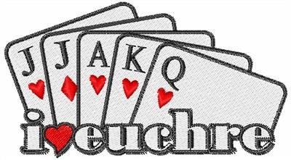

**CREATIVE WRITING GROUP**

**Wednesdays / 1 pm**

We meet every Wednesday. It’s a chance to share what you’ve written or would like to write, to get feedback, tips and ideas from others in a relaxed and fun setting. Your writing can be poetry, fiction, or non-fiction and may even appear on our Center’s bulletin board. Brenda Layman, a published writer, leads the group. Everyone is welcome, no experience necessary.

**TITLE BOXING**

**Thursday / December 5th, 12th & 19th**

**9:15-10:00 am**

Maria Manzo from Title Boxing will lead the class at our Center. Sessions are around the *Rock Steady Boxing Curriculum,* which increases the neuroplasticity of the brain to help produce healthy brain cells. The exercises are designed to improve quality of life, have fun and get results.

**BOOK CLUB**

**Thursday / December 19th / 9:30 am**

This month the Book Club will meet on the third Thursday of the month, December 19th. We will be discussing both “A December to Remember” by Jenny Bayliss and “Bright Lights, Big Christmas” by Mary Kay Andrews. In January we will be reading “The Four Winds” by Kristen Hannah.” New members are always welcome. Call Faith Hoek at (201) 739-7241 if you have any questions.

**CHAIR VOLLEYBALL**

**Thursdays / 11:30 am**

We play chair volleyball every Thursday. Warm-ups start at 11 am. No need to sign up, just show up and join in the fun. If you have any questions, contact Darie Wilson at (740) 358-6394.

**CARDIO FITNESS CLASS**

**Fridays / 9:15 – 10 am**

This is a 45-minute cardio class every Friday. It’s a total workout. See the power you have and make great things happen for your health and well-being. We have plenty of room for you to move and groove to great music with our instructor Maria Manzo.

|  |  |
| --- | --- |
| **PICKLEBALL**  **Fridays**  **10:30 am** | How to Pick the Right Pickleball Paddle | Qranc |

Join us for this fun game. If you have paddles, please bring them with you. If you’ve never played and want to learn, our instructor Fred will be happy to teach you. There will be NO PICKLEBALL on Friday, December 6th at the Center, if it’s a nice day we will meet and play in the park.

**SOCIAL EUCHRE**

**Fridays / 11 am**

This is a relaxed pace euchre game where we can meet and play cards non-competitively. If you like to play cards for fun and don’t mind teaching others when needed, then please join us.

**OUR LIBRARY**

Check out our library. We have videos, puzzles and a large selection of books to choose from. We are currently in need of large print books. If anyone has any large print books to donate, we would greatly appreciate it. We have a puzzle started in the library, feel free to stop in and work on it whenever you like.

**2024 TRIPS**



**NASHVILLE COUNTRY CHRISTMAS**

**December 1st – 4th / Gaylord Opryland Hotel**

Nashville Country Christmas 2024 promises a delightful holiday experience in the heart of Music City. This includes a guided Nashville tour, Grand Ole Opry Show, General Jackson Showboat Cruise, Fantasy on Ice, and a Christmas Dinner Show at the Opryland Hotel. **WAITING LIST**

**Cost per person: Single - $1,538**

**Double - $1,039**

**Triple - $969**

**LIONS CLUB – RECYCLE FOR SIGHT**

The Lions Club has a Recycle for Sight box in our Center’s entrance lobby. You can donate your old eyeglasses there. The glasses are used in Third World Nations where eye care is practically non-existent. The glasses can’t be given away in the United States because it is illegal to give away a prescription that was meant for someone else.

**COAT ROOM**

Now that cooler weather is here and we’re wearing our winter coats again, please remember to hang your coat on the rack in our library or on the coat rack by our back entrance. Please don’t put them on the tables or on the floor. Thank you.

**UPCOMING EVENTS**

December

1st–4th Nashville Country Christmas Trip

7th Annual Breakfast with Santa

17th Christmas Luncheon and

Board of Trustees Election

January

21st Monthly luncheon

February

18th Membership Appreciation luncheon

**BLANKETS FOR THE HOMELESS**

Seton Homeless Comfort Crew is collecting old bedding, curtains, material, etc., to make sleeping bags for the homeless. When the sleeping bags are finished, they are given to the Holy Family Soup Kitchen who distributes them to the homeless.

**ATTENTION MEMBERS**

Please call our office at (614) 837-3020 if you know of any illnesses or deaths of any of our members, or the birth of any grandchildren or great-grandchildren. We’ll post the information on our Center’s bulletin board and in our monthly newsletter.

Let Everyday Be Christmas

Christmas is forever, not just for one day, for loving, sharing, giving, and not to put away like bells and lights and tinsel,

in some box upon a shelf. The good you do for others is good you do yourself.

By Norman Wesley Brooks



(1) Duane Stagge, Susan VanKannel; (2) John Meighan, Mike Richardson, Richard Schwab, Kimberly Woods; (3) Gene Montgomery; (4) Bertie Heitmeyer; (6) Marie Lockhart, Cindi Swisher; (8) Mike Gohr, Rebecca Haley; (9) Olive McClurg, Debbie Shaffer, Lois Williams; (10) Sharon Buccilla, Connie Myers; (11) Carolyn Niemann, Nida Saavedra; (13) Karen Edwards, Cindy Ganem, Cheryl Kilroy; (14) Keith Cline, Jay Dawson, Mark Killian, Roger Ratliff, Barbara Smith; (15) Marilyn Clinger, Cynthia Losey; (18) Shirley Jacobs, Caroly Johnson, Mary Jane Metcalf; (19) Neva Nameth, Marie Percy, M. Joyce Steinbrink, Cathy Trimmer; (20) Cookie Stanski; (21) Kim Houf; (22) Joanie Allbaugh, Norma O’Neil, Janet Paskievicch; (23) Robert Bricher, Paul Reiner, Marian Sies; (24) Sherry Clark, Deborah Whalen; (25) John Dodson, Patricia Routte; (26) Carol Bakenhaster, Craig Kidwell, Ray Knight, Ann Spring, Jerry Woodruff; (29) Richard Anderson; (30) Larry Van Orman; (31) Rose Curts.

**IN LOVING MEMORY OF**

Al Sharpless

Tony Yenichek – Sue’s husband

**MEMBERS KNOWN ILL**

Rhonda Judy – fell

Shirley McKitrich – recovering from Covid

Carole Pruiksma – home from rehab facility

**CONGRATULATIONS**

Patricia Routte on the birth of great-grandson

Barrett Christopher Jackson Wemer

|  |  |
| --- | --- |
| **December**  **Word Search Puzzle** |  |

|  |  |  |  |  |  |  |  |  |  |  |  |
| --- | --- | --- | --- | --- | --- | --- | --- | --- | --- | --- | --- |
| **W** | **Y** | **S** | **C** | **H** | **U** | **R** | **C** | **H** | **N** | **Q** | **R** |
| **J** | **S** | **G** | **A** | **A** | **Z** | **M** | **R** | **C** | **G** | **E** | **I** |
| **O** | **L** | **N** | **N** | **N** | **J** | **A** | **A** | **J** | **I** | **L** | **U** |
| **Y** | **E** | **I** | **D** | **F** | **T** | **Q** | **Y** | **N** | **O** | **E** | **L** |
| **Y** | **I** | **K** | **Y** | **S** | **G** | **A** | **D** | **Y** | **G** | **N** | **R** |
| **L** | **G** | **C** | **C** | **W** | **R** | **E** | **A** | **T** | **H** | **E** | **F** |
| **L** | **H** | **O** | **A** | **Q** | **E** | **Z** | **V** | **L** | **L** | **D** | **R** |
| **O** | **K** | **T** | **N** | **R** | **H** | **E** | **L** | **V** | **E** | **S** | **W** |
| **H** | **V** | **S** | **E** | **O** | **T** | **E** | **L** | **T** | **S** | **I** | **M** |
| **Y** | **T** | **S** | **O** | **R** | **F** | **A** | **N** | **G** | **E** | **L** | **S** |

|  |  |  |  |
| --- | --- | --- | --- |
| JOY | REINDEER | ELVES | ANGELS |
| STAR | MISTLETOE | SANTA | WREATH |
| NOEL | STOCKINGS | SLEIGH | MANGER |
| HOLLY | CANDY CANE | FROSTY | CHURCH |
|  |  |  |  |
|  |  |  |  |
|  |  |  |  |
|  |  |  |  |