

We offer a unique party package that combines FUN with PHYSICAL ACTIVITY….including introductory gymnastics, games and contests. These parties are a blast for all ages!

We provide the facility, a certified coach, all of the paper products, fruit punch, and a free gym pass for each participant. Choose from our variety of party packages to plan your next birthday party. BEST OF ALL … we do the clean up!

Party packages start at 1 hour and we offer three different packages to suit your particular needs.

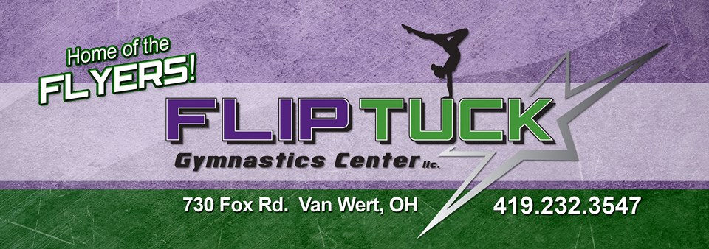

If you have any questions or would like to see our facility before booking a party, please contact the gym:



Come Have Your Birthday Party At Flip Tuck!





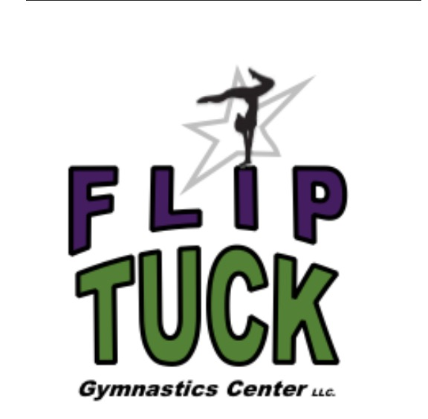

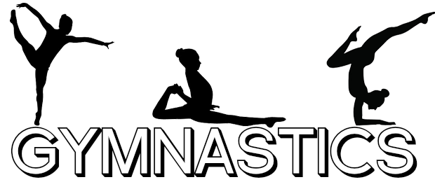



Staff Use:

Date Received: _____________

Deposit: ____________

Cash Check: ___________

**Package C**

**$200**

* 2 Hours Party Length: 1 ½ hours in gym + ½ hour in Party Room for up to 10 Guests ($5 charge for each additional child)
* Certified Coach/Activities Director
* Party Set Up and Clean Up
* Cake, Juice, Paper products
* Party Decorations
* 1 Free Trial Class “PASS” for Each Guest

A $50, nonrefundable deposit is due with the “book your party” form.

All parties must be booked one month prior to the party date. We will try to honor the date requested, but please be advised that it is subject to availability of the gym and our coach’s schedule.

All guests (including the birthday girl/boy) must have a signed waiver prior to participating in all gym activities.

All children under the age of 4 must be accompanied by a parent.

**Book Your Party!**

**Name of birthday girl/boy:**

___________________________________

**Phone Number:**

___________________________________

**Age:** ____________

**Date Requested:** __________________

**Cake:**

____ Gymnastics

____ Cheer

____Other: __________________

____ White ____ Chocolate

**Party Theme:**

___________________________________

**Package A**

**$100.00**

* 1 Hour Gym Time for up to 10 Guests ($5 charge for each additional child)
* Certified Coach/ Activities Director
* Party Set Up and Clean Up

**Package B**

**$150.00**

* 1 ½ hour Party Length: 1 Hour of Gym Time + ½ Hour in Party Room for up To 10 Guests ($5 charge for each additional child)
* Certified Coach/Activities Director
* Party Set Up and Clean Up
* Cake, Juice, Paper products
* Party Decorations
* 1 Free Trial Class “PASS” for Each Guest