PUBLIC HEARING/REGULAR MEETING

MAY 20, 2015

A Public Hearing and the Regular Meeting of the Town Board of the Town of Hampton, County of Washington and the State of New York was held at the Town Hall, 2629 State Route 22A, Hampton, New York on the 20th day of May, 2015.

PRESENT: David K. O’Brien------------Supervisor

Tamme Taran----------------Councilwoman

David Jensen-----------------Councilman

Donald Sady-----------------Councilman

Andrea Sweeney------------Councilwoman - absent

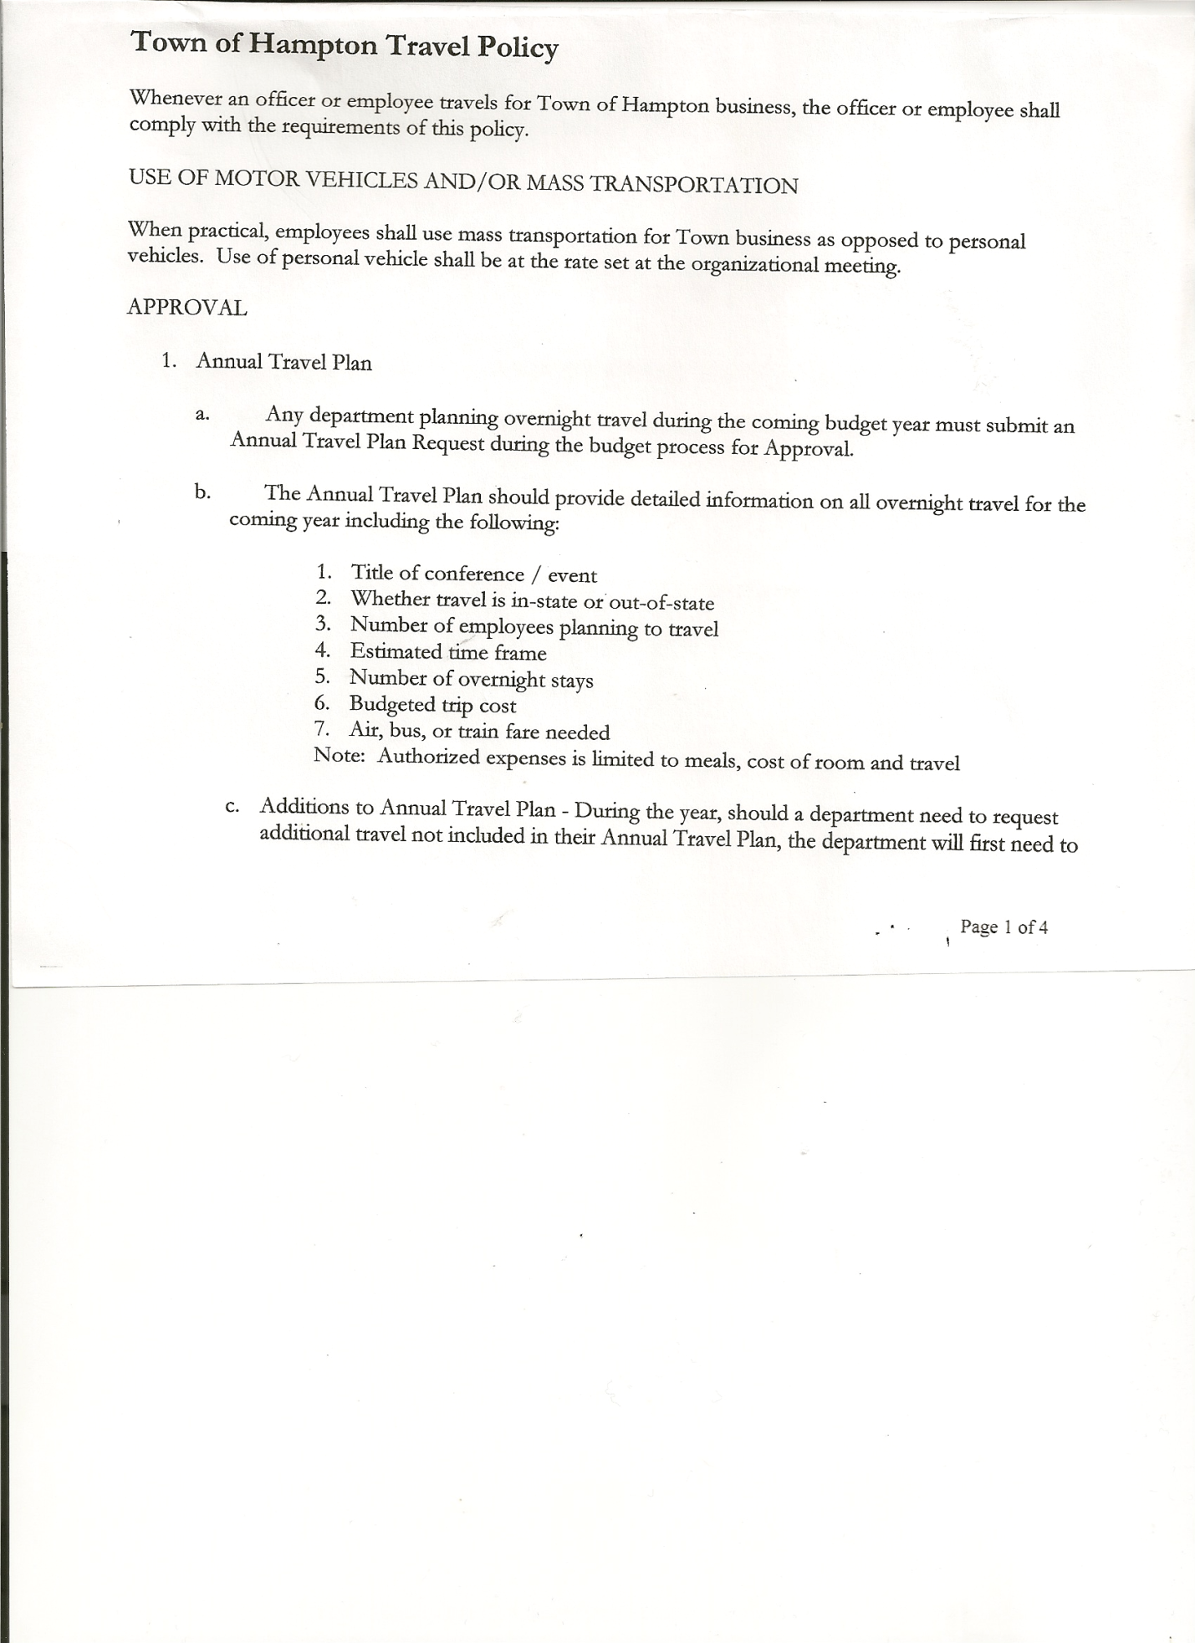 Rebecca Jones---------------Town Clerk

Camilla Shaw----------------Tax Collector/Deputy Town Clerk

Herbert Sady, Jr. -------------Highway Superintendent

Planning Board Member(s): Bonnie Hawley, Chair and Francis Baker

Also present: See attached sheet

The Public Hearing was called to order by Supervisor O’Brien at 7:00pm.

Legal Notice of Public Hearing was read by Town Clerk Jones regarding the Fire Department property, (copy is attached)

Supervisor O’Brien opened the public hearing by explaining that the Town Board desires to convey property currently owned by the Town at 2520 County Route 18 to the Hampton Volunteer Fire Company, Inc., he further explained that if the Fire Department owned the building/property they might qualify for grants.

Upon reviewing the proposed Resolution, resident Leonard Reed asked about the verbiage stating “…..that any such sale must be approved by the Town Board”; his suggestion was to change “approved” to “acknowledged”.

All persons desiring to be heard, having been heard, the Public Hearing was closed at 7:12pm.

**REGULAR MEETING**

The Regular Meeting was called to order by Supervisor O’Brien at 7:30pm followed by the Pledge of Allegiance. Locations of Fire Exits were given.

**RESOLUTION NO. 35-2015**

**APPROVAL OF THE MINUTES**

On a motion of Councilwoman Taran, seconded by Councilman Sady, the following resolution was ADOPTED: Ayes 5 O’Brien, Taran, Jensen, Sady

Nays 0

Absent 1 Sweeney

RESOLVED that the Regular Town Board Minutes for April 15th, 2015 are approved.

**Permits/Subdivision**

Jonathan Braun, Agent for Adirondack Holdings and Supply Corp. came before the board regarding a Subdivision at 131 Golf Course Road/County Route 11A.

TOWN BOARD MEETING

MAY 20, 2015 PAGE 2

**RESOLUTION NO. 36-2015**

**SHORT ENVIRONMENTAL ASSESSMENT FORM**

On a motion of Councilman Sady, seconded by Councilwoman Taran, the following resolution was ADOPTED: Ayes 5 O’Brien, Taran, Jensen, Sady

Nays 0

Absent 1 Sweeney

RESOLVED, that the Short Environmental Assessment Form, Parts 1 and 2 are complete.

**RESOLUTION NO. 37-2015**

**SUBDIVISION – NEGATIVE DECLARATION**

On a motion of Councilman Sady, seconded by Councilwoman Taran, the following resolution was ADOPTED: Ayes 5 O’Brien, Taran, Jensen, Sady

Nays 0

Absent 1 Sweeney

RESOLVE, to adopt a negative declaration and finding that there will be no adverse environmental impacts and to consider it a minor subdivision, therefore waving the public hearing.

**RESOLUTION NO. 38-2015**

**APPROVAL OF SUBDIVISION**

On a motion of Councilwoman Taran, seconded by Councilman Jensen, the following resolution was ADOPTED: Ayes 5 O’Brien, Taran, Jensen, Sady

Nays 0

Absent 1 Sweeney

RESOLVED, to approve Adirondack Holdings and Supply Corp.’s subdivision.

Camilla Shaw, Tax Collector submitted her report to the Town Board , she also had board members sign and date bank reconciliation statement dated April 30th, 2015.

Larry Carman, Dog Control Officer submitted his report, which was read by Supervisor O’Brien, copy of report is attached for 4/13/15 – 5/18/15.

Rabies Clinic was held at the Town Garage on May 16th, 2015…35 people came.

Received a “Satisfactory” Dog Control Inspection Report from NYS Dept. of Ag & Markets.

Planning Board Report….Bonnie Hawley, Chair gave the report:

* Mobile home park/campground law was sent to Town Attorney for review-Planning Board will review changes as suggested by Town Attorney
* Sue Perry, Dianne Sofia & Bonnie Hawley attended 4 hours of yearly training in Ticonderoga. Tim Richards will be doing his on-line
* Discussion regarding who would enforce the Town Law, County only handles violations, will discuss at County Level…may use Code Officers on a per use charge
* Next Planning Board meeting will be at 7:00pm at the Town Hall on May 26th, 2015

Herbert Sady, Jr., Highway Superintendent gave his report: (a copy is attached)

* Carver Falls Road….cleaning up brush and digging out ditches
* Mowing and trimming cemeteries
* Roberts Road, Hickey Road and Quivey Hill Road (North Quivey Hill Lane)….graded and watered down with calcium mix

TOWN BOARD MEETING

MAY 20, 2015 PAGE 3

* 2000 International is at Turunen’s …rear brakes being repaired
* Would like to use the CHIPS money on Chapman Road
* June 24th is Safety Day at Lake Lauderdale…$15.00 per person to attend,

Herb, George and Tyler going

* Compliments to George Palmer and Tyler McClure from neighboring towns for doing a good job plowing and grading.
* Resident Doran Pratt questioned the brake job…he had offered the brake shoes and his time and wasn’t taken up on it
* Not obtaining three (3) quotes was also questioned

**RESOLUTION NO. 39-2015**

**AGREEMENT TO SPEND TOWN HIGHWAY FUNDS**

On a motion of Councilman Sady, seconded by Councilman Jensen, the following resolution was ADOPTED: Ayes 5 O’Brien, Taran, Jensen, Sady

Nays 0

Absent 1 Sweeney

RESOLVED, to accept the Agreement to Spend Town Highway Funds (copy is attached).

**COUNTY UPDATES/COMMUNICATIONS**

* Internet/ broadband access to unserved and underserved areas in New York State….goal is that by 2019 to provide availability and upgraded service to all New York residents
* Checking on how to have mailing addresses changed from “Whitehall” to “Hampton” for people that reside in Hampton but have a Whitehall mailing address.
* County Highway Department is looking at what can be done at the intersection of County Route 18 and County Route 21
* Check on reducing speed limit on County Route 18
* Cemeteries…Burdick Cemetery…may have space available…Supervisor to find out the cost to determine if there are vacant lots

…Warren Cemetery…alternative sentencing will be working on repairing some of the stones

* County to put some Road Aprons on several Town Roads.

**RESOLUTION NO. 40-2015**

**APPROVAL OF SUPERVISOR’S MONTHLY REPORT**

On a motion of Councilwoman Taran, seconded by Councilman Sady, the following resolution was ADOPTED : Ayes 5 O’Brien, Taran, Jensen, Sady

Nays 0

Absent 1 Sweeney

RESOLVED that the Supervisor’s Monthly report be accepted as submitted for **APRIL 2015**

3/31/15 4/30/15

ACCOUNT BALANCE RECEIPTS DISBURSEMENTS BALANCE

General Fund $ 82606.39 $ 2524.66 $ 6317.55 $ 78813.50

Highway Fund $ 146881.53 $ 5.94 $ 8637.41 $138250.06

Equipment Reserve $ 100170.97 $ 4.12 $ 0.00 $100175.09

Fire #1 $ 34009.31 $ 1.59 $ 0.00 $ 34010.90

Fire #2 $ 4754.00 $ 0.00 $ 0.00 $ 4754.00

Totals $ 368422.20 $ 2536.31 $ 14954.96 $356003.55

All Board Members present signed Supervisor’s Report.

TOWN BOARD MEETING

MAY 20, 2015 PAGE 4

Hampton Fire Department….

**RESOLUTION NO. 41-2015**

MOTION BY: Councilwoman Tamme Taran

SECONDED BY Councilman Donald Sady

**TITLE: RESOLUTION AUTHORIZING CONVEYANCE OF 2520 COUNTY ROUTE 18, TOWN OF HAMPTON, COUNTY OF WASHINGTON, STATE OF NEW YORK BEARING TAX MAP IDENTIFICATION NO. 72.-2-24 FROM THE TOWN OF HAMPTON TO THE HAMPTON VOLUNTEER FIRE COMPANY, INC. FOR THE SUM OF $1.00**

**WHEREAS**, pursuant to Section 64 of the Town Law of the State of New York, the Town Board of the Town of Hampton (the “Town Board”) has the authority to convey real property of the Town of Hampton; and

**WHEREAS**, the Town of Hampton desires to convey property currently owned by the Town located at 2520 County Route 18, Town of Hampton, Washington County, State of New York bearing Tax Map Parcel number 72.-2-24 to the Hampton Volunteer Fire Company, Inc. and generally valued at around $76,000 for purposes of owning and operating a fire department out of said location; and

**WHEREAS**, the Hampton Volunteer Fire Company, Inc. has conveyed their desire to the Town to own the property, which they currently lease from the Town in order to operate their volunteer fire operations currently servicing residents in the Town of Hampton; and

**WHEREAS**, the Hampton Volunteer Fire Company, Inc. has proposed that the Town convey such Tax Map Parcel 72.-2-24 to the Hampton Volunteer Fire Company, Inc. in consideration for the sum of One Dollar ($1.00) as well as for extraordinary services provided in the past during Storms Irene, ice storms, and other similar storms, and in consideration of continued services to be provided to the Town of Hampton as currently provided by the Fire Company, and provided that the such parcel is to be used solely for the operation of the fire department facility for emergency fire response vehicles and related meetings and gatherings, and for no other uses, except for the possible sale of the property to build a new firehouse building or purchase of new equipment to benefit the Hampton Volunteer Fire Company, Inc. or the lease of such premises to provide income solely related to funding the Hampton Volunteer Fire Company, Inc., and that in the event the parcel to be conveyed ever ceases to be used as the firehouse facility or for income related to firehouse purposes benefiting the Hampton Volunteer Fire Company, Inc., title to the parcel together with all improvements on the property shall revert to the Town; and

**WHEREAS**, Pursuant to Town Law section 64(2), this resolution is subject to permissive referendum and shall not take effect until thirty (30) days from the date hereof pursuant to Town Law section 91 and that no conveyance shall be made prior to the expiration of said thirty (30) day period, and that no conveyance shall take place after said period if a petition has been duly filed Town Law section 91, without further action of the Town Board; and

**WHEREAS**, the Town Board has reviewed the environmental assessment form provided at this meeting and has found that the proposed conveyance will not have an adverse impact on the environment.

TOWN BOARD MEETING

MAY 20, 2015 PAGE 5

**NOW, THEREFORE BE IT:**

**RESOLVED,** that the Town Board hereby approves of the conveyance of Tax Map Parcel 72.-2-24 for the sum of $1.00 and other good and valuable consideration as noted above, subject to the following conditions and restrictions:

1. That the deed include provisions to be drafted by counsel to the Town generally providing for the following:

1. Should the Fire Company cease to use the above described property for purposes of operating a firehouse or other lawful fire department purposes, the title to such property, together with all improvements, shall revert back to the party of the Town.
2. Upon the dissolution, insolvency, bankruptcy or merger with another entity or fire department of the Fire Company the title to the above described property, together with all improvements, shall revert back to the Town.
3. The Fire Company shall not be prohibited from selling the above described property for the purposes of investing the proceeds of such sale in to a new firehouse building or equipment to benefit the Fire Company, provided that any such sale must be acknowledged by the Town Board.
4. The Fire Company shall not be prevented from leasing portions of the above described property to provide income solely related for purposes of funding the Fire Company.

; and be it further

**RESOLVED**, that nothing contained herein shall be deemed to substitute or limit any payments for fire services that the Town of Hampton may now or in the future make to the Fire Company; and be it further

**RESOLVED**, that pursuant to Town Law section 64(2), this resolution is subject to permissive referendum and shall not take effect until thirty (30) days from the date hereof pursuant to Town Law section 91 and that no conveyance shall be made prior to the expiration of said thirty (30) day period, and that no conveyance shall take place after said period if a petition has been duly filed Town Law section 91, without further action of the Town Board; and be it further

**RESOLVED**, that the Town Clerk is directed to publish a notice that this resolution has been adopted subject to permissive referendum as provided for in Town Law Section 90; and be it further

**RESOLVED,** this resolution shall take effect immediately.

DATED: May 20, 2015 Supervisor David O’Brien AYE

Councilwoman Tamme Taran AYE

Councilman David Jensen AYE

Councilman Donald Sady AYE

Councilwoman Andrea Sweeney ABSENT

TOWN BOARD MEETING

MAY 20, 2015 PAGE 6

The Town Clerk’s report for April 2015 was submitted to the Board. The Town Clerk had Board Members review and sign bank reconciliation statements for the Town Clerk Account and Special Town Clerk Account dated April 30th, 2015.

**RESOLUTION NO. 42 -2015**

# **AUDIT OF CLAIMS**

On a motion of Councilwoman Taran, seconded by Councilman Jensen the following resolution was ADOPTED Ayes 5 O’Brien, Taran, Jensen, Sady

Nays 0

Absent 1 Sweeney

RESOLVED that the bills have been reviewed by the Town Board and are authorized for payment in the following amounts.

General Fund No. 58 through No. 74 $ 3750.88

Highway Fund No. 44 through No. 53 $ 2626.82

Total both funds $ 6377.70

On a motion of Councilman Sady, seconded by Councilwoman Taran, the meeting adjourned at 8:59pm. All in favor Aye.

Respectfully submitted,

Rebecca S. Jones, RMC

Town Clerk