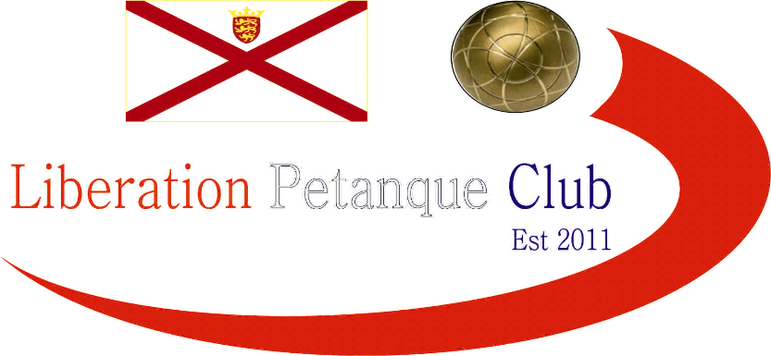

# Summer 2017 Season

# Week 10

# 31st May 2017

# Singles League

# LIBERATION DOUBLES OPEN – Saturday 10th June – Entry Form on the website.

# A double fixture and a chance to pick up 6 league points in total. Andrew Bellamy Burt recovered from losing his first game against Keith Pinel to get a draw but beating Ross Payne in his second match for 4 points on the night.

# Matt Pinel only got 1 point after drawing with Toby Northern and then losing to Brian Harris. Brian also drew with David Ibitson taking him to 8 league points and sits in the top half of the table.

# Toby also drew with Jake Romeril and sits on 7 points. David Ibitson lost a very close match to Geoffroy 13-12, 13-11, with Geoffroy also beating Alice Ibitson for the maximum 6 points.

# Keith Pinel also drew with Matt Buesnel who also drew with Jake Romeril for 2 league points all round.

# Division 1 saw Paul Le Moine win one (against Ian Foster) and lose one (against Brendan Jones). Brendan also drew with Alex Stewart. Callum Stewart took 4 points beating Rob Gregory and drawing with James Mold.

# James also drew with Jonny Hill who then drew with Brigitte as both players got two points on the night.

# Division 2 was a single fixture week.

# Well done to Chris Le Gallais who got hs first ever league win, as Richard Williams struggles to get any points. Harrison Marie’s 100% record finally fell with a draw against Cassie Stewart.

# Finally Jean Stewart and Ian black shared to spoils with a good draw.

# 

***NEXT WEEK***

**Melee 2 – Start Time 6pm**

**WEBSITE** [**www.liberationpetanque.co.uk**](http://www.liberationpetanque.co.uk)

**EMAIL** [**liberationpc@gmail.com**](mailto:liberationpc@gmail.com)

**Kind Regards**

**Report Editor**

**Liberation Petanque Club**

# SPONSORED BY

# http://nebula.wsimg.com/135a1bd6338e1b589a50cdec98bd84d1?AccessKeyId=C6E923731F1A482DD910&disposition=0&alloworigin=1