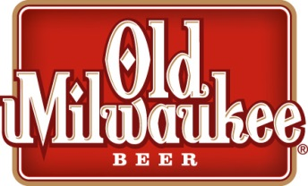
OLD MIL
RANCH BRONC RIDING

GLASGOW RODEO COMMITTEE
OFFICIAL ENTRY FORM
Entry fee: $60.00

Contestant Name:_________________________________________________
Phone Number:_____________________________

Release and Waiver
I hereby release the Glasgow Rodeo Committee, Valley County Fair Commission members, officers, employees, members, , judges, agents, sponsors or any person helping put on this competition from all claims, demands, actions or cause of action of any kind or nature whatsoever whether now known or ascertained or which may hereafter develop or accrue in favor of ourselves, our heirs, representatives, or dependents, on account of or by reason of any injury, loss or damage which may be suffered by me or them to any property, animate or inanimate belonging to me, or used by me because of any major thinking or condition of negligence of default whatsoever. I hereby assume and accept the full risk of danger of any injury or damage which may occur through or be any reason or condition of negligence of any default of any person whatsoever.
Signature:_____________________________________________Date:_______________
Bronc Riding is located at the Valley County Fair Grounds & will be held Saturday, July 29, 2017 following the Ranch Rodeo.

For more information contact:
Del Hanson: 406-263-2451

