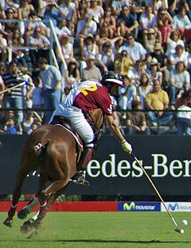
Sports marketing 101
Sport marketing is a subdivision of marketing which focuses both on the promotion of sports events and teams as well as the promotion of other products and services through sporting events and sports teams. It is a service in which the element promoted can be a physical product or a brand name. The goal is to provide the client with strategies to promote the sport or to promote something other than sport through sports. Sport marketing is also designed to meet the needs and wants of the consumer through exchange processes. Sports marketing is a means of advertising products and services either related or unrelated to sports through the use of sporting events, sponsorship and franchises. The sporting market has a sales value of approximately $180 billion, and this amount is growing annually by 20%. The sport marketplace reaches a variety of demographic and psychographic groups but in particular the audience is often young, male and are involved in sports themselves. One aspect of sports marketing is when a company advertises a product that is related to the sporting industry. Examples of this are things such as Nike advertising Air Jordan shoes at Basketball games. This type of sports marketing is useful for viewers to better understand the products they should be purchasing, to perform at their highest capabilities in their chosen sports. Also this use of advertising, where products related to a sport are advertised during the event or activity creates a stigma around the product. This stigma suggests to audiences, that in order to perform like a top athlete, they must dress in the same brands as a top athlete. Sponsorship of athletes within a sport is another way of marketing sporting products. Audiences are more likely to purchase the goods through the use of having signature series sporting goods allowing consumers to purchase the same equipment that their idols are using. An example of this is where the surfboard fin system company, FCS, released fins for sale that are identical to the ones the professionals ride. Julian Wilson, who is sponsored by FCS, has a signature JW1 model fin and this creates the opportunity for consumers that aspire to surf like him to actually use the same fins that he does. This is a way in which sports marketing really captures the attention of aspiring athletes and viewers of the sport. Another way sports marketing uses sponsorship, is when companies sponsor events and/or advertise at events through a variety of mediums. A good example would be the banners at all major sporting games and events. Companies such as ADIDAS are prime examples of a company that sponsor sports games and events. The company has banners around the sidelines of All Blacks rugby game. Also they are a FIFA partner with advertisements at all the major football games played under the FIFA organisation ("FIFA Partners - FIFA.com", 2016). Sports marketing also allows sponsors with enough money and trust to be a part of a sports game or event not just from the sidelines but actually on the field. Continuing on with the FIFA and ADIDAS partnership, a way companies can make it on the field is through their products. ADIDAS products get advertised on the sports field by all the greatest soccer stars in the world using their balls in every FIFA organised match ("FIFA Partners - FIFA.com", 2016). This is a massive advantage for the company as anyone who watches a FIFA football game sees the ADIDAS ball. Viewers naturally make an assumption that the balls must be of the highest quality if the world's best use them. This in turn leads the viewer to be swayed towards ADIDAS products when in a situation where football products are desired by the consumer. Consumers trusting a brand and knowing the brand has a good reputation can lead to increases in sales of the company's products. Another aspect of sports marketing is when a company that is unrelated to a sport advertises and promotes their company. They use the wide audience that is reached by the sporting industry as a way to target a greater range of consumers. An example of this is Coca-Cola’s affiliation with the Olympic Games since the late 1920s. This is a prime showing of how a product that is unrelated to sporting events within the Olympic Games uses the sports marketing platform to their advantage. By using the sports marketing platform to promote products it creates the opportunity to advertise to a variation of viewers around the world. Sports marketing has transitioned into being one of the most effective marketing strategies available in today's society. Companies all over the world such as the Coca-Cola example above are finding ways to market their non sport related products to the sporting world. Heineken is an alcohol company that has partnerships with a range of sporting events globally. This shows that products entirely unrelated to sports are taking advantage of the sports marketplace to gain a wider customer base. The company is involved in the Rugby World Cup which was in the top ten New Zealand viewed series in 2015.This allowed the company's advertisements and product details to reach a big percentage of the country's population. This is an effective way to reach a wider customer base and gain a spot in the sport viewers niche. Heineken also have partnerships with the UEFA championship football league and the ATP Tennis open creating the company to be recognised with a wide range of sports ("The HEINEKEN Company - Age Gate", 2016). With the right sports marketing a company can have a huge advantage in their products marketplace due to reaching such a wide customer base (Schaaf, P, 1995).
Trend conscious teens are very active in utilizing the media and advertising in seeking out the latest products, services, and fashions. In this day and age; professional athletes are easily able to influence this generations youth more effectively under the condition that the athlete maintains a professional stance and/or has in their possession a certain level of knowledge about the product they’re advertising (i.e. Tiger Wood and golf-clubs). It is easy for consumers to mentally compare the success of a sporting celebrities with the brand/product that they are advertising; such information supports the belief that the popularity of celebrity athletes could benefit brands, creating positive associations for the consumer between the athlete and brand, contributing to brand name recognition and creating meaning for even the most ordinary. Essentially, this statement supports the theory that a product advertised through an idolised sporting celebrity should create a positive cognitive recognition for consumers despite said athlete and product being unrelated in a logical sense. An example of this in recent times is the latest ‘Budweiser’ (alcohol) advertisement featuring a famous UFC fighter Conor McGregor (Budweiser, 2016). In an ethical standpoint, Conor McGregor’s home nation of Ireland had the advertisement (that would have otherwise aired on television) banned stating that the advertisement itself promoting underage drinking. This (as previously mentioned) is to prevent the association of McGregor’s fame and success with that of the brand/product Budweiser. In the present day, advertisements such as this can be deemed unethical as a result of the negative message it portrays.
Other ways marketers’ effectively advertise a product and/or brand is by sponsoring not just an athlete, but an event. Certain company’s viewed under a negative light utilise such an opportunity to market their brand exploiting the events positive nature in order to be associated with such a thing. This technique is more welcomed by alcohol brands that generate brand capital through positive association, as previously addressed. This can be seen as an effective marketing strategy because through integrating the event’s certain culture and/or life-style; consumers in specific market segments are able to identify the correlation between brand and sporting event. Essentially meaning, by ‘piggy-backing’ a positive idea or public interaction, a company held under negative tension is able to grasp positive momentum from the desired target market. An example of this is the use of Heineken’s (Beer Company) various sponsorship deals. Such deals include movie premieres: James Bond; sporting events: Rugby World Cup; and music festivals. While Heineken is by no means related to any of these three codes of entertainment, through sponsorship consumers undergo a natural tendency to associate the two. This reduces the negative connotations usually linked with alcohol consumption, while providing a feel of nostalgia through natural cognitive association. The word ‘nostalgia’ in this sense meaning that the consumption of Heineken will trigger the consumer to think of the sporting event/s sponsored by Heineken.
Sport marketing is an element of sports promotion which involves a wide variety of sectors of the sport industry including broadcasting, advertising, social media, digital platforms, ticket sales, and community relations. Sports marketing is divided into three sectors. The first is the advertising of sport and sports associations such as the Olympics, Spanish Football league and others, as well as sport teams like Manchester United. The second concerns the use of sporting events, sporting teams and individual athletes to promote various products. The third category is the promotion of sport to the public in order to increase participation. A fourth category, one that is growing exponentially, is marketing sports to women.
In the first case, the promotion is directly related to sports. In the second case, the products can but do not have to be directly related to sports. When the promotion is about sports in general, the use of this kind of strategy is called “Marketing of Sports.” When the promotion is not about the sports but sports events, athletes, teams or leagues are used to promote different products, the marketing strategy is denominated “Marketing through sports." When the promotion is about increasing participation among the public, it is called "Grassroots Sports Marketing." To promote the products or services, the companies and associations use different channels such as sponsorships of teams or athletes, television or radio advertisement during the different broadcast sports events and celebrations, and/or advertisement on sporting venues.
“Street marketing of sport” considers sport marketing through billboards on the street and also through urban elements (street lighters and sidewalks, etc.) to help promote and gain publicity during major worldwide sporting events such as the Football World Cup or the Olympic Games,

Growth in sports has been partially fueled by an increased emphasis on leisure activities, such as jogging. Consumer-driven growth factors have also spurred the growth of sports, with the introduction of new sports,, such as the X Games for extreme sports as skateboarding, inline skating, motocross, skysurfing and bicycle stunts. The Winter X Games began in 1997 to include sports such as snowboard, snow mountain bike racing and ice climbing. Another popular sports marketing need is toward a growing interest in martial arts, such as the Ultimate Fighting Championships. These attract the 18- to 34-year old males who may be seeking an alternative to mainstream sports.

There is a growing interest in women’s sports, especially for coverage during both summer and winter Olympic games. An increased involvement in personal fitness as experienced by the growth of fitness clubs and personal training also increases the need for marketing.

Sport fans
Like all sectors of business, sports relies on market segmentation to effectively market itself. Sport fans differ according to a number of attributes including motivations to attend sporting events, emotional attachment, economic attachment, identity, and loyalty. These attributes also make sports different than other forms of entertainment as sport fans behave differently than consumers of other products and services.
Attributes such as loyalty can be recognized through the contracts players and athletes sign with sports companies in which they get paid to wear or use their products in each game or sporting event. By doing so, the players and athletes and also their fans develop a loyalty to the products for a longer time.

The 5 P’s of Sports Marketing

The 5 P’s of Sports Marketing (Positioning, Platform, Promotion, Profits, People) creates “The Sports Product” around which both tangible goods and intangible services or experiences revolve. Describing products in a sports marketing context requires that we expand the term “product” to include teams, events, athletes, sponsorships, licensed merchandise, support products that are needed to execute a sporting event or activity (e.g. electronic timing equipment, ticket distribution, led lighting and video production, etc.), experiential products (e.g. sports camps), and sporting goods.
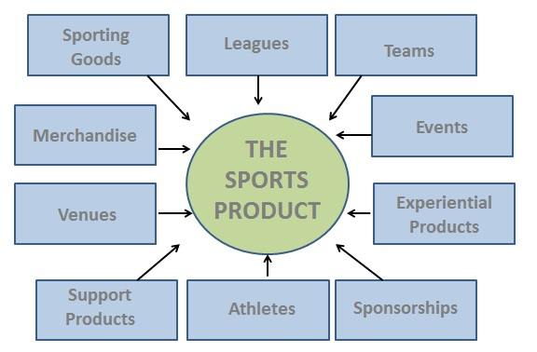

5Ps: Positioning – Understanding the Customer: Any marketing effort that fails to have the interests of the customer at the heart of decisions are likely doomed to fail. Key marketing tasks related to positioning are: (1) establishing values and mission, (2) conducting market analysis, (3) setting marketing objectives, and (4) selecting target markets.
- Values and Mission – Answer the question, “why do we exist?” Values are attributes or characteristics held by an organization and often matter to its stakeholders, including employees, customers and local communities. Values a sports team might hold include excellence on the field, family-friendly, educational advocates for youth, etc. The mission is a statement of what an organization does, and a well-defined mission is the starting point for formulating marketing strategies. For example, Reebok’s mission simply says “always challenge and lead through creativity.” FC Barcelona fans identify on a personal level with the ups and downs of the team. This symbolizes what it means for Barça to be “more than a club”. The French Open touts its mission statement “Un nouvel Ecrin Pour Un Tournoi de Legende”, referring to the The French Tennis Federation’s decided to maintain the tournament at Roland Garros in Paris – its traditional historic venue to preserve the inimitable character of the tournament.
- Market Analysis – a review of trends both inside and outside the organization. Any marketing decision should be guided by managerial understanding of occurrences outside the organization – the external marketing environment, consisting of five factors or forces that should be monitored regularly: Competition, Economy, Political/Legal, Technology and Demographics.

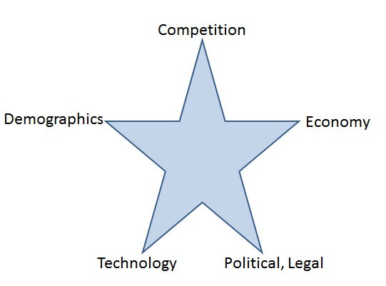

Competition – Requires gaining insight into the strengths and weakeness as well as predictions about future moes the competition will make. Competition often comes from unlikely sources, and can be classified as brand competition (similar sports), category competition (other sources of entertainment), or generic competition (usually consumer related such as need to purchase food rather than spend on sports entertainment).

Economy – While economic trends are beyond the control of any one organization, they must not be ignored and proactively monitored to avoid poor marketing decisions to be made. Consider how football tickets are purchased. Full-season ticket sales are important to team marketers because they represent a rather consistent revenue stream. However, consumers who are reluctant to make an outlay for full-season tickets as a result of modified buysing behaviors pose a challenge for ticket sales in sports organization. One response to this change in the economic environment was offering a variety of multiple-game ticket packages to appeal to fans’ loyalties and yet not require the outlay of funds necessary for a full-season ticket package. These “mini plans” offer flexibility in purchasing tickets that encourages multiple-game purchases without the commitment required of a full-season plan.

Technology – Developments in technologies available to firms in the sports entertainment industry, the rate of technological change, and anticipation of future technologies that will potentially impact the industry should be considered. A good example of technology is the trend to go cashless at concession areas. Fans can load money onto cards that are used for payment when purchasing food or merchandise. The team touts that fans spend less time in line and thus spend more time enjoying the game. It has the added benefits to the team of reducing employee theft and potentially increasing per capita spending by fans who are not constrained to spending cash on hand. Another technology enhancement are paperless tickets, adds value for consumers by reducing the time required to stand in line to buy tickets by making them available online on on the mobile phone. Additionally, it saves the team considerable money to go paperless by saving on printing and delivery costs. Furthermore, paperless ticketing gives sports teams more information about ticket holders, as recipients of paperless tickets have to create an account to have tickets sent to them digitally. Smart phones deliver content to fans in the stands, allowing fans to watch replays and see action from multiple camera angles, such as the service provided by YinzCam. The challenge for sports marketers is to determine which technologies have the greatest potential to affect their business.

Political, Legal and Regulatory Climate – Sports organizations are often regulated by varying entities, from industry regulators (i.e. those setting the rules for the sport) to government regulators (i.e. municipalities regulating the staging of local, national and international sports events).

Demographics – Trends that shape culture will differ over time, but marketers cannot lose sight of the power of sociodemographic trends to alter consumer behavior. These five socio-demographic trends will impact marketing practices in sports: a general aging of the populations world-wide, greater ethnic diversity and immigration influxes, increased buying power of women, decreased leisure time, demand for social responsibility.

5Ps: Platform – Refers to the bundle of benefits developed for customers and includes: (1) branding, (2) products, and (3) place or distribution.
- Branding – A brand position refers to how customers perceive a brand. While an organization owns tangible pieces of its brand (trademarks, logo, etc.), the customers determine the value of that brand. A brand matters to customers and others because of the meaning the brand holds for them, the benefits or value the brand delivers, and the feelings of trust that develop when a brand delivers a consistent experience. Marketers are caretakers of brands, not their owners. Because professional sports teams and leagues are constantly evolving, it is important to re-examine a brand and perhaps even re-energize it every few years. A sports brand has four different purposes or roles to add value for both buyers and marketers:

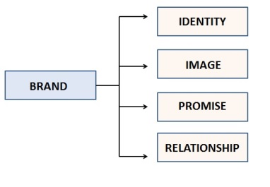

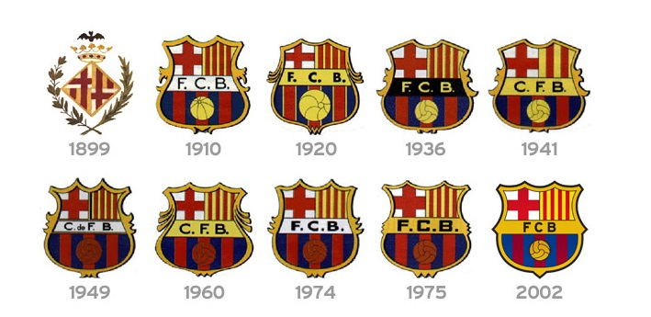
- Identity: A name, term, design, symbol or any other feature that identifies a seller’s good or service as distinct from those of other sellers. These can serve as mental shortcuts that associate a produce with its owners – think of the Nike swosh symbol. Identity elements are important because they can play a role in creating brand awareness among consumers. In the case of a sports franchise, choice of a team name, logo and colors are important because they not only create an identity for that team, but also set them apart.
Evolution of the FC Barcelona – Barça emblem

- Image: serves as a representation of thoughts or mental associations that people hold for a product or service. For virtually every grand, a gap exists between abrand identity and brand image. A team that has desired associations of “excellence”, “success”, and “quality” may find it difficult to success in building brand identity if people’s perceptions of the team are based on a history of mediocre performance, managerial missteps, or other negative associations with the team. Public perceptions that influence brand image may be inconsistent with associations the brand aspires to maintain inaccurate or untrue perceptions. The seemingly never-ending quest to align image and identity means there will always be a need for marketing.
- Promise – Brands represent a promise of action that will benefit a customer. People value brands because they stand for intent to deliver value. Promises made by brands can be explicit or implicit, with the implied promise playing a more important role in branding – think of the following brands’ promises: Coca-Cola – “refreshment”; McDonald’s – “consistency”, Apple – “simplicity”. The importance of brand promises in sports must not be overlooked. Man sports organizations place an emphasis on community relations in an effort to create implied brand promises. Support for a school, donations to a nonprofit organizations, promoting youth sports are examples of ways sports brands create and deliver against an implied promise of “community partner”. This strategy can be important for gaining acceptance among casual fans and nonfans of a sport, as well as obtaining support from local government and the community at large.
- Relationship: For sports brands, two motivations exist for practicing relationship marketing: (1) The expense to retain existing customers through marketing activities is much lower than the investments needed to attract and acquire new customers. Viewing a customer’s interaction with a brand as an ongoing relationship rather than a one-time purchase will influence how a marketer engages customers. (2) Motivations for consuming sports are often based on emotional connections, such as affinity for a sport, team or athlete. Sports brands have the luxury of tapping the passion felt by fans to deepen relationships with them. A trend in relationship marketing in sports is attracting customers that desire a more intimate connection with their favorite player by offering more insider access, whether it is lock room tours or behind-the-scene experiences. This strategy is particularly important to connect with premium customer segments.

- Products – A strategic planning perspective requires that marketers continually look to the future for new product ideas. Determining viable product ideas for future development requires examination of the external environment to predict what will occur (e.g., changes in customer needs and preferences, competitors’ new product strategies, etc.). New products fail all the time even when innovations are based on learning from consumers and competitors through market research and design that is inspired by the marketing concept of meeting customer’s needs. Four influences on the adoption of variables that impact consumer acceptance of innovations that marketing managers can observe include:

relative advantage: the benefit or point of difference the innovation offers compared to existing alternatives available to consumers. If the relative advantage is not understood by the target market, buyers may not be compelled to change their current behavior to try a product and eventually adopt the innovation. If an innovation does not offer a relative advantage, its likelihood of successful adoption is diminished. Characteristics of relative advantage include: relevance, being recognizable, and real.

compatibility: consumers will more likely adopt an innovation if it is compatible with their values, beliefs and practices. They will reject a new product if it is perceived as incongruent with their morals, lifestyle or behaviors, even if an innovation possess relative advantage characteristics.

complexity: this is an issue that can threaten success product adoption. Failure to account for complexity by marketers can result in consumers being unwilling to adopt a new product because of perceived inconveniences in its acquisition or use.

triability: consumers must be able to experience a new product firsthand in order to judge the value it delivers. Sampling is an effective promotion tactic that enables consumers to try a product with little or no financial risk.
- Place or Distribution – Consider making the product available when the target market wants it, where they want it. Examples of sports marketing distribution decisions are choice of geographic markets to locate a team or events, schedules, choice of media partners to broadcast events, choice of licensees or retail outlets to market merchandise, amenities that will be offered inside the sports arena, etc.

5Ps: Promotion – Marketing and communication tactics that engage customers can develop long-term relationships. For example, social media allows fans to post phots and comments on a team’s Facebook page. Sponsorship is an element of promotion that differes in significance for sponsors and sports teams. For sponsors, it is a communications strategy used to market through sports to reach and engage audiences. For sports teams, sponsorships represent an important revenue stream that impacts the financial position of the organization.

5Ps: Profits – Marketers must understand the importance of price in creating customer value and positively impacting customer satisfaction. Price is not the sole focus for profitability – a commitment to measuring results from marketing activities is needed to assess how effective strategies and tactics are for enabling a team to achieve its financial goals.

5Ps: People – Sports is really a people’s business, heavily dependent on the quality of interactions that employees have with customers. Front-line service employees – ticket salespeople, account services representatives, community relations specialists – either serve a customer directly or provide support to employees with immediate contact. Another consideration of the “people” element is preparation of future sports marketing professionals. The sports industries attract a great deal of interest from young people who want to connect their love of sports with responsibilities of a job with a company, league, team or event involved with sports. As the sports industries continue to evolve, jobs have been developed into specialized responsibilities like ticket sales, sponsorships, facility management and marketing operations. Future sports marketers can better position themselves to work in sports marketing if they learn about different career opportunities and the skills and training sought of job candidates. A job in sponsorship sales, for example, involves a great deal of communication, from making initial contact with prospective corporate clients to making sales presentations, to maintaining relationships with sponsors.
Responsibilities | Personal Characteristics | Qualifications
Prospecting and cold calling on corporations and others | Innovative | Bachelor’s degree
Developing consuiltative selling approaches | Energetic | Track record or results
Nurturing relationships | Self-Movitaved | Excellent communication and organizational skills
Fulfilling advertising and sponsorship packages | Entrepreneurial Spirit | Outstanding strategic selling skills
Collaborate with vendors, sponsors, and others to insure sponsorship fulfillment | Poise and ability to present oneself well to others | Creative solution development

Brand Communication careers include jobs in advertising, public relations, community relations, and interactive marketing through the Internet, social and email. In some cases, sports teams will outsource these jobs, in other cases, they manage brand communications functions in-house, recruiting and hiring employees to perform these tasks within the organization. Brand marketing professionals often have a graphic design background and are proficient in many design software. Successful event marketing and management employees are able to creatively solve problems as well as coordinate vendors, suppliers and staff to complete necessary tasks for an event to go off as planned. The emergence of technologies for collecting and analyzing data has created new job opportunities in the sports industry. Marketing departments in sports organizations are increasingly adding employees with skills in customer relationship management (CRM) and database marketing.

Benefits of sport marketing
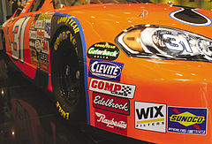
Stickers on a NASCAR racecar from companies with large advertising contracts.
The benefits of sports marketing are wide-ranging. Stakeholders involved in sports include leagues, teams, athletes, and fans as well as cities and countries hosting sporting events. The media and businesses who promote their products and services through sports also receive benefits. Direct benefits to leagues, teams, and athletes include revenue from tickets, media rights, and sponsorships. Cities and countries also receive revenue from taxes, and all of the stakeholders gain from the exposure provided through sports.

The marketing of sports teams and events
According to different authors and organizations the marketing of sports events and teams is defined as “Designing or developing a 'live' themed activity, occasion, display, or exhibit a sporting event to promote a product, a team, cause, or organization. Which in other words it can be defined as follows: The marketing of sports events and teams is the marketing strategy which is designed or developed a “live” activity, which has a specific theme. Mostly this kind of strategy is used as a way to promote, display or exhibit different things, such as a sports team, a sport association among others. There are different events that can clearly exemplify this concept, such as the Olympic Games, the UEFA Champions League, the World Marathon Majors, and the FIFA World Cup.
Major sports brands compete to link up with the best marathons in the world, the test for excellence in ‘running’, in what is a genuine showcase for strengthening its marketing strategy to its target audience. Adidas, Asics and Nike are dividing the market into the ‘World Marathon Majors’, the international athletics competition created in 2006 that brings together the most prestigious marathons on the planet. They are not title but technical sponsors, but these runs are popular and are not to be missed events for these brands, which create specific advertising campaigns to one of the few competitions that brings together professionals and amateurs under the same chrono.

The marketing of products through sport
'Marketing through sport' is a concept that's been used since the 1980s, but has increased in importance in the last two decades due to the growth and expansion that the different types of sports have enjoyed since then. “Marketing through sports” it is a marketing strategy that can be used in sports in two different ways. First, the use of marketing and promotion can be carried out through the sport or through the sports club. In the first case, the use of marketing is under responsibility of the different sporting associations, while in the second case, the responsibility falls on the different sports clubs. In this manner, marketing and promotion through the sport and through the club involve sponsorship, corporate events and boxes, licensed merchandise, names and images also known as “endorsement”, advertising through broadcaster, advertising such as advertising as ground signage/clothing/equipment advertising, promoting games, promoting using players/club/league or developing ‘business opportunities.’ The peculiarity of sports is that “sport is the only entertainment where, no matter how many times you go back, you never know the ending.” This singular fact is used by marketing companies as an advantage: every time the audience attends an event it will see the advertisements again and again, providing a wide range of opportunities for the different companies which operate on this field.

Examples of marketing of products through sport

Sponsorship of events
One of the oldest examples of the marketing of products through sports is Slzenger’s supplying of the official ball of Wimbledon (1902- 2015).Another international example of marketing products through sport is Adidas’ sponsorship of FIFA, which includes the company supplying the balls used in the World Cup and having its logo on the side boards along the field of play. In what it described as a "world first" in corporate sport sponsorship, in 2016 BNY Mellon and Newton Investment Management announced they had donated their title sponsorship of the annual Oxford and Cambridge Boat Races to Cancer Research UK.
Source: FIFA
Retrieved from: http://www.fifa.com/about-fifa/marketing/sponsorship/appeal.html

Sponsorship of teams
Sponsorship of teams is found throughout sports. Some of the most visible examples are found in the MLS as company names and logos are featured on team jerseys. For example, Barca shirts display Qatar Airways. Turkish Airlines established a sports marketing strategy involving high-profile sports teams, players, and sport associations including Manchester United, FC Barcelona, the Euroleague basketball competition, NBA player Kobe Bryant, the Turkey national football team, and tennis player Caroline Wozniacki.
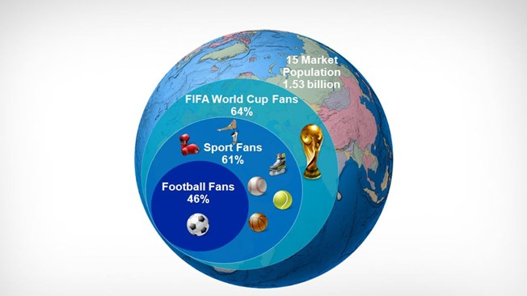
The universal popularity and appeal of football (also known as soccer) makes it a common denominator for everyone, irrespective of gender, age, race and social standing. As a result, the FIFA World Cup™ represents one of the most effective global marketing platforms, offering sponsors unrivalled opportunities to connect with consumers. Football is the world’s favourite sport, played by more than 240 million players in 1.4 million teams and 300,000 clubs across the world. The FIFA World Cup™ reaches an audience of a size and diversity that is unrivalled by any other single-sport body. Add to this a passion for the game found in all corners of the world, and you have a sporting, social and marketing A universal interest in the FIFA World Cup™ that transcends all age, gender and social barriers has been proved time and time again by research figures from FIFA’s 15-market global research programme. The diagram highlights the fact that interest in world football’s flagship competition goes above and beyond traditional football, and even traditional sporting, interest. This is a clear indication of the huge global reach that a sponsorship deal with FIFA ensures for a brand.
In addition to the huge appeal of the event itself, the packages offered by FIFA make a sponsorship deal with world football’s governing body a hugely attractive proposition. Each Commercial Affiliate is granted product category exclusivity, offering a unique platform vis-à-vis their competitors.
A dedicated account management team works exclusively with each sponsor, adding value to the agreement and ensuring that all sponsorship rights are delivered. When aligned with the outstanding portfolio of programmes that FIFA opens to its Partners, as well as brand-enhancing sponsorship tools such as LED advertising boards, it is clear to see why many of the world’s top brands are already associated with FIFA events.
These are examples of sports marketing because as it is defined, sports marketing is a marketing strategy in which companies related to sports products or services promote their trademark through design, production or other resources. In this case apparel companies Nike, Under Armour, and Adidas, which are all completely related to sports, design the uniforms of these teams and as a consequence their trademarks are being promoted every time there is a game.

Sponsorship of athletes
Apparel companies also sponsor professional athletes such as Usain Bolt, who receives US$10 million a year from Puma. Many athletes maintain contracts with a variety of companies, some that are related to sports and others that are not. Roger Federer holds agreements with Nike, Wilson, Rolex, Mercedes-Benz, and Gillette, worth in sum close to $60 million each year. Lionel Messi has signed for endorsements from Adidas, Pepsi, Audemars Piguet, Dolce & Gabanna. Herbalife, Turkish Airlines and Proctor & Gamble. Golfer Rory McIlroy has a US$93-million dollar contract with Nike,
Another example of marketing through sports is the strategy used by Gillette to promote its personal hygiene products through representative figures of each sport on television during broadcast sports events. Gillette uses athletes such as tennis player Roger Federer, golfer Tiger Woods, and footballer Thierry Henry. In the commercial these celebrities appear using the products of the company showing the results in order to demonstrate that if successful people use the products you should use them to. It is a clear example of this concept, because the company using this marketing strategy is not related to sports at all, but through important personalities of each sport it has the possibility to get to its target audience. Nike and Gatorade also hold sponsorship agreements with top athletes. Included among Nike's clients are Federer, Woods, golfer Rory McIlroy and tennis player Rafael Nadal.

Sport marketing through social media
Professional leagues, teams, and athletes have begun using social media as part of their marketing strategy in recent years. The most popular social media platforms are Facebook and Twitter, but athletes and teams have begun using sites including Instagram and Snapchat. Like all business, the advantages of social media use in sports include building brand awareness, reaching a large audience in an easy and cost-effective way as well as creating brand advocates and engaging passionate sport fans. Social networking has definitively changed the way we connect with the world. News reaches us via Twitter the moment it happens. Other communication channels are proliferating. “We need to pay special attention to how the digital world is changing marketing techniques, and it is a challenge for students to acquire new skills to manage digital marketing tools. But the indiscriminate use of these new channels may have a risk: destroying marketing budgets in campaigns without any kind of effect. What really matters is how you use your communication channels”, said Edwin Schravesande, professor of e-marketing at the Johan Cruyff University of Tilburg.
For a brand like Babolat, for example, having a world icon like Rafa Nadal as its top representative is priceless. There is no better way to stand up to your competition than by joining up with the strongest. But you must know how to do it, it is not a case of anything goes. And this is where knowing how to use social media is fundamental. “A message on Twitter is not just an advertising channel with which you can win an audience. Its power lies in the message being relevant and credible”. A college sports team Rewards Program (when fans decide to "Like" or "Follow" the team on either Twitter or Facebook), gives followers day-to-day updates on their favorite teams. From a marketing aspect, the team’s athletics page on Facebook and Twitter keeps track of fans who have "tweeted" or "commented" on certain links, posts, or tweets. There is an incentive for these fans to post and tweet because at the end of each year, the top three posting or tweeting fans who are selected receive prizes, from free jerseys and merchandise to season tickets. Many athletes including Rafael Nadal have taken advantage of social media to increase their followers and enhance their brand. Athletes have also engaged in promoting brands through social media including Russell Wilson’s sponsorship of Recovery Water and Serena Williams’ promotion of Wheels Up. Because of this marketing tool, these fan-based website pages have increased greatly in numbers and give them the recognition that they were looking for.

