Personal Disclosure, Notice of Policies and Privacy Practices
Creative Arts Counseling, Jaime Dawson, MA, LMHC* LH60520804
58 Logan Ave S Renton WA 98057 * 206-234-1124
www.creativeartscounseling.com
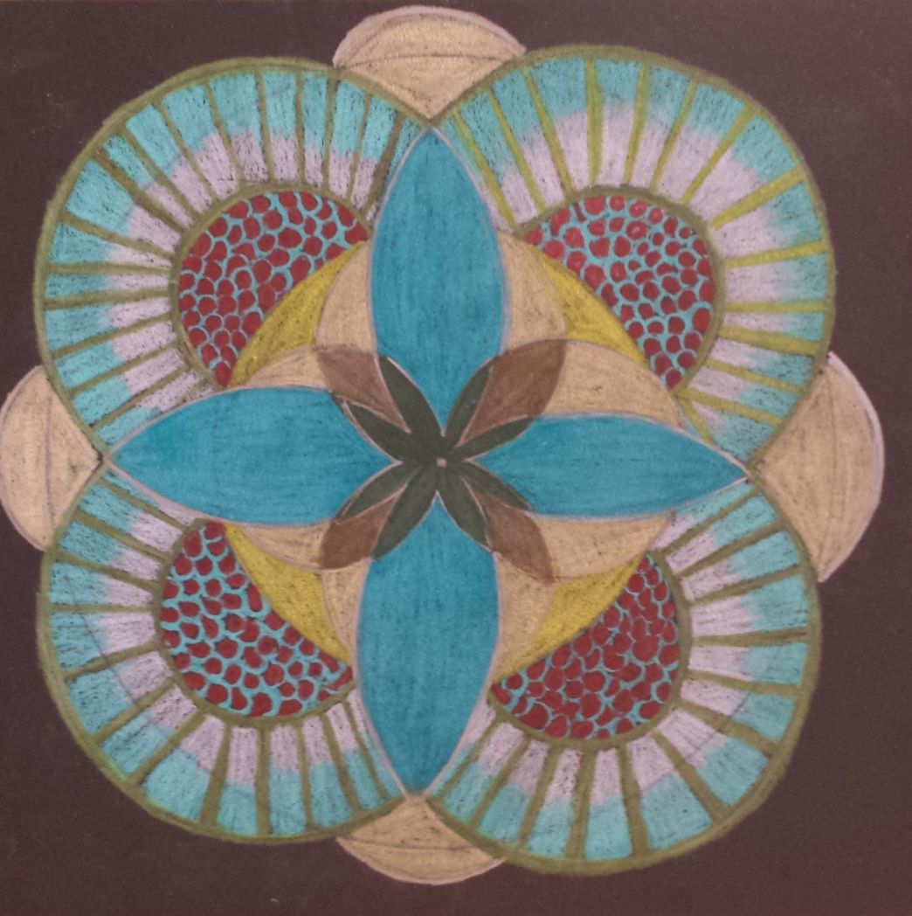

This document contains information about your rights as a therapy/counseling client; my personal disclosure statement pertaining to my education and training; my therapeutic orientations and my therapeutic style; what to expect in therapy/counseling; and the Policies of Creative Arts Counseling to help you make an informed choice about your mental/psychological health care. If you have any questions or concerns about this document or any of the policies contained within, please ask for clarification.
Last Update: 1/9/2023
Your Rights & Confidentiality
You have the right to respectful treatment as a human being and the right to choose a counselor/therapist that fits your needs. You have the right to start and end your treatment at any time. You have the right to request and review your records (see Other Policies). You have a right to confidentiality regarding your Personal Health Information. There are a very few exceptions to this, which are listed below:
1) You specifically request in writing that I release information to a third party. You may revoke this permission, in writing, at any time. Please note that not all third parties are bound by confidentiality or HIPPA requirements.
2) There is a significant threat that you may cause harm to yourself or other person.
3) There is suspected abuse or neglect of a child, disabled or elderly person. I am mandated by law to report suspected abuse or neglect of a minor (under 18) to Child Protective Services.
4) If you are involved in any legal issues, your records could be subpoenaed, or I may be required to testify.
5) In response to Washington State Department of Health oversight or action, records may be reviewed and examined.
Education & Training
I hold a Bachelor’s Degree in Psychology from Willamette University (2005), a Master of Arts in Psychology from Seattle University (2009) , a Post Masters Certification in Expressive Arts Therapy (2016) from San Diego University for Integrative Studies and a Master of Arts in Depth Psychology with an emphasis in Somatic Studies (2019) from Pacifica Graduate Institute . I am currently a PhD candidate at Pacifica Graduate Institute Depth Psychology with a specialization in Somatic Studies (Estimated Completion 2024). I currently hold a Mental Health Counselor License with the State of Washington. I have been a trained SoulCollage(R) Facilitator since 2011.
Therapeutic Orientation, Therapeutic Style, What You Can Expect in Therapy
My therapeutic style is grounded in the here and now and based upon the philosophy that you are a unique individual with your own view of your needs, your situation and your world. Together we will identify and examine issues, identify needs and emotions and work towards your goals/intentions. Because therapy is an unfolding process and a journey, issues, emotions, goals and intentions will often present themselves during the course of your treatment. I am heavily influenced by Existential-Phenomenological Psychology and Depth Psychology, which tend to be more client-focused styles of therapy. I also use Expressive and Creative Arts as a tool in therapy to aid in a way that sometimes words cannot. The use of Art and Image making is a tool to help you discover new parts of yourself, work through issues and make feelings/emotions visible and tangible. It is important to remember that the use of Art and Image making in therapy is for expressive qualities and not about technical proficiency.
I strive to provide for you during your sessions a safe and trusting environment for you to explore yourself, relationships, emotions, life-situations, etc., while maintaining professional and ethical boundaries. Therapy is a judgement-free zone where all emotions and attitudes are given space to have their say. I do not provide advice or interpretation. Instead, I make observations, ask questions and reflections to help and empower you to find your own meaning so that you can choose your own course in life.
Therapy/Counseling is not without risks. Some emotions and situations can feel overwhelming and old wounds may be reopened. At times you may feel vulnerable or feel as though you are moving backwards. Please express these feelings as they are part of therapy/counseling and are integral to your healing process. Since therapy/counseling is a collaborative effort, I welcome input on your process and how you feel you are progressing.
The duration of therapy is generally as unique as each individual. As we form goals and intentions for your therapeutic process we can discuss duration and frequency of session.

Therapeutic Services, Fees and Payment Policies
Standard Therapeutic Service and Fees
Phone Consultation--15 minutes No Charge
Individual Session 55 minutes *: $120.00
Extended Session/Family Session 75 minutes: $180.00
*Sliding Scale Applies

Sliding Scale Policy
I offer Sliding Scale Fees to help mediate the out-of-pocket cost for therapeutic services. Sliding scale fees will be negotiated during our consultation and may be renegotiated by either party at any time. In addition to taking your financial situation, the frequency of sessions will also be taken into consideration when determining sliding scale fee. Sliding Scale Fees are divided into three tiers with a limited number of spaces available. Once a tier is full it can no longer be offered. Additionally, Tier Three of the Sliding Scale is only offered to clients seeking weekly sessions. Sessions at a frequency of once per month do not qualify for Sliding Scale.
Sliding scale tiers with available space will be discussed at the time of consultation. The following chart illustrates the structure of my sliding scale fees, this is meant for information only and doesn’t guarantee that a particular tier will be available.
Tier One | Tier Two | Tier Three  (weekly and bi-weekly sessions only)
$100-115 | $80-95 | $55.00-$75.00

Insurance Policy
I am currently in network with Regence. If you are out-network and would like to be reimbursed by your insurance company for any fees you pay for your sessions, I am considered an Out-of-Network or Non-Preferred Provider. I will provide you with a receipt for services that you can submit to your insurance company. Depending on your insurance provider and policy, you may have to meet your deductible before your insurance reimburses your sessions. Please contact your insurance company to determine what your coverage is. Another option to use out of network benefits is to use the service Adevekit (advekit.com) Remember that you are responsible for payment of your sessions.

Other Policies
48 Hour Cancellation Policy & No-Show Policy
You may cancel your appointment 48 before it occurs without penalty. If you cancel your appointment under 48 hours before it occurs, you will be charged the full session fee, unless you reschedule your appointment within the same week. If you do not show up for your appointment at all, you are considered a No-Show for your appointment and will be charged the full fee for your session. Please note that insurance does not reimburse for missed or canceled appointments.
Late Policy
Please show up on time to your appointment. If you show up late, your time will not be extended. If possible, please notify me if you feel like you might be late and we may be able to arrange a same-day rescheduling. A late arrival of 10 minutes or more without prior notice is considered a No-Show.
*Note: Insurance companies do not reimburse or pay for canceled or missed appointments. If you accrue fees for canceled or missed appointments, you will be responsible for them.
Social Media
With respect to your privacy and confidentiality, I do not “friend’ or follow clients on any social media platform or communicate via messenger services, including skype or other video chat. This is to protect your privacy and confidentiality. All video conferencing is done via the secure HIPPA compliant platform doxy.me, please see telehealth policy below for more information.
Telehealth Policy
Creative Arts Counseling is not a telehealth provider. Online or phone appointments will only be offered upon request under emergent/unusual circumstances such as but not limited to illness, chronic illness/pain issues, dangerous driving conditions, inclement weather conditions.

Phone, Email & Text Policy
If you need to contact me in between sessions, please feel free to call and leave a voicemail, or email me. Text messaging for scheduling purposes only. My policy is to answer any phone, email or text message within 24 hours when I am in my office. Any messages sent after office hours will be answered the following working day.
Current office hours as of 7/2022 Mondays 1-6pm and Tuesdays 1-6pm.
If you are experiencing a crisis that is not during office hours I encourage you to call the 24 Hour Crisis Line- 1-888-4CRISIS, or if it is an emergency, to call 911. If you are not quite in crisis but need to talk to someone you can also call the Washington Warm line 877-500-WARM (9276)
Record Keeping
Included in your records are the forms you fill out at intake, records of written communication (email, letters and any other forms such as Release of Information forms), a record of your visits, a record of your payments, a process plan, brief process notes and archived digital copies of your artwork.
Artwork and Images
You may choose to take your artwork with you at its time of completion or you may leave it for me to store for you. If you choose to take your artwork with you, I will ask to take a picture of your artwork for your file. This also serves as an archive in case you or I need a backup copy of your artwork.
At the end of your therapy, you may choose to take your artwork, or you may leave it. 30 days after the termination of your therapy, if you have not collected your artwork, I will respectfully recycle it.
Termination Policies
Ideally ending therapy is a mutual decision between therapist and client, though, as mentioned, you have the right to end therapy whenever you feel is necessary and for any reason. If you feel that you are ready to end your sessions, please talk to me so we can discuss any termination issues that may arise.
If I do not receive any communication from you within 30 days of our last session or attempted contact, I will close your file. If you decide you want to come back to therapy/counseling, I will at that time re-open your file or create a new one.
It may also occur that I might feel your needs might be beyond the scope of my practice, skills and capabilities. If that occurs, I will provide you with a list of referrals to
Records Requests
You may request a physical copy of your records at any time. And you may request that I amend your record at any time. Requests must be made in writing, and will be fulfilled within 30 days. There is no fee to request a copy for yourself, however, if you would like me to release a physical copy of your records or a summary of your records to a third party there is a fee of $75.00.
Grievance Procedure
If you feel your rights have been violated let us discuss and see if it can be resolved. If it is not an issue that can be resolved through the therapeutic process, you can begin a grievance procedure with the Washington State Department of Health.
Health Care Quality Assurance Systems
Call Center phone number: 360-236-4700
Fax number: 360-236-4818
Email Address hsqa.csc@doh.wa.gov
Please feel free to ask any questions or for any clarifications about the policies outlined in this document.

