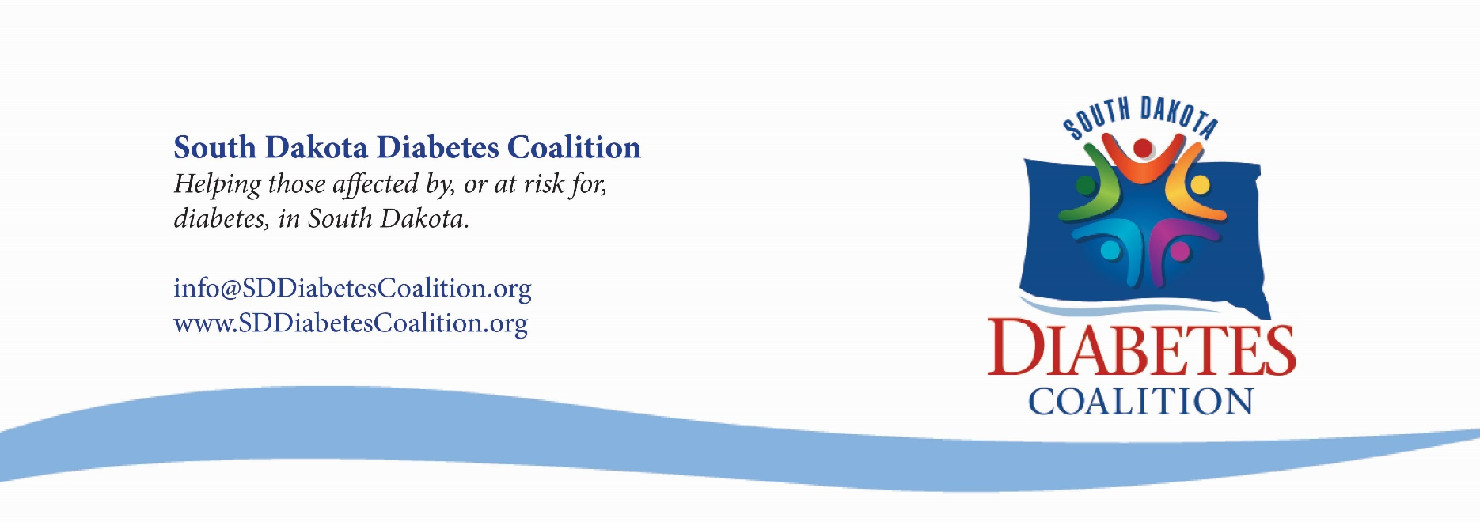

[Employer/Supervisor],
Diabetes is chronic disease that touches every life in South Dakota. According to the American Diabetes Association, approximately 80,282 people in South Dakota – roughly 11.4% of the adult population – have diabetes. The negative effects of diabetes are vast. For example, quality of life indicators among South Dakotans show people with diabetes are more likely to report poor physical and mental health as well as significant limitations to their usual activities. Despite these staggering statistics, around 34.5% of South Dakotans with diabetes reported that they had not taken a course to learn about diabetes and diabetes self-care.
The reasons to implement diabetes education at our organization are as vast as the negative effects of diabetes. Diabetes education would allow us to offer new services, expand our practice, and open new opportunities for the organization. It will also allow us to become more knowledgeable as an organization. With a diabetes education program at our organization, our entire staff will become more versed in diabetes and diabetes management. This will increase our professionalism as well, further promoting our organization and representing it in the best light. This would also ease the stress some patients feel as they would have to spend less time on traveling to find a different diabetes education program. Most importantly, having a diabetes education program at our organization will allow us to give our patients the high-quality care that they deserve.
A Certified Diabetes Care and Education Specialist (CDCES) (formerly referred to as Certified Diabetes Educators or CDEs) would greatly impact a diabetes education program at our organization. A CDCES is a health professional who possesses a comprehensive knowledge and experience in diabetes prevention, prediabetes, and diabetes management. The role of the CDCES is to educate, support, and advocate for those affected by diabetes. They also promote and teach about diabetes self-management, a vital tool for the long-term health of those with diabetes. A CDCES must take a rigorous examination and renew their certification on a regular basis in order to demonstrate knowledge and experience in the specialty. This is a critical role for any organization who wants to implement diabetes education.
With my passion for diabetes care, I believe that I will be a good fit for this role and will be pursing certification in order to become a CDCES. While I am excited to start this new journey in my career, I cannot be successful in this venture without you and your support. One important piece of my ability to get my credentials is time to study for the CDCES exam. Another piece I am asking you to support me with are the necessary resources I will need in order to get my credentials. I am also asking you to support my continuing education so that I may be the most effective in my new role as I can possibly be.
Diabetes education is a necessary step in order to reduce the negative impacts that diabetes has in the state of South Dakota. According to the American Association of Diabetes Care and Education Specialists, compared with no prevention, self-management reduces a high-risk person’s 30-year chances of getting diabetes by about 11%, the chances of a serious complication by 8%, and the chances of dying of a complication of diabetes by 2.3%. In addition, the hospitalization rate was 34% lower (25.0 per person per 100 years) for patients who had at least one educational visit. Despite these statistics, approximately 24% of South Dakotans, or 1 in 4 South Dakotans, are more than an hour’s drive from a Diabetes Self-Management Education and Support (DSMES) program. This lack of access cannot continue if we want to see a significant change in diabetes in South Dakota.
Diabetes education and CDCESs greatly increase the quality of life for those with diabetes. I am excited to have a positive impact on South Dakota and our organization as a Certified Diabetes Care and Education Specialist. I hope that I can count on your support as I continue this journey. I know that my becoming a CDCES will benefit our organization as a whole and will allow us to continue to provide the best service possible to the patients in our care.
Sincerely,

