

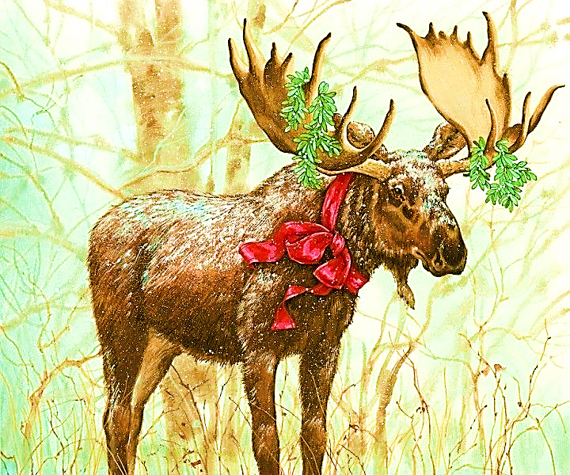

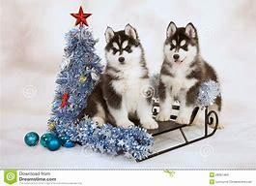

December 2019

Greetings to All

Honored Ladies, Sir Knights

and Families from Grand Court of WI.

The holiday seasons are now upon us. As we enter a new year, we should not forget our Amaranth families. What gifts can you give to your Court? With the snow arriving in Midwest our Wisconsin “Moose” is making tracks for the husky dogs to “Mush for Diabetes”.

*Put up a splash of Christmas spirit*

*Put in a dash of love*

*Stir up the sounds till you can hear it*

*Sing out to those you love*

*Paul Moosberg*

May God be with you your family and friends as we celebrate all holidays--- Happy Hanukah,

Merry Christmas and Happy New Year.

*H. L. Betty Anne Miller S. K. LeRoy Kifer*

*Grand Royal Matron Grand Royal Patron*