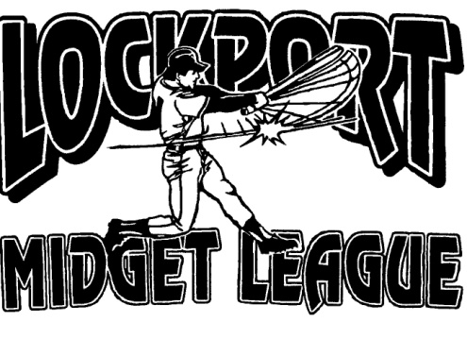
Lockport Midget Baseball League

lockportmidgetbaseballleague.com

Coaches Contract

I, ____________________________, the undersigned, being permitted to Coach the _________________

Team, hereby certify on my honor to the truth of the following:

Name: ______________________________________________ |  |  | Date of Birth: __________________
Address: ____________________________________________ |  |  | Age____ | _______________
City, State, Zip: __________________________________________ |  |  | Phone: ________________________

As a member of The Lockport Midget Baseball League, I pledge myself to:

1. Demonstrate at All times the Highest Ideals of Sportsmanship.

2. Coach my Best no matter what the Score or Playing Conditions may be.

3. Respect All League Players, Officials, Rules, Fellow Coaches, and Spectators.

4. Conduct Myself in such a manner as to be a Credit to My Team, My Sponsor, the Lockport Midget Baseball League, and Myself.

5. Carry on the high ideals of Fair Play and Clean Competition that have been established by the Lockport Midget Baseball League.

Signature of Coach: ________________________________________

