A WINTER GET-AWAY

Our ten-day trip to Alice Springs, partly on the glorified Ghan
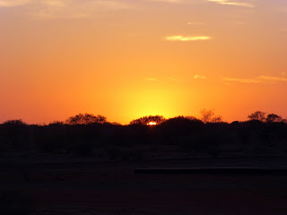
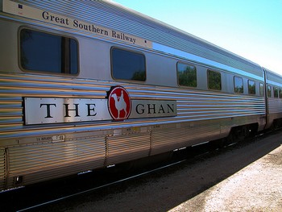
Where camels ran the silk route, steered by an ambitious Afghan!
The 1.2 km stretch of carriages snakes its way slow and steady
To enjoy an endless view of scenic landscape and service on the ready
A dawn stop around campfires at Marla to catch the rising sun
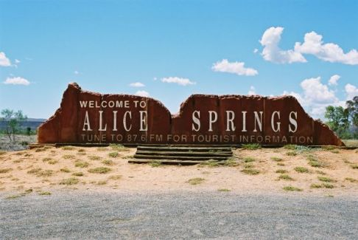
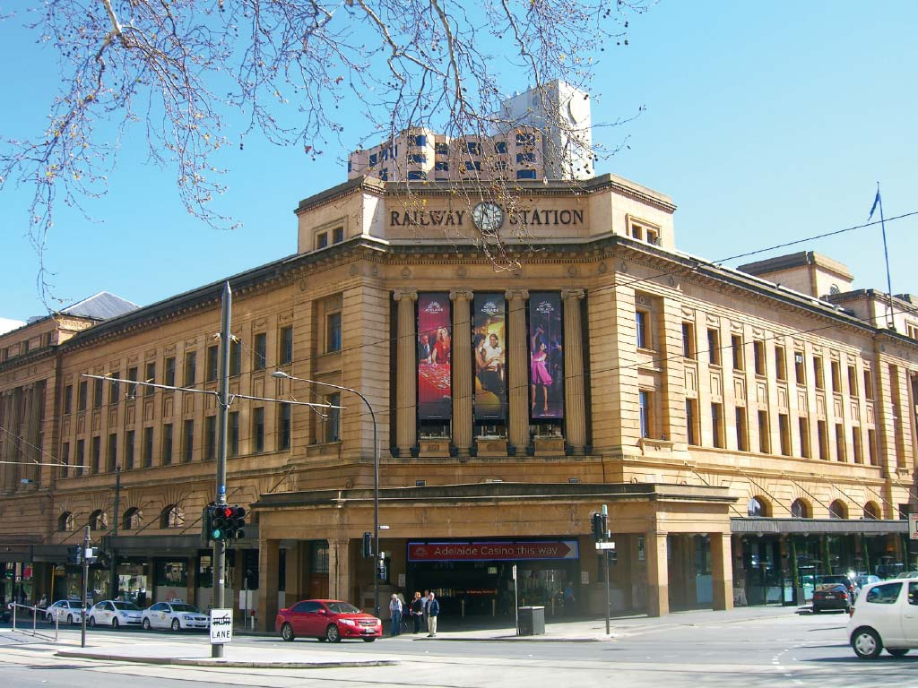
That finally peaked out later, as brekkie was cooked & done!

With flexibility to do what you want, just sticking to timings set
One is able to experience safe travel, that’s as good as it can get
Our group of 55 strong, with seniors numbering high
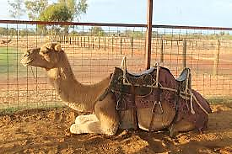
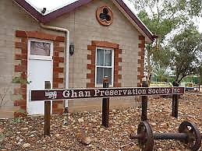
Was out to make the most, of holidaying under sunny sky
And so we did at every stop, game for anything fun and cool
Not to mention a morning mishap of one man, landing in the pool!
Music, laughter, card games, bingo, sharing treats and a yarn or two
We took in the sights of Alice Springs, with much more than a view!
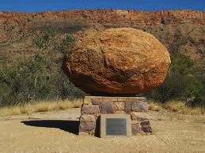
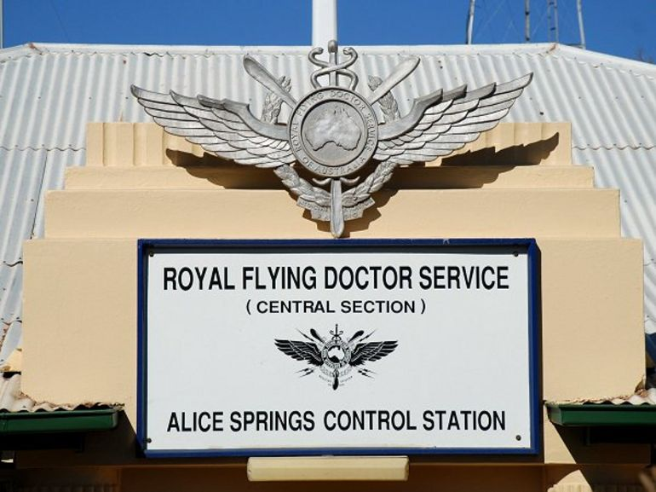

Flying Doctor’s Headquarters, the founder John Flynn’s grave
A wonderful legacy of compassion, to reach-out, serve & save

Rides on mini trains at the Railway Museum- not to miss for a thrill
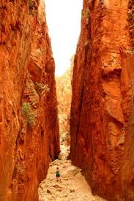

More scenic spectacles – Ochre Pits, Standley Chasm, Simpsons Gap – our wonder to fulfil!
Crazy camel rides and camel burgers too for those daring to try
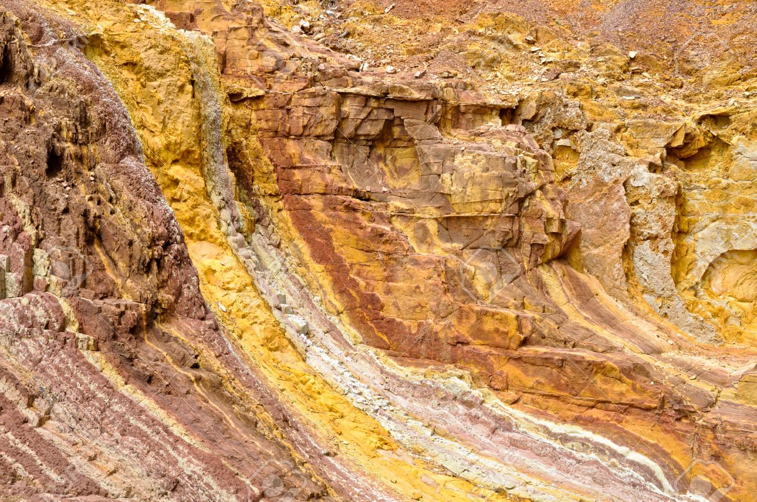

o
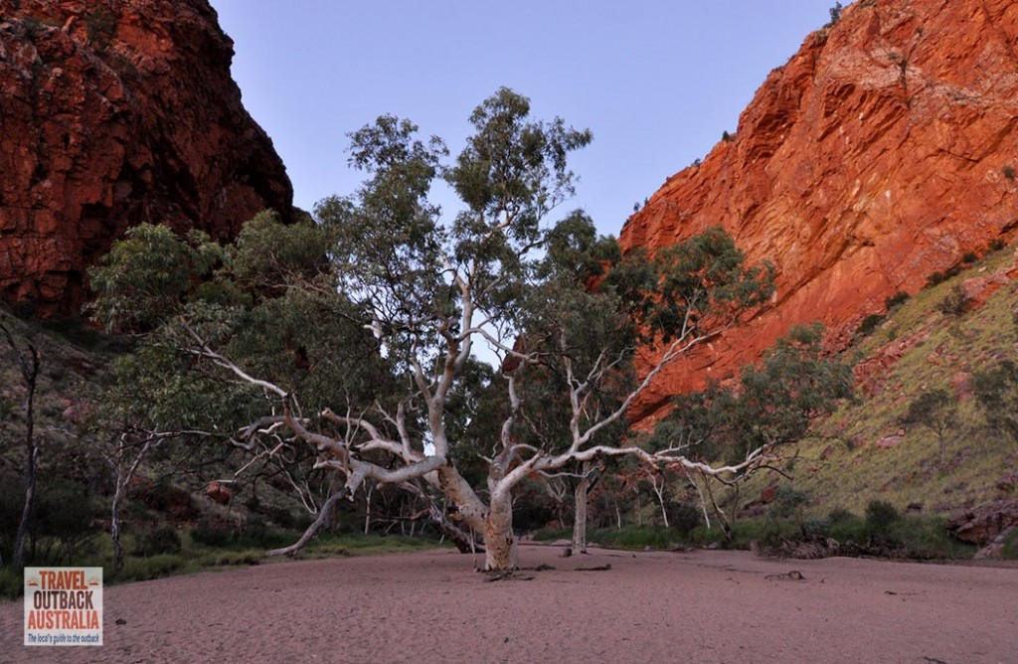
Can’t go wrong in a carefree group where there’s no need to be shy!

After a 3-night luxury stay at the Hilton’s Double Tree
It was through to Erldunda for more camp like majesty!
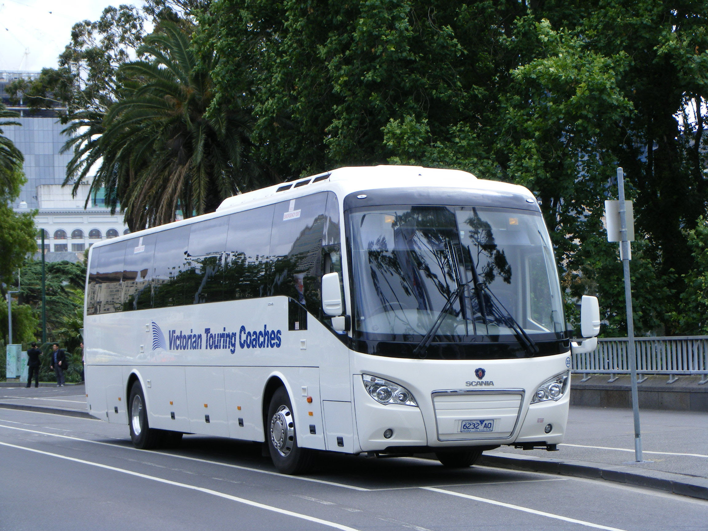
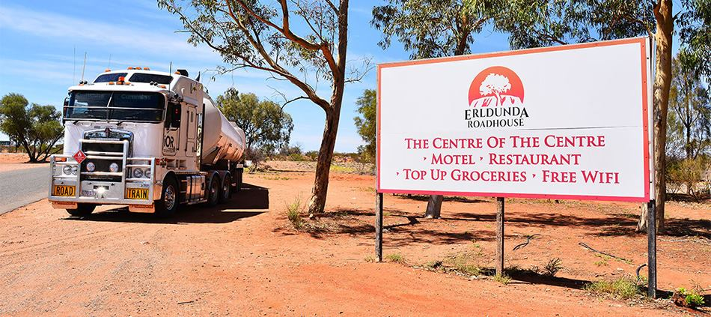
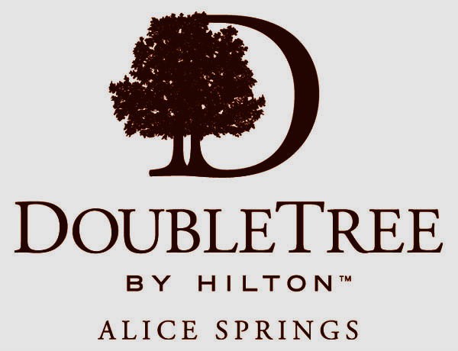
Nearer the tour’s main highlight of Uluru or Ayers Rock
The excitement had us waking up, well before the alarm clock!
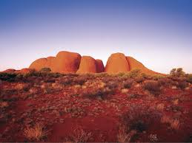
No words can describe the magnificence of this sacred treasure
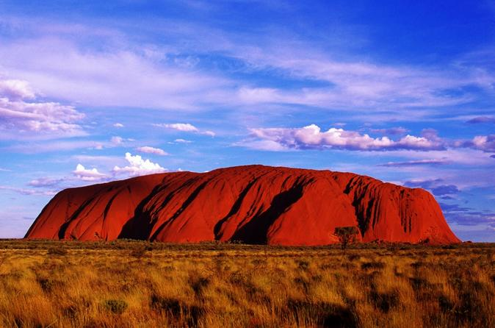
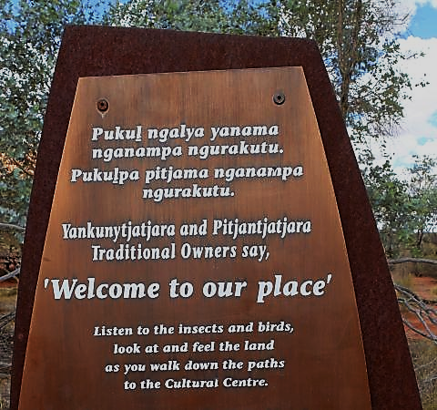
As stories take you back & beyond, where time has no measure
There are notices to respect and not climb the rock – an invitation to understand
Tracks detailed with scripted tales of the First People, on how they value this land
Aboriginal Cultural Centre, the Olgas – kata Tjuta, Ayers Rock Resort – visits that did impress
But for the uplifting Uluru where the soul gets a soft caress!
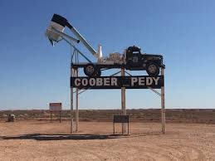

Next on the agenda, near the border of South Australia, was the town of Coober Pedy
The Aboriginal name for ‘white man’s burrows’ – mine digging for the opal greedy!

The full town tour took all of two hours – quaint and most fascinating
Beside mines, there’s developed housing underground – cheaper and worth contemplating!
A personal attraction was indeed, the beautiful underground Catholic Church
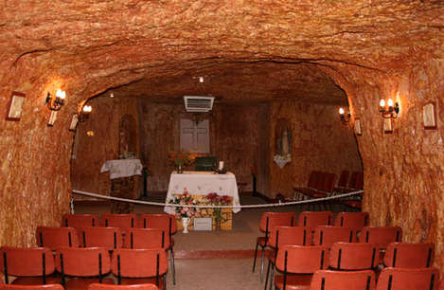
The Parish of Saints Peter & Paul–a divine find after a long day’s search!
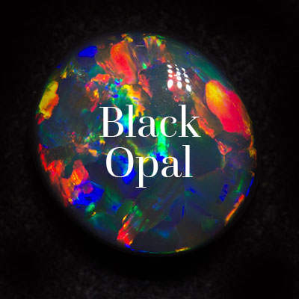
Attending Mass later that evening, many of our group joined in
Taking a spiritual initiative, to even sing a Communion hymn!
Blessed & refreshed, some had dinner at Australia’s 5th best Pizza place
Then for footy time-watching St Kilda stunning Geelong in the face!
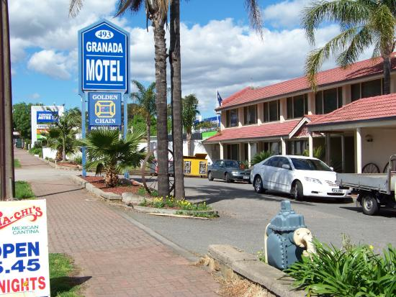

A hearty breakfast and early start for the long ride to Adelaide
With Heidi our bus driver managing solo, well in control she stayed!
Bonding together we journeyed on and as the tour neared its end
A general sense of both satisfaction and sadness, quietly did descend
Resting the night at Adelaide’s Granada motel, we agreed on another early rise
And then it was home to Melbourne – freezing weather for shocking surprise!

All said & done the get-away was GREAT and so, a big THANK YOU
To Rodney, Heidi and fellow travellers – stay HAPPY in all you do!

