CCUMC COMMUNICATES cCCommunicates
ISSUE
6

July 2021


In This Issue
Pg 1 Pastor’s Page
Pg 2 Important Announcements
& Upcoming Events
Pg 3 Did You Know
Pg 4 Finance Updates & Bible
Study Groups
Pg 5 Vacation Bible School flyer
Pg 6 Church Information

In Junes Pastor’s Corner I addressed the question, “How did we get here?” This month I would like to address what do we now as it appears the evil one is even more determined to cause even more division in the world and inside the Body of Christ itself. The Body of Christ has faced the forces of division from its very beginnings in the book of Acts. As the Gospel message was spread through out the Greco Roman world after new churches were started once the Apostles left the evil one would come in and spread division through various methods.
In 1 Corinthians 1:10-12 we read, 10 I appeal to you, brothers and sisters, in the name of our Lord Jesus Christ, that all of you agree with one another in what you say and that there be no divisions among you, but that you be perfectly united in mind and thought. 11 My brothers and sisters, some from Chloe’s household have informed me that there are quarrels among you. 12 What I mean is this: One of you says, “I follow Paul”; another, “I follow Apollos”; another, “I follow Cephas (Peter)”; still another, “I follow Christ.” The earliest division is over pastoral preaching and teachings, and it did not stop there, in 2 Corinthians 11:3-4 Paul writes, 3 But I am afraid that just as Eve was deceived by the serpent’s cunning, your minds may somehow be led astray from your sincere and pure devotion to Christ. 4 For if someone comes to you and preaches a Jesus other than the Jesus we preached, or if you receive a different spirit from the Spirit you received, or a different gospel from the one you accepted, you put up with it easily enough.
We need to be on our guard when some new teaching is presented telling us who Christ is or what is essential for us to follow as disciples of Jesus Christ, otherwise we may end up like our brothers and sisters in First and Second Corinthians following the Jesus of the world’s creation and not the Jesus who God reveals to us in the scriptures. In the parable of the Rich Man and Lazarus in Luke 16:19-31 in verse 29 Abraham replies to the Ruch Man’s demand that Lazarus go and warn his brothers so they can avoid hell, “They have Moses and the Prophets; let them listen to them.” I say to you, we have Moses and the Prophets along with Jesus revealed in the Gospels and the Epistles, lets listen to them whenever we are presented with a new teaching about Jesus or a new requirement for discipleship and ask this question, where is the Jesus that is revealed in this new teaching or requirement of discipleship found in the scriptures that God has given to us.

Join the UMW in a summer movie matinee and discussion that started June 22nd with a movie called Asian Americans. July 6th matinee is Dawnland. July 13th matinee is Pushout. July 20th matinee is Race: the Power of an Illusion. Matinee’s start at 3:00 pm & will be held in the Ambassador’s Room. Please contact Wally Leavitt @ 989-640-0238 for more information.

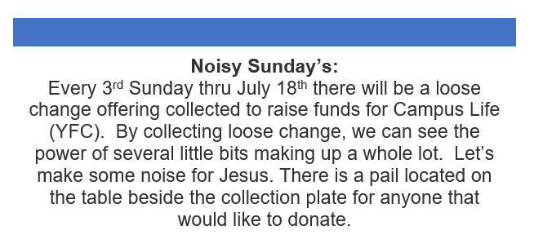



The Montcalm Commission on Aging has received many donations of medical equipment from people who don't need it. If you are in need of walkers, wheelchairs, shower benches, commodes, or canes, give them a call at 989-831-7476. You may also go to COA in Stanton located at 613 N. State St. If you would like to take a look at what they have.






The Finance Team met on June 15, 2021, and looked at the trend for giving vs. outgoing bills. CCUMC needs about $3500.00 per week to cover salaries and bills. The overall giving has been closer to $2500.00 per week. There are a few ways to correct this situation.
- If you are unable to attend church, you may mail your check to:
CCUMC, Box 298, Carson City, MI 48811
- Give electronically through Vanco. Paula or Wally can assist you with this.
- You can put your offering in the offering plate found on the table before the sanctuary.
Thanks to all that have done so far. This is a gentle reminder and a notification where your church is at.
Here is an update on the mortgage balance. It currently is at $77,448.08. If we can just hang in there for approximately 16 more months, it will be paid off.
If you have any questions, please let us know.

Tyler Wilson, Chairman
Walthagaye Leavitt, Finance Secretary
Paula Wiles, Finance Secretary
Robin Shepler, Treasurer

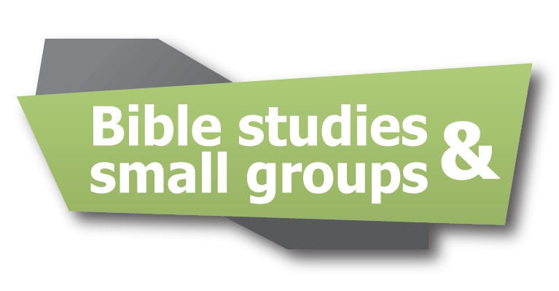


Class meets Monday nights @ 6:30 pm or can join from a Facebook group. Currently, we are studying Moses by Adam Hamiltion. There is a video which takes us to places Moses would have been. The book delves into his life and shows us how God used this ordinary man to do extraordinary things. Starting July 12th we will gather for a devotion and card signing before watching family movies. We will end in a prayer.
Total:____________


Mission u, previously called School of Christian Mission, is an educational event of United Methodist Women. Throughout the year, women are encouraged to read books on Social Action, Leadership Development, Spiritual Growth, Education for Mission, and Nurturing for Community. One book from each category is the minimum for obtaining a certificate. Of course, one can read many more than that. This is known as the Reading Program. UMW has always been about making people aware about the injustices being done here and across the globe.
Pre-COVID, Mission u has been held as a site where women from the state gather for 1 to 3 days to learn and fellowship. This year, it will be held virtually. The first study is Finding Peace in an Anxious World. There are recorded teachings on this on the UMW Conference website; umwmichiganconference.org. The Monday night PT class did this and found it very interesting.
The second study is Pushout, a book about the criminalization of black girls in schools, is being offered via ZOOM July 9 & 10. July 9 will be a worship service and introduction to the study on the 10th.
The third study is Aug 13 & 14; Bearing Witness in the Kin-dom: Living into the church’s moral witness through radical discipleship. It is suggested to read the books before attending, but not necessary.
Both events will be held at church in the Servants of God room (time to be determined). What a great opportunity to be involved on a deeper level. Put this on your calendar and hope to see you there.
Open to anyone- if you have questions- you can call WalthaGaye at 989-640-0238.

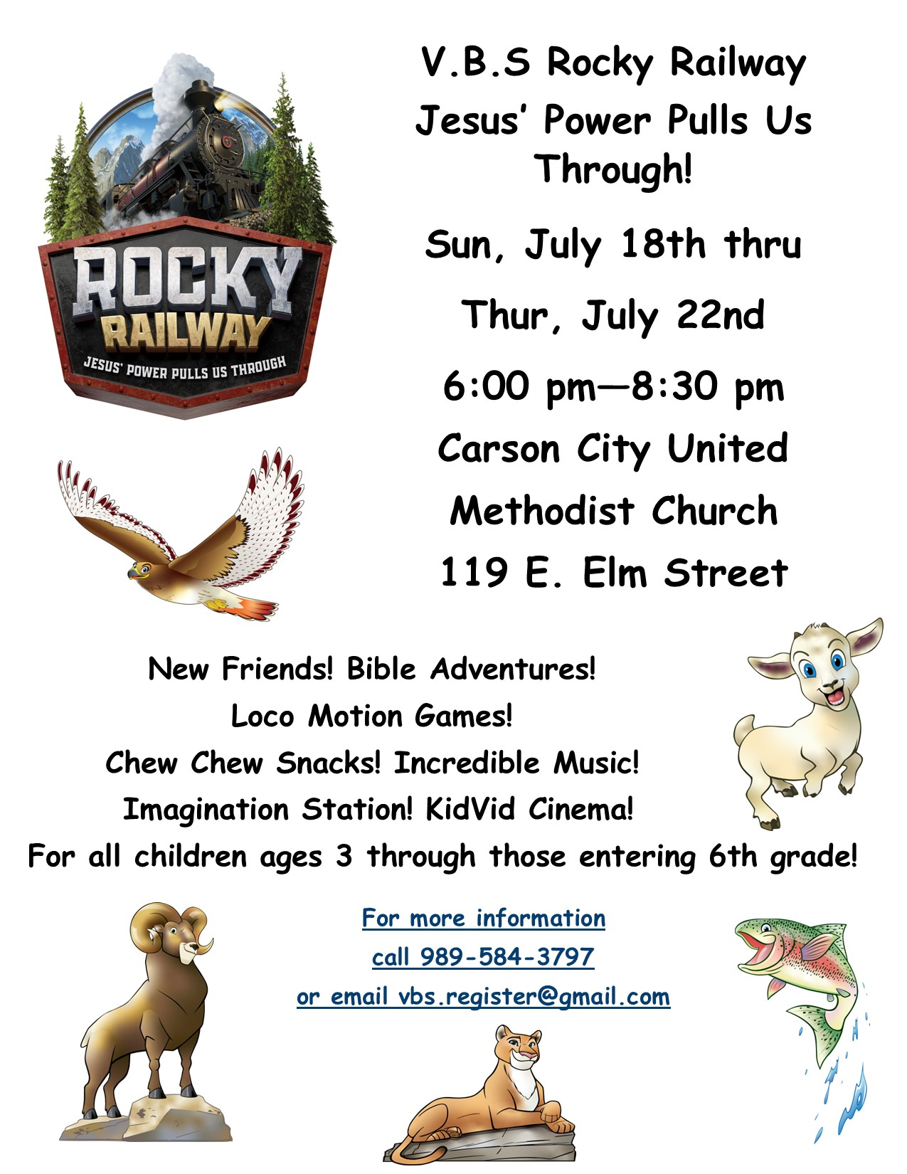
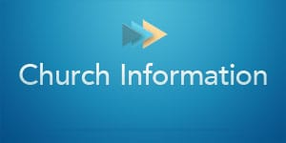
Stay connected! Follow us on:






Carson City United Methodist Church
Phone: 989-584-3797
Email: carsoncityumc@gmail.com
Website: carsoncityumc.com
Office Hours: Monday, 9:00 am-2:00 pm
Tuesday-Thursday, 9:00 am-12:00 pm
Pastor: Ian McDonald (906) 322-5318
Secretary: Bonnie Seaman (989) 763-1674

Seeds of Faith - daily devotion on Facebook by Pastor Ian McDonald. The pastor will be giving a four to five minute devotional on a portion of scripture that speaks to our faith.

Online giving available - on CCUMC Website: http://www.carsoncityumc.com/donate.html

Join Us Each Sunday

Worship Services 10:00 am

(masks are optional)
Weekly Sunday Bulletin now available on our website
at www.carsoncityumc.com

