Northern Neck Recreation, LLC
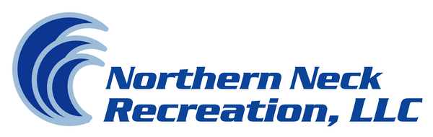
Boat & Beach Club
42406 Azalea Ln.
Sterling, Va. 20166
(571) 375-5327
info@nnrboatandbeachclub.com

NNR Boat and Beach Club Membership Fee Agreement
NNR Boat and Beach Club recreational facilities for Northern Neck Recreation (NNR) include the following:
- NNR Pool and Pool House
- NNR Beach
- NNR Boat Ramp and Dock Facilities

The NNR Boat and Beach Club recreational facilities are solely owned by Northern Neck Recreation, LLC.

Northern Neck Recreation, LLC agrees to maintain and operate these facilities for the benefit of the NNR Boat and Beach Club members during reasonable business hours, so long as the members pay Northern Neck Recreation, LLC its reasonable charges for such operation and maintenance. Northern Neck Recreation, LLC has determined that the membership fee will be $400.00 per member/family for the 2014 season. These fees may change yearly in order to support the operational costs of the Northern Neck Boat and Beach Club.
Northern Neck Recreation, LLC reserves the right to deny the use of any or all NNR Boat and Beach Club recreational facilities, if such member is delinquent in payment of the annual membership dues. In addition, Northern Neck Recreation, LLC reserves the right to cancel a membership and deny access to all NNR Boat and Beach Club recreational facilities for reasons including but not limited to, destruction of NNR property, disorderly conduct or the operation of a vessel within Swan Lake in a dangerous or destructive manner.
BY SIGNING BELOW, the undersigned acknowledges that he/she received, read and accepted the above provisions concerning the NNR Boat and Beach Club recreational facilities owned and operated by Northern Neck Recreation, LLC.

Lot(s) ________________________ Email Address_______________________

_____________________________ Vehicle Tag #________________________
Print Name Date

_____________________________ ___________________________________
Sign Name Mailing Address

