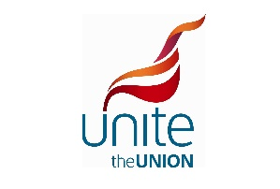

Here is the pay deal in full:

Pay elements
- Basic and Sectors increase as per table below.
- Positioning and Airport Standby are, pursuant to current T&C, impacted by the sector rates increases.
- Up ranking payment – 2.5% one-off increase from Jan17 : current £12.81 – new rate £13.13
- Office payments (OFC4/8, RCMT, SPIN, EWC, UNN, UN4) and the Holiday Pay Supplement are impacted by the related increase on sectors per rank/year (as OFC4/OFC8 in the table below)
- Night-Stop payment
  - 5% increase from 1st of Jan17 – current £27.35 - new rate: £28.72
  - 7% increase from 1st of Jan18 - new rate: £30.73
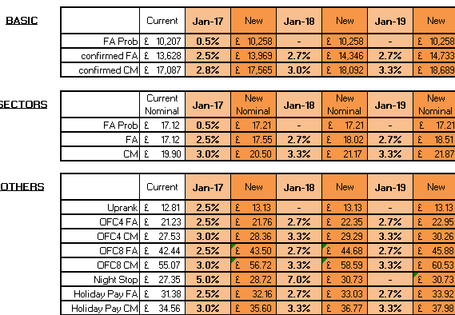
With the exception of the above-mentioned pay elements, all other payments would remain unchanged.

New and improved compensation for day to day disruption (from January 17)
- ADTY – In case of operational needs on the day of operation cabin crew may be required for an ADTY duty of less than 4 hours. If not called to fly, cabin crew shall receive 1 nominal sector payment from 00:01 to 03:59.
- Goodwill Allowance (renamed Roster Disruption Payment) - one-off 40% increase from £25 to £35
As of 1st January 17 the "Goodwill Allowance" currently existing will be known as Roster Disruption Payment (RDP). Payments will continue to be made as per current rules.

The Company is committed to meet Unite as soon as practicable and no later than March 2017 to agree changes to the rules that are triggering the payment with a view to be effective for the Summer 17 flying schedule. The rules for discussion will look at the application of the current payment that is in existence and how that could be paid during times of disruption that directly affect our crew on the day of operation.
Subject to agreement, the payment rules could cover either a loss of earnings through sector payments that is not covered by current payments such as ADTY, WIDO, and/or by a duty day that is extended by additional time to be agreed by both parties.

- Complementary Bars - Commissions calculated as per current rules with a 5% rate applied against the total value of the products given away during Comp Bars.
- Working into a Day-Off – (current rate: FA £90 / CM £110)
Infringement length | FA | CM
00:00 to 00:29 | £100 | £120
00:30 to 01:30 | £105 | £125
From 01:31 | £110 | £130

