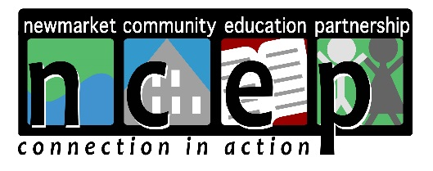

NCEP GRANT APPLICATION

NCEP’s Board looks forward to considering your grant application. To ensure proper review, please carefully follow the instructions listed below. Grants received after the stated deadlines or grants that are missing requested information cannot be considered. Please visit www.ncepconnects.com for grant-writing assistance. Thank you in advance for your understanding.

NCEP offers two (2) grant cycles each year. Grants may be written for up to $1,000. Grants must be received by the following deadlines:
- February 15
- September 15

Steps for successful submission:
- Prepare cover sheet.
- Complete Parts I, II, III and IV. See important note below.
- Make five (5) copies of the entire package (including steps 1 and 2 above); collate the copies and staple them together.
- Mail copies to:
Newmarket Community Education Partnership
P.O. Box 536
Newmarket, NH 03857

IMPORTANT NOTE ABOUT NEWMARKET JR./SR. HIGH SCHOOL GRANTS:
School grants require review and pre-authorization to ensure they meet school gifting policies. Pre-authorization must be obtained from both school and district administration. Please make sure to work in enough approval time to ensure grant deadlines are met. How to:
- Complete grant application submission instructions step 1 and 2.
- Provide grant scope and details to school principal; obtain approval (email is fine).
- Provide grant scope and details to Assistant Superintendent Chris Andriski at the school district (email is fine), or drop a copy of the grant off at the district office; obtain approval.
- Continue with step 3 and 4.

Responsibilities of Grantee and Grantor:
Organizations that receive grant money from NCEP must use the grant funds only for the purposes of which the grant was made. All grantees must provide a final written report at the end of their project; evaluating the project and an accounting of how grant funds were used (available on website). NCEP has the authority to withhold and/or recover grants funds in case funds are, or appear to be, misused.

Questions:
- Please visit our website www.ncepconnects.org, or email: ncepconnects@gmail.com

NCEP GRANT APPLICATION
COVER SHEET

Grant deadline: | February 15 or September 15
Grant request name:
(i.e. “iPads for 3rd Grade,” “8th Grade Trip,” “Supplies for Cooking Club,” etc.)
Name of organization:

Pre-authorization:  School district grants require pre-approvals. | Approvals in place? Please indicate date:  Principal: _____________  School District: ____________
Address:

Contact person for application:

Contact phone number:

Contact email:

Tax ID (if not School or Rec. Dept.):

Funding (grant maximum $1,000): | Project total: $_________________  Amount requested: $______________  Are you seeking other funding from other sources as well? ______ If yes, please explain: _
Number of children/ youth grant will impact:

Brief description of grant request (one paragraph):

NCEP GRANT APPLICATION

Part I – Project Description
Describe the project. What are the goals and objectives? Who will the project serve (how many children and/or youth). Provide a timeline for implementation. Validate grant request amount by providing copies of receipts, quotes, etc.

Part II – Rationale
Why is this project needed and how does it serve NCEP’s mission?

Part III – Staffing
Who are the key personnel? List names/titles and their roles.

Part IV – Evaluation
How will progress be monitored, and success measured?

