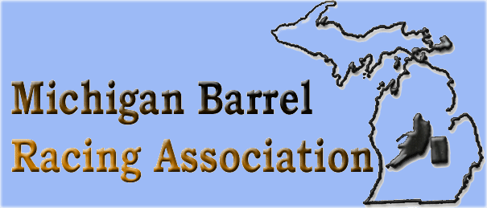
SPONSORSHIP AGREEMENT 2020-2021
MBRA is a family oriented barrel racing organization that seeks to encourage a love of barrel racing and horses. It also offers a great opportunity for sponsors to show support in return for advertisement and recognition at well-attended shows throughout the year and year-end finals.

$500 Platinum Sponsor: Large advertisement sign at Finals & in
Newsletters, on MBRA website/Facebook & announcement of sponsorship at shows
$250 Gold Sponsor: Medium advertisement sign at Finals & in
newsletters, on MBRA website/Facebook & announcement of sponsorship at shows
$100 Silver Sponsor: Advertisement in newsletters, on MBRA
website/Facebook page & announcement of sponsorship at shows
$75 Bronze Sponsor: Announcement of sponsorship on
website/facebook page & announcement at shows
YOUR SUPPORT IS APPRECIATED!

Sponsors Name: ________________Company_____________
Telephone:___________________Email: ________________
Other Cash contribution /
Other contributions(prizes, gift certificates)__________________________
You can contact us through our website (www.mibarrelracing.com) or message us on facebook to discuss alternate ways to support MBRA!
Checks payable to: MBRA Please mail to: Heather Kedzierski
3300 N Lake Pleasant, Attica, MI 48412

