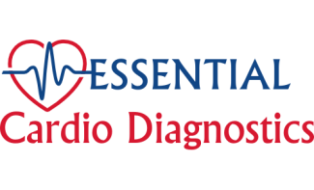 | Essential Cardio Diagnostics  Tel: 647-878-5766  Fax: 647-930-1688  www.ecdcorp.ca

Holter Responsibility Agreement

I, (name) ________________________, understand that the Holter monitor is given to me for diagnostic purposes, and it should be returned on _______________ in working condition along with all the accessories within 10 days after the recording is completed.
I agree to pay Essential Cardio Diagnostics (ECD) $ 2,500 fines in case of loss, physical damage of the Holter Monitor or in situations when the Holter machine is not returned to the clinic.

Patient’s Signature_____________________, Date_____________________

