The Pros Of Buying An Electric Car
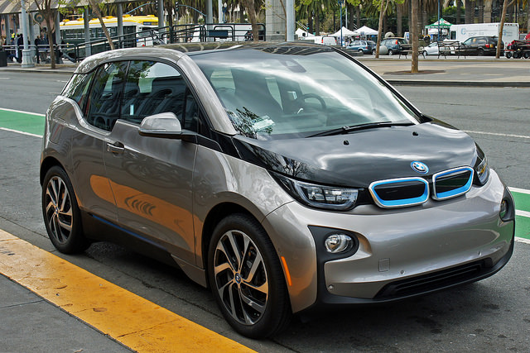
BMW i3 Electric Car

The fact that gasoline powered cars contribute to the pollution of the earth and electric cars run with an engine that is emission free, many people are now considering purchasing an electric car, also known as EV’s, so they can try to live as eco-friendly as possible. If you desire to live as “green” as possible or even if you just want to do what you can to save on the cost of gas, you may be interested in knowing the pros to buying an electric car so that you too, can help cut down on air pollution and be able to save a little money along the way.

Before we discuss the pros to owning an electric car, let’s ensure that we also touch on the few disadvantages that can come along with ownership as well. When it comes to the negative aspects of owning an electric car, the list is short.

- You will need to recharge after driving between 100-200 miles depending on the car you own. When you need to recharge you need to allow 1-2 hours for a full charge. Most electric car owners will place their car on charge overnight when it will be convenient to charge. Others use an onboard charger and will be able to charge during work hours so the car will be fully charged at the end of the workday.

- Electric cars, on average, will cost anywhere between $28,000 and $50,000 when buying new. Some of the more elite electric cars can range anywhere between $50,000 and $75,000 or more although for standard cars, you can expect the lower cost range. You can also however, find many electric cars through auction and used sales for significantly lower than the new price.

Now that we have the small negatives out of the way, let’s move on with the great reasons that owning an electric car can be a benefit to your life, and to the world around you.

The Best Reasons To Buy An Electric Car

When it comes to owning an electric car, whether you may be interested in shipping over one of the smaller cars like the Smart Fortwo, manufactured by the Smart division of Daimler AG which is an ultra-compact two-seater and has been a huge success in Europe as well as the U.S. or if you prefer a sportier model such as the BMW i3 or other luxury models, they all have similarities that make them a great choice in a vehicle.

The excellent aspects of an electric car include:

- Many models are very compact.
- Sporty models are available.
- Up to 500% or more efficient than internal combustion engines.
- Much quieter than gasoline powered cars.
- No air pollution since the cars are powered by a battery rather than gasoline or diesel fuels that pollute the atmosphere.
- With a smaller, compact car you can get far better mileage than a gas powered car.
- On average, an electric car will cost less than five cents per mile to run.
- Lower purchase cost than many of the gasoline powered cars.

The motor in an electric car is remarkably smaller than those found in gasoline powered cars. Many of the motors are less than 11 inches in diameter and contain several batteries that are basically the same size as a typical battery found in a gasoline powered car.

Many people that want an electric car to help protect the environment are also opting to modify their current gasoline powered car. A kit to convert a motor from gasoline to electric can be obtained and used to fully modify a car for under $10,000 which makes it even easier to own an eco-friendly and money saving vehicle.

An Eco-Friendly Future
While you can find many electric cars that are compact, you can also find many that are very stylish and smooth and it is difficult to even tell they are eco-friendly for the environment because their design makes them look just as sporty as many of the gasoline powered cars. With the efficiency available as well as the fact that these cars are safer for the atmosphere, it is hopeful for manufacturers as well as clean air that these cars will really begin to see a boost in sales as more people become aware of just how great it can be to own one. Buying an electric car today is a great way to ensure that tomorrow is safe from pollutants that cause harm to the environment.

