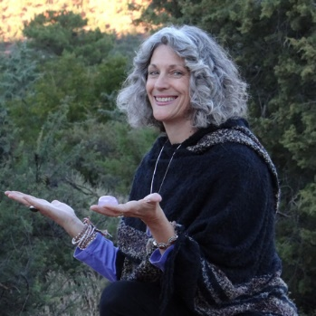
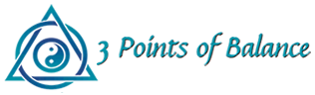

Full Body Swedish/Deep Tissue Massage
60-90 min -Deep Tissue Massage Therapy - $85 - $110
Description
Traditional therapeutic bodywork – “From the Greek word “massein,” meaning “to knead,” this is a manipulative therapy designed to relax, stimulate and invigorate the body by kneading, stroking, and pressing the soft tissues of the body using a variety of techniques”. (Free dictionary)
Benefits
Relieve tensions and soreness in your body. It will promote relaxation, wellness and release of toxins. Trigger point release can reduce specific areas of soreness in neck, shoulders and throughout body.
Reason to choose this technique
If you experience injury, strains, tightness in the body and to maintain overall well-being. Want to encourage stress reduction, decrease overall tension in your body, increase circulation and flexibility. Maintain health.

Integrated Therapeutic Bodywork
60-90 min -Massage/Cranial Sacral/Polarity Therapy - $100 -$125
Description
Energy healing works on the energetic or etheric body to address those issues of trauma and disease that can manifest in the physical body as injury, chronic illness, or muscle pain. It also addresses emotional imbalances by allowing the trapped energy to be released and the emotions to flow harmoniously.

Benefits
It opens and balances energy flows in the body to facilitate release of tension, on both the emotional and physical level. The release of energy blocks inhibiting ease of movement and by utilizing massage therapies to increase range of motion and allow muscles to relax, creates full body~mind~spirit health.

Reason to choose this technique
Provides a combination of energy work and physical massage which gently addresses issues of repeated patterns of injury, tension or tightness in the body. This is accomplished by looking at core issues and supporting healing so the patterns can be shifted at the deepest level.
Paula Lockwood, LMT,
Craniosacral, Shamanic Energy Practice, Reiki
Locations in Sedona, Arizona and Safety Harbor, Florida 845.546.3361

Shamanic Energy Healing Session
with Cranial Sacral/Polarity Therapy/Reiki/Crystals
30 min - $55; 60 min - $100
Description
Open, align and balance the flow of energy through the various meridians and chakras (or energy centers) using Eastern traditional methods to allow the natural self-healing processes of the body to restore health. It facilitates the release of blocked energy and toxins by releasing points of trapped energy.

Benefits
This method allows release with little physical intervention. The practitioner works in the energetic field after the client is brought into a relaxed and calm state, allowing healing to occur on a subtle and powerful level.

Reason to choose this technique
To address issues which have not responded to Western allopathic methods and affect you on subtler levels. This is most effective for those who are open to working with spiritual and esoteric concepts using ancient energetic medicine practices from native traditions.

Ionic Detox Footbath
30 min - $40

Description
Utilizes the skin - one of the seven avenues of elimination to assist in accelerating the body’s detoxification process
Benefits
It uses positive/negative ions to attract and eliminate toxins from the body, where they are lodged in joints, organs and in the blood.
Reason to choose this technique
An easy, relaxing cleanse to clear your system of trapped, harmful toxins.

Paula Lockwood, LMT,
Craniosacral, Shamanic Energy Practice, Reiki
Locations in Sedona, Arizona and Safety Harbor, Florida 845.546.3361

