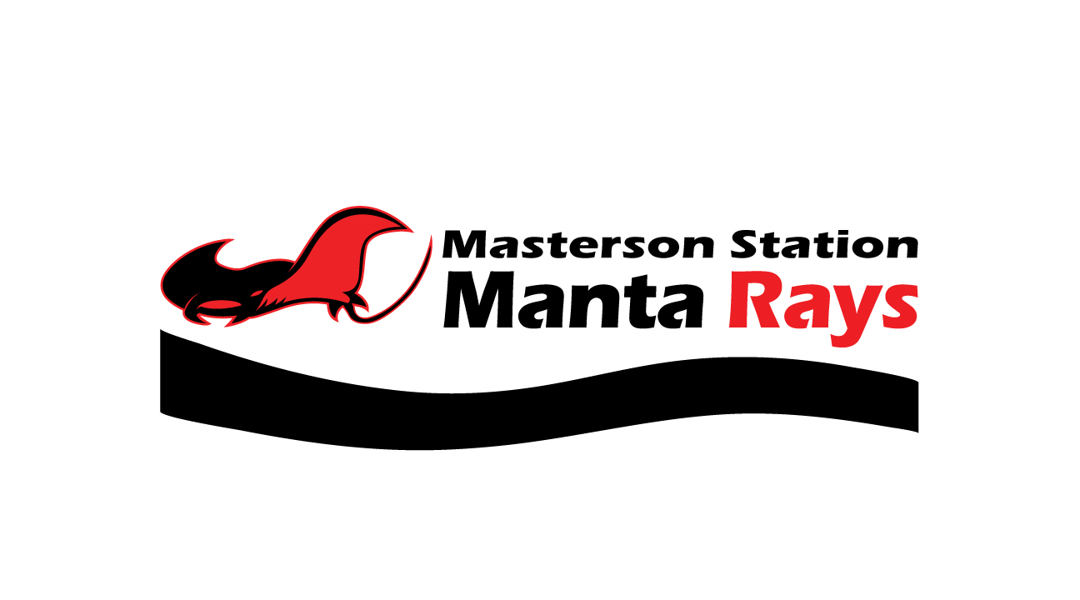
Spirit Wear

For different options of Manta Ray spirit wear visit

https://www.etsy.com/shop/EllesEmbroidery?ref=ss_profile&section_id=23806621

Each family will order and make their payment on the website individually.

For orders made by May 10th put in as pick up and Chassity VanderHorst will pick up and distribute at the pool.

For orders made after May 10th families will be responsible for getting their orders shipped or picked up.

**For returning families, these are the tank tops we had made last year for conference. This year she has extended our options from tank tops to t-shirts, hoodies, quarter length zips and these are available in youth sizes as well.

