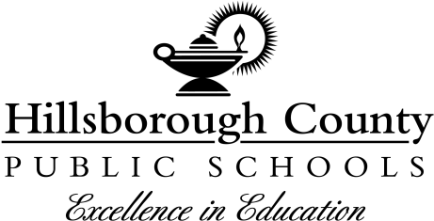

Davidsen Middle School 6th Grade Second Semester Electives

Dear Sixth Grade Students & Parents/Guardians:
6th grade students will be selecting their electives for the Spring Semester the week of November 29th using an online form during their current wheel class. Please review the options with your student (listed below) and return this form to your child’s current wheel teacher by November 29th. Every attempt will be made to give you your first choice; however, this is not always possible.

Please sign below to indicate that you are aware that your child will be making their elective choice the week of November 29th online during their wheel class and return this sheet to your child’s current wheel teacher by November 29th.
Student Signature ___________________________________________ Date _________________
Parent/Guardian Signature ____________________________________ Date _________________

6th Grade Elective Descriptions Spring 2022
- Visual Art 1- 6th grade students will use clay, paint, pencil, collage, and many other mediums to create art works that are both 2-dimensional and 3-dimensional. Students will also learn the Elements of Art and learn about Art Criticism.
- Business Keyboarding (Computers)- provides an opportunity to develop keyboarding skills needed for school and your future! We focus on learning word processing software, presentation software, and how to safely use the Internet. We also explore spreadsheet and desktop publishing software. You will learn by completing a variety of mini-projects and interactive online learning modules.
- Orchestra- A beginning string course where students will learn how to read music and how to play and care for an instrument. Students will participate a Spring concert, showcasing their achievements.
- Chorus- This ensemble is for any 6th grader who loves to sing! Students will learn how to sing with a healthy, free and relaxed tone, how to balance and blend in a choral ensemble, how to read music, and how to become independent musicians.
- Band- A beginning band course where students will learn how to read music and how to play and care for an instrument. Students will participate a Spring concert, showcasing their achievements.
- AVID- Advancement Via Individual Determination (AVID) helps students improve the reading, writing, and math skills that are necessary to succeed in high school, college and in their professional careers. Student achievement will be supported through the instruction of study skills, organization and higher-level thinking. Students will also participate in collaborative study groups and team building. Check us out on Twitter @mrsdub_avid
- Spanish- An introductory course for beginners that will establish a strong foundation and promote future success in Spanish learning for years of study to come. There is plenty of practice on the lexical and grammatical topics and detailed practice and accompanying drills to develop the four essential skills of learning Spanish: understanding, speaking, reading, and writing. This is a class with lots of speaking! It will be fun mixed in with some work.

