How do I… change my address?

You can access your address information by selecting the “Profile & Settings” option on the menu panel.
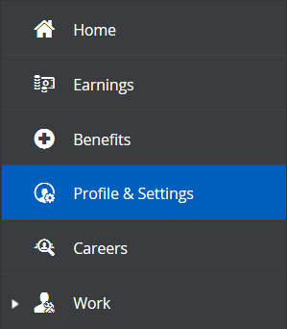

You will then select “Forms” from the options at the top of the screen.

Next, you will select “Address” from the list of available forms.
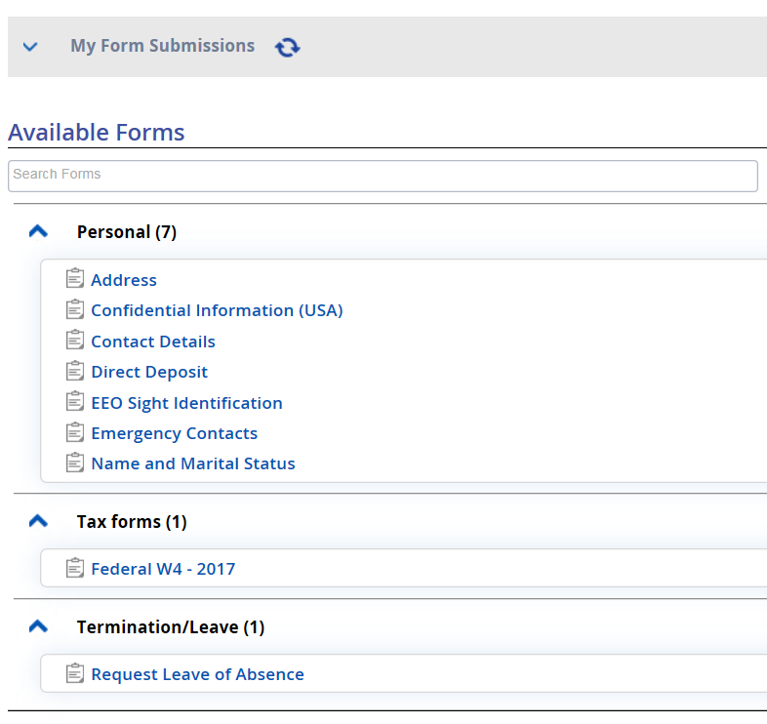
If you are changing your address, you can click the “Address Lines, City, State, & Zip Code” boxes (you will have to scroll to the right) and type over the existing information.
If you are adding another address, you will select the “Add” option, and enter your additional address. You would use this if you had a different address for mailing, or had a secondary address.
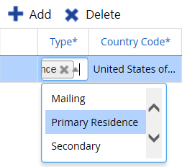
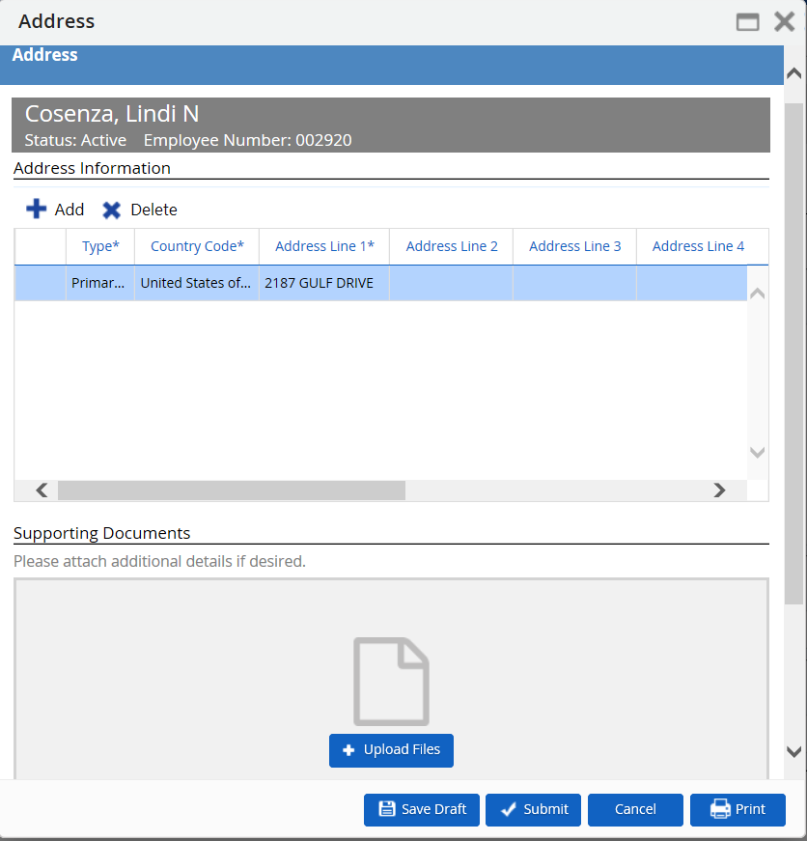
Click “Submit”
The changes will save directly to the database.

